ANTENNA QY74208XL3D35
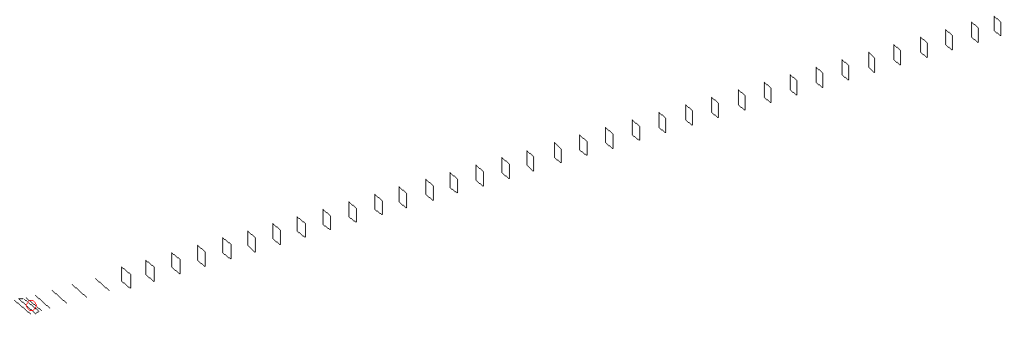
DESCRIPTION
Radiator |  |  |  |  | Number of  yagi elements |  |  |  |  |  | Number of  oblong elements |  |  |  |  | Total number  of elements |  |  |  |  |  |  |  | Boomlength  (mm)
LFA |  |  |  |  | 6 |  |  |  |  |  | 35 |  |  |  |  | 42 |  |  |  |  |  |  |  | 11225
DIMENSIONS
 | Ref |  | De1 |  |  | De2 |  | D1 | D2 |  | D3 |  | D4 |  | D5 | DQ1 |  |  |  | DQ2 | DQ3 |  | DQ4 |  |  |  | DQ5 |  | DQ6 | DQ7
Position | 0 |  | 70 |  |  | 120 |  | 158 | 257 |  | 442 |  | 672 |  | 928 | 1201 |  |  |  | 1476 | 1765 |  | 2073 |  |  |  | 2363 |  | 2661 | 2946
Length | 332 |  | 330 |  |  | 330 |  | 303.5 | 305 |  | 295 |  | 288 |  | 279.5 | 173 |  |  |  | 165 | 162 |  | 159 |  |  |  | 157 |  | 156 | 155
 | DQ8 |  | DQ9 |  |  | DQ10 |  | DQ11 | DQ12 |  | DQ13 |  | DQ14 |  | DQ15 | DQ16 |  |  |  | DQ17 | DQ18 |  | DQ19 |  |  |  | DQ20 |  | DQ21 | DQ22
Position | 3232 |  | 3516 |  |  | 3806 |  | 4081 | 4374 |  | 4649 |  | 4943 |  | 5233 | 5512 |  |  |  | 5824 | 6126 |  | 6432 |  |  |  | 6731 |  | 7047 | 7374
Length | 154 |  | 153 |  |  | 152 |  | 151 | 150 |  | 149 |  | 148 |  | 147 | 146 |  |  |  | 145 | 144 |  | 143 |  |  |  | 142 |  | 141 | 141
 | DQ23 |  | DQ24 |  |  | DQ25 |  | DQ26 | DQ27 |  | DQ28 |  | DQ29 |  | DQ30 | DQ31 |  |  |  | DQ32 | DQ33 |  | DQ34 |  |  |  | DQ35
Position | 7671 |  | 7986 |  |  | 8283 |  | 8591 | 8886 |  | 9172 |  | 9478 |  | 9776 | 10072 |  |  |  | 10368 | 10672 |  | 10964 |  |  |  | 11225
Length | 139 |  | 139 |  |  | 139 |  | 139 | 139 |  | 131 |  | 131 |  | 131 | 131 |  |  |  | 131 | 131 |  | 125 |  |  |  | 125
Remark | All elements made of Al tubes Ǿ8 mm  The height of rectangles is 170 mm  All dimensions given in milimetres
PERFORMANCES (No loss condition)
G  (dBi) |  | F/B  (dB) |  |  |  |  | F/Sh  (dBi) |  |  | F/Sv  (dBi) |  |  |  | Hor  (◦) |  |  |  |  | Ver  (◦) |  |  | Temp  (◦K) |  |  |  |  |  | G/T  (dB)
21.69 |  | 37.40 |  |  |  |  | 17.78 |  |  | 17.10 |  |  |  | 16.6 |  |  |  |  | 16.6 |  |  | 23.8 |  |  |  |  |  | +8.54
DIAGRAMS
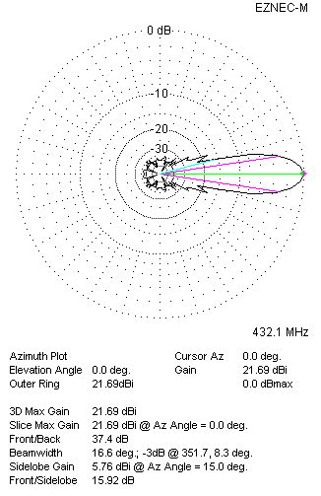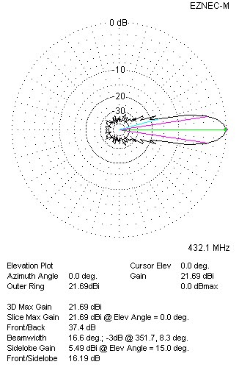
Horizontal and verticall pattern in free space, no loss condition
PERFORMANCES (Loss included for aluminum)
Aluminum |  |  |  |  |  |  | G  (dBi) |  |  | Tloss  (K) |  |  |  | T_{A}  (◦K) |  |  |  |  | G/T  (dB) |  |  | Bandwidth for SWR=1.5  (MHz)
After NEC/EZNEC |  |  |  |  |  |  | 21.62 |  |  | 4.9 |  |  |  | 23.8 |  |  |  |  | +7.64 |  |  | 424.900 – 437.200
After KF2YN correction |  |  |  |  |  |  | 21.56 |  |  | 4.9 |  |  |  | 28.3 |  |  |  |  | +7.05
Remark: Red coloured data are the final antenna data, which means: KF2YN correction formula applied and loss for aluminum included
DIAGRAMS
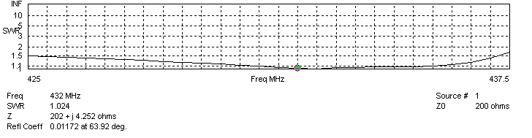
Frequency diagram for SWR better than 1.5
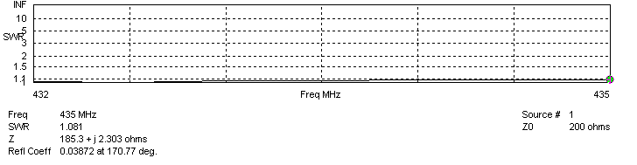
SWR diagram for the range from 432.000 – 435.000 MHz
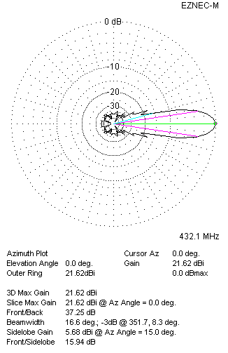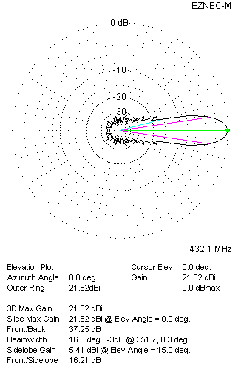
Horizontal and vertical pattern in free space, loss included for aluminum
STACKING
(ALL DATA GIVEN IN ACCORDANCE WITH KF2YN CORRECTION, LOSS INCLUDED)
RECOMMENDED STACKING DISTANCES
 |  |  |  |  |  |  | Two antennas vertically  (mm) |  |  |  |  |  |  | Two antennas horizontally  (mm) |  |  |  |  |  |  |  | Four antennas in H-stack  (mm)
Horizontal distance |  |  |  |  |  |  |  |  |  |  |  |  |  | 2920 |  |  |  |  |  |  |  | 2920
Vertical distance |  |  |  |  |  |  | 2880 |  |  |  |  |  |  |  |  |  |  |  |  |  |  | 2880
TWO ANTENNAS STACKED VERTICALLY
DISTANCE  (mm) |  |  |  | G  (dBi) |  |  |  |  |  |  |  | TA  (K) |  |  |  |  | Tloss  (K) |  |  |  |  |  |  |  | G/T  (dB)
2880 |  |  |  | 24.60 |  |  |  |  |  |  |  | 28.3 |  |  |  |  | 4.9 |  |  |  |  |  |  |  | +10.09
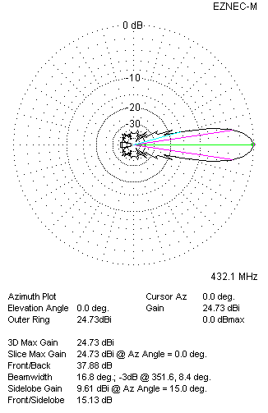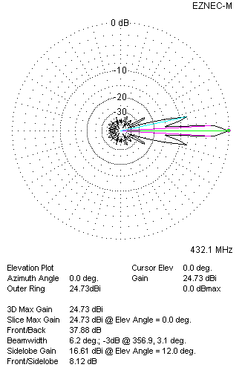
Two antennas stacked vertically
TWO ANTENNAS STACKED HORIZONTALLY
DISTANCE  (mm) |  |  |  | G  (dBi) |  |  |  |  |  |  |  | TA  (K) |  |  |  |  |  | Tloss  (K) |  |  |  |  |  |  |  | G/T  (dB)
2920 |  |  |  | 24.60 |  |  |  |  |  |  |  | 28.3 |  |  |  |  |  | 4.9 |  |  |  |  |  |  |  | +10.09
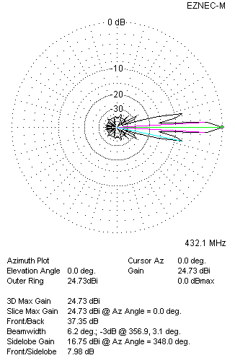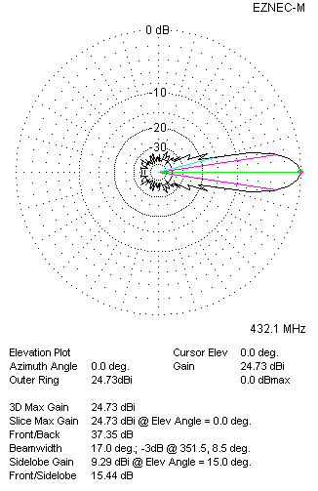
Two antennas stacked horizontally
FOUR ANTENNAS IN H-STACK
DISTANCE  (mm) |  |  |  | G  (dBi) |  |  |  |  |  |  |  | TA  (K) |  |  |  |  |  | Tloss  (K) |  |  |  |  |  |  |  | G/T  (dB)
H = 2920 |  |  |  | 27.64 |  |  |  |  |  |  |  | 28.3 |  |  |  |  |  | 64.9 |  |  |  |  |  |  |  | +13.13
V = 2880
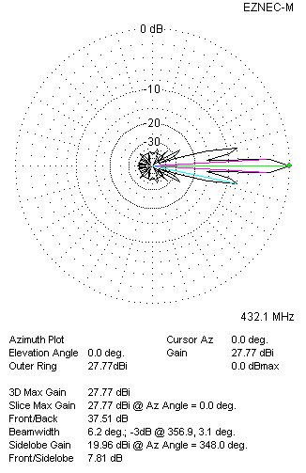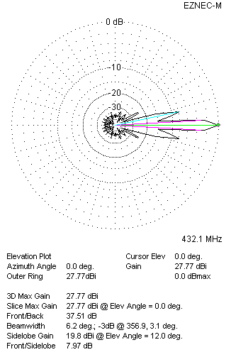
Four antennas in H-stack

