ANTENNA QY74206XL1D35
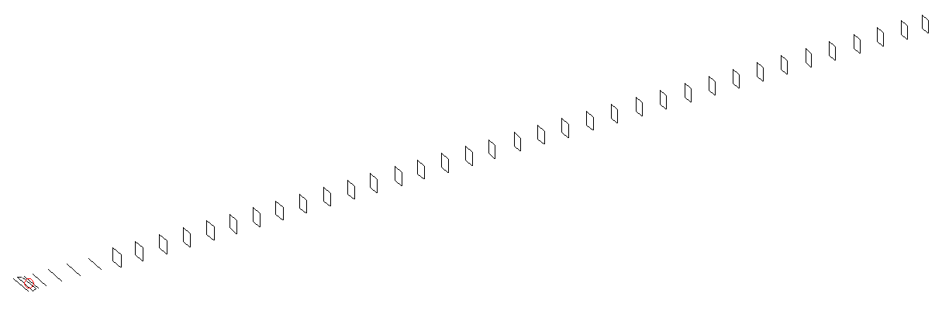
DESCRIPTION
Radiator |  |  |  |  | Number of  yagi elements |  |  |  |  |  | Number of  oblong elements |  |  |  |  | Total number  of elements |  |  |  |  |  |  |  | Boomlength  (mm)
LFA |  |  |  |  | 6 |  |  |  |  |  | 35 |  |  |  |  | 42 |  |  |  |  |  |  |  | 11225
DIMENSIONS
 | Ref |  | De1 |  |  | De2 |  | D1 | D2 |  | D3 |  | D4 |  | D5 | DQ1 |  |  |  | DQ2 | DQ3 |  | DQ4 |  |  |  | DQ5 |  | DQ6 | DQ7
Position | 0 |  | 60 |  |  | 105 |  | 143 | 244 |  | 428 |  | 658 |  | 915 | 1190 |  |  |  | 1467 | 1756 |  | 2062 |  |  |  | 2352 |  | 2649 | 2935
Length | 333 |  | 330 |  |  | 330 |  | 303.5 | 307.5 |  | 298 |  | 291 |  | 283 | 171 |  |  |  | 165 | 160 |  | 158 |  |  |  | 157 |  | 156 | 155
 | DQ8 |  | DQ9 |  |  | DQ10 |  | DQ11 | DQ12 |  | DQ13 |  | DQ14 |  | DQ15 | DQ16 |  |  |  | DQ17 | DQ18 |  | DQ19 |  |  |  | DQ20 |  | DQ21 | DQ22
Position | 3221 |  | 3507 |  |  | 3796 |  | 4072 | 4362 |  | 4638 |  | 4930 |  | 5225 | 5503 |  |  |  | 5815 | 6114 |  | 6421 |  |  |  | 6719 |  | 7039 | 7361
Length | 154 |  | 153 |  |  | 152 |  | 151 | 150 |  | 149 |  | 148 |  | 147 | 146 |  |  |  | 145 | 144 |  | 143 |  |  |  | 142 |  | 141 | 140
 | DQ23 |  | DQ24 |  |  | DQ25 |  | DQ26 | DQ27 |  | DQ28 |  | DQ29 |  | DQ30 | DQ31 |  |  |  | DQ32 | DQ33 |  | DQ34 |  |  |  | DQ35
Position | 7657 |  | 7971 |  |  | 8274 |  | 8585 | 8884 |  | 9172 |  | 9474 |  | 9768 | 10072 |  |  |  | 10378 | 10682 |  | 10984 |  |  |  | 11225
Length | 139 |  | 138 |  |  | 138 |  | 137 | 137 |  | 137 |  | 133 |  | 133 | 131 |  |  |  | 131 | 129 |  | 131 |  |  |  | 129
Remark | All elements made of Al tubes Ǿ6 mm  The height of rectangles is 170 mm  All dimensions given in milimetres
PERFORMANCES (No loss condition)
G  (dBi) |  | F/B  (dB) |  |  |  |  | F/Sh  (dBi) |  |  | F/Sv  (dBi) |  |  |  | Hor  (◦) |  |  |  |  | Ver  (◦) |  |  | Temp  (◦K) |  |  |  |  |  | G/T  (dB)
21.27 |  | 41.66 |  |  |  |  | 17.21 |  |  | 16.17 |  |  |  | 17.8 |  |  |  |  | 18.0 |  |  | 24.1 |  |  |  |  |  | +8.25
DIAGRAMS
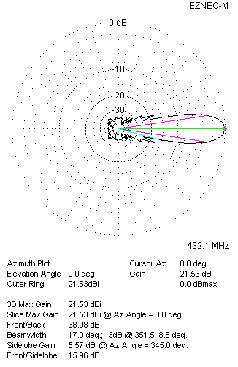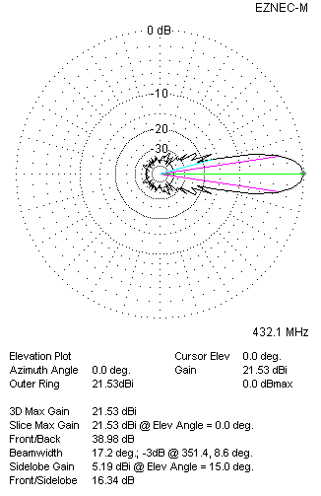
Horizontal and verticall pattern in free space, no loss condition
PERFORMANCES (Loss included for aluminum)
Aluminum |  |  |  |  |  |  | G  (dBi) |  |  | Tloss  (K) |  |  |  | T_{A}  (◦K) |  |  |  |  | G/T  (dB) |  |  | Bandwidth for SWR=1.5  (MHz)
After NEC/EZNEC |  |  |  |  |  |  | 21.46 |  |  | 4.9 |  |  |  | 24.3 |  |  |  |  | +7.34 |  |  | 424.200 – 438.800
After KF2YN correction |  |  |  |  |  |  | 21.41 |  |  | 4.9 |  |  |  | 28.8 |  |  |  |  | +6.82
Remark: Red coloured data are the final antenna data, which means: KF2YN correction formula applied and loss for aluminum included
DIAGRAMS
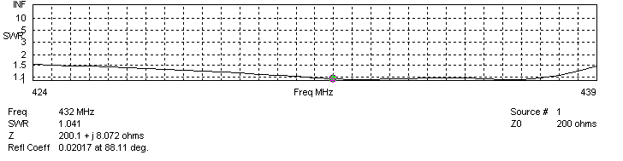
Frequency diagram for SWR better than 1.5
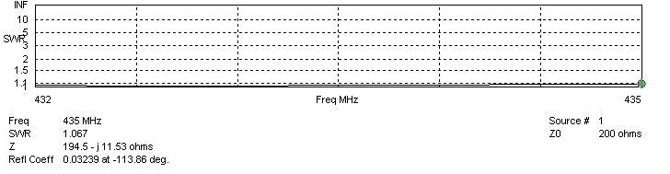
SWR diagram for the range from 432.000 – 435.000 MHz
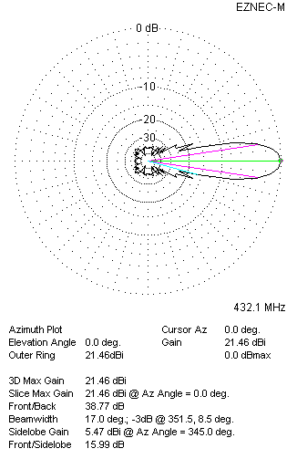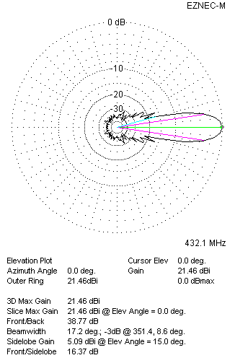
Horizontal and vertical pattern in free space, loss included for aluminum
STACKING
(ALL DATA GIVEN IN ACCORDANCE WITH KF2YN CORRECTION, LOSS INCLUDED)
RECOMMENDED STACKING DISTANCES
 |  |  |  |  |  |  | Two antennas vertically  (mm) |  |  |  |  |  |  | Two antennas horizontally  (mm) |  |  |  |  |  |  |  | Four antennas in H-stack  (mm)
Horizontal distance |  |  |  |  |  |  |  |  |  |  |  |  |  | 2820 |  |  |  |  |  |  |  | 2820
Vertical distance |  |  |  |  |  |  | 2860 |  |  |  |  |  |  |  |  |  |  |  |  |  |  | 2860
TWO ANTENNAS STACKED VERTICALLY
DISTANCE  (mm) |  |  |  | G  (dBi) |  |  |  |  |  |  |  | TA  (K) |  |  |  |  | Tloss  (K) |  |  |  |  |  |  |  | G/T  (dB)
2860 |  |  |  | 24.27 |  |  |  |  |  |  |  | 29.3 |  |  |  |  | 4.9 |  |  |  |  |  |  |  | +9.60
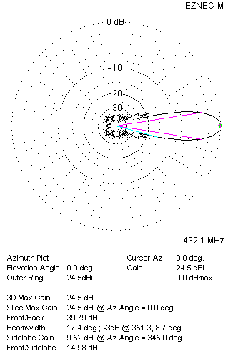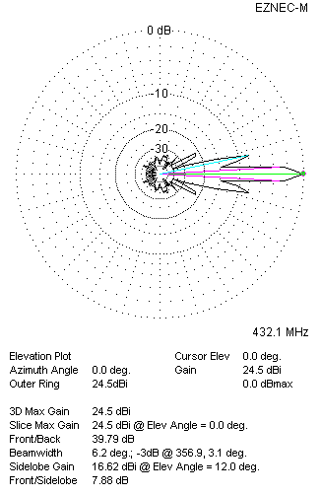
Two antennas stacked vertically
TWO ANTENNAS STACKED HORIZONTALLY
DISTANCE  (mm) |  |  |  | G  (dBi) |  |  |  |  |  |  |  | TA  (K) |  |  |  |  |  | Tloss  (K) |  |  |  |  |  |  |  | G/T  (dB)
2820 |  |  |  | 24.44 |  |  |  |  |  |  |  | 28.6 |  |  |  |  |  | 4.9 |  |  |  |  |  |  |  | +9.88
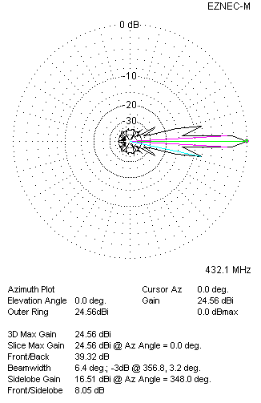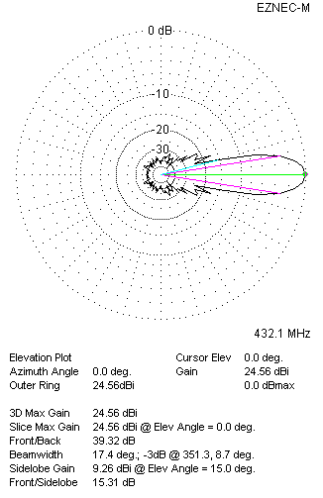
Two antennas stacked horizontally
FOUR ANTENNAS IN H-STACK
DISTANCE  (mm) |  |  |  | G  (dBi) |  |  |  |  |  |  |  | TA  (K) |  |  |  |  |  | Tloss  (K) |  |  |  |  |  |  |  | G/T  (dB)
H = 2820 |  |  |  | 27.59 |  |  |  |  |  |  |  | 27.8 |  |  |  |  |  | 4.9 |  |  |  |  |  |  |  | +13.15
V = 2860
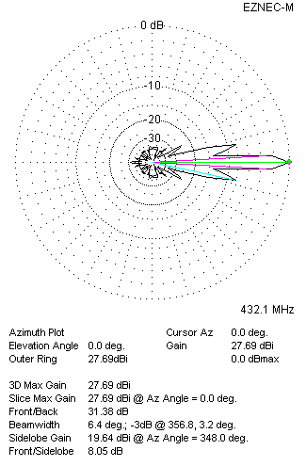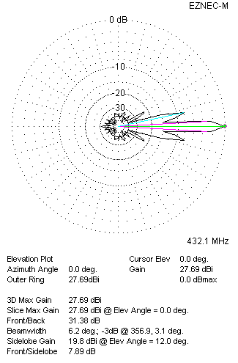
Four antennas in H-stack

