ANTENNA QY74008XL2D33
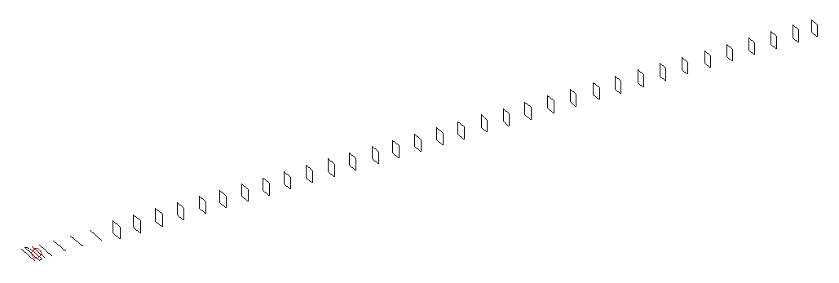
DESCRIPTION
Radiator |  |  |  |  | Number of  yagi elements |  |  |  |  |  | Number of  oblong elements |  |  |  |  |  | Total number  of elements |  |  |  |  |  |  |  | Boomlength  (mm)
LFA |  |  |  |  | 6 |  |  |  |  |  | 33 |  |  |  |  |  | 40 |  |  |  |  |  |  |  | 10625
DIMENSIONS
 | Ref |  | De1 |  |  | De2 |  | D1 | D2 |  |  |  | D3 | D4 |  | D5 |  |  |  |  | DQ1 | DQ2 |  | DQ3 |  |  |  | DQ4 |  | DQ5 | DQ6
Position | 0 |  | 70 |  |  | 120 |  | 158 | 257 |  |  |  | 443 | 672 |  | 928 |  |  |  |  | 1201 | 1476 |  | 1765 |  |  |  | 2073 |  | 2363 | 2661
Length | 332 |  | 331 |  |  | 331 |  | 303.5 | 305 |  |  |  | 295 | 288 |  | 280 |  |  |  |  | 173 | 165 |  | 162 |  |  |  | 159 |  | 157 | 156
 | DQ7 |  | DQ8 |  |  | DQ9 |  | DQ10 | DQ11 |  |  |  | DQ12 | DQ13 |  | DQ14 |  |  |  |  | DQ15 | DQ16 |  | DQ17 |  |  |  | DQ18 |  | DQ19 | DQ20
Position | 2946 |  | 3232 |  |  | 3516 |  | 3806 | 4081 |  |  |  | 4374 | 4649 |  | 4943 |  |  |  |  | 5233 | 5512 |  | 5824 |  |  |  | 6126 |  | 6432 | 6731
Length | 155 |  | 154 |  |  | 153 |  | 152 | 151 |  |  |  | 150 | 149 |  | 148 |  |  |  |  | 147 | 146 |  | 145 |  |  |  | 144 |  | 143 | 142
 | DQ21 |  | DQ22 |  |  | DQ23 |  | DQ24 | DQ25 |  |  |  | DQ26 | DQ27 |  | DQ28 |  |  |  |  | DQ29 | DQ30 |  | DQ31 |  |  |  | DQ32 |  | DQ33
Position | 7047 |  | 7374 |  |  | 7671 |  | 7986 | 8283 |  |  |  | 8591 | 8886 |  | 9172 |  |  |  |  | 9478 | 9776 |  | 10072 |  |  |  | 10368 |  | 10625
Length | 141 |  | 141 |  |  | 139 |  | 139 | 139 |  |  |  | 139 | 139 |  | 131 |  |  |  |  | 131 | 133 |  | 131 |  |  |  | 125 |  | 125
Remark | All elements made of Al tubes Ǿ8 mm  The height of rectangles is 170 mm  All dimensions given in milimetres
PERFORMANCES (No loss condition)
G  (dBi) |  | F/B  (dB) |  |  |  |  | F/Sh  (dBi) |  |  | F/Sv  (dBi) |  |  |  |  | Hor  (◦) |  |  |  |  | Ver  (◦) |  |  | Temp  (◦K) |  |  |  |  |  | G/T  (dB)
21.50 |  | 31.63 |  |  |  |  | 17.46 |  |  | 16.60 |  |  |  |  | 17.0 |  |  |  |  | 17.0 |  |  | 23.9 |  |  |  |  |  | +8.32
DIAGRAMS
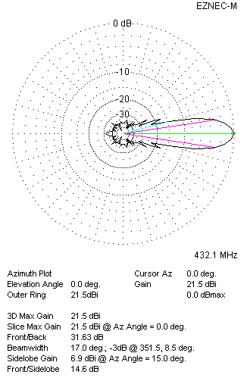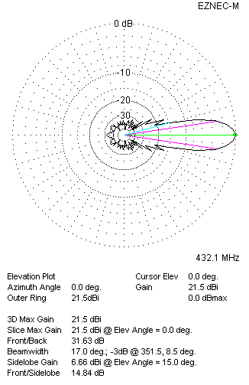
Horizontal and verticall pattern in free space, no loss condition
PERFORMANCES (Loss included for aluminum)
Aluminum |  |  |  |  |  |  | G  (dBi) |  |  | Tloss  (K) |  |  |  |  | T_{A}  (◦K) |  |  |  |  | G/T  (dB) |  |  | Bandwidth for SWR=1.5  (MHz)
After NEC/EZNEC |  |  |  |  |  |  | 21.43 |  |  | 4.9 |  |  |  |  | 24.0 |  |  |  |  | +7.42 |  |  | 425.000 – 437.100
After KF2YN correction |  |  |  |  |  |  | 21.37 |  |  | 4.9 |  |  |  |  | 28.4 |  |  |  |  | +6.85
Remark: Red coloured data are the final antenna data, which means: KF2YN correction formula applied and loss for aluminum included
DIAGRAMS
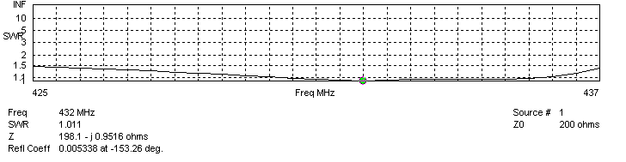
Frequency diagram for SWR better than 1.5
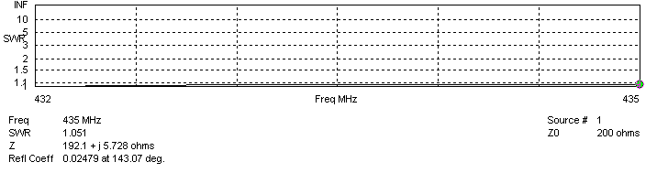
SWR diagram for the range from 432.000 – 435.000 MHz
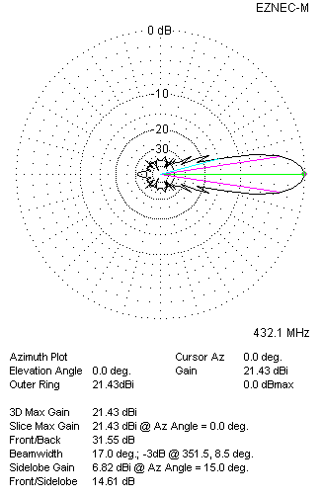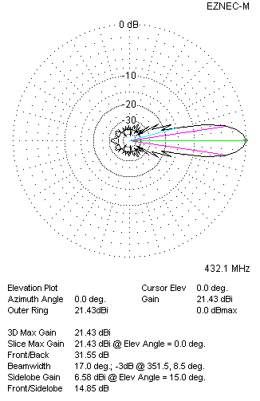
Horizontal and vertical pattern in free space, loss included for aluminum
STACKING
(ALL DATA GIVEN IN ACCORDANCE WITH KF2YN CORRECTION, LOSS INCLUDED)
RECOMMENDED STACKING DISTANCES
 |  |  |  |  |  |  | Two antennas vertically  (mm) |  |  |  |  |  |  |  | Two antennas horizontally  (mm) |  |  |  |  |  |  |  | Four antennas in H-stack  (mm)
Horizontal distance |  |  |  |  |  |  |  |  |  |  |  |  |  |  | 2840 |  |  |  |  |  |  |  | 2840
Vertical distance |  |  |  |  |  |  | 2780 |  |  |  |  |  |  |  |  |  |  |  |  |  |  |  | 2780
TWO ANTENNAS STACKED VERTICALLY
DISTANCE  (mm) |  |  |  | G  (dBi) |  |  |  |  |  |  |  | TA  (K) |  |  |  |  |  | Tloss  (K) |  |  |  |  |  |  |  | G/T  (dB)
2780 |  |  |  | 24.41 |  |  |  |  |  |  |  | 28.7 |  |  |  |  |  | 4.9 |  |  |  |  |  |  |  | +9.44
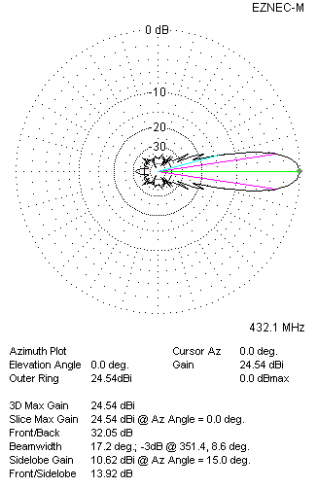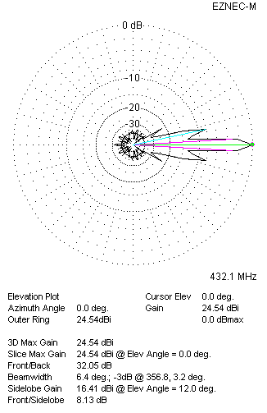
Two antennas stacked vertically
TWO ANTENNAS STACKED HORIZONTALLY
DISTANCE  (mm) |  |  |  | G  (dBi) |  |  |  |  |  |  |  | TA  (K) |  |  |  |  |  |  | Tloss  (K) |  |  |  |  |  |  |  | G/T  (dB)
2840 |  |  |  | 24.35 |  |  |  |  |  |  |  | 28.4 |  |  |  |  |  |  | 4.9 |  |  |  |  |  |  |  | +9.83
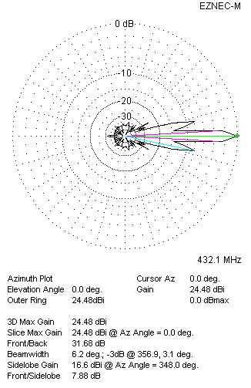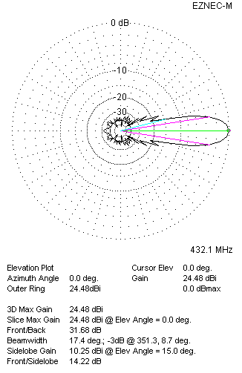
Two antennas stacked horizontally
FOUR ANTENNAS IN H-STACK
DISTANCE  (mm) |  |  |  | G  (dBi) |  |  |  |  |  |  |  | TA  (K) |  |  |  |  |  |  | Tloss  (K) |  |  |  |  |  |  |  | G/T  (dB)
H = 2840 |  |  |  | 27.45 |  |  |  |  |  |  |  | 28.5 |  |  |  |  |  |  | 4.9 |  |  |  |  |  |  |  | +12.91
V = 2780
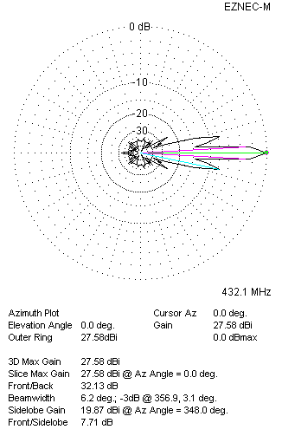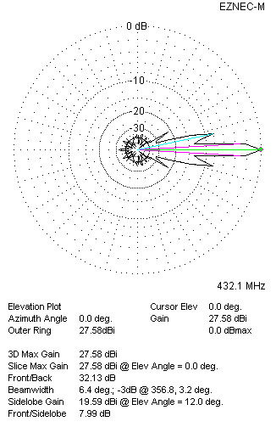
Four antennas in H-stack

