ANTENNA QY74006XL1D33
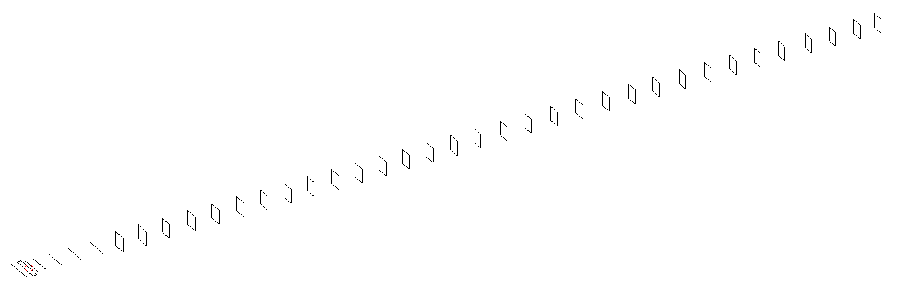
DESCRIPTION
Radiator |  |  |  |  | Number of  yagi elements |  |  |  |  |  | Number of  oblong elements |  |  |  |  |  | Total number  of elements |  |  |  |  |  |  |  | Boomlength  (mm)
LFA |  |  |  |  | 6 |  |  |  |  |  | 33 |  |  |  |  |  | 40 |  |  |  |  |  |  |  | 10625
DIMENSIONS
 | Ref |  | De1 |  |  | De2 |  | D1 | D2 |  |  |  | D3 | D4 |  | D5 |  |  |  |  | DQ1 | DQ2 |  | DQ3 |  |  |  | DQ4 |  | DQ5 | DQ6
Position | 0 |  | 60 |  |  | 105 |  | 143 | 244 |  |  |  | 427 | 659 |  | 917 |  |  |  |  | 1190 | 1467 |  | 1756 |  |  |  | 2062 |  | 2352 | 2649
Length | 333 |  | 332 |  |  | 332 |  | 303.5 | 307.5 |  |  |  | 298 | 291 |  | 284 |  |  |  |  | 171 | 165 |  | 162 |  |  |  | 159 |  | 157 | 156
 | DQ7 |  | DQ8 |  |  | DQ9 |  | DQ10 | DQ11 |  |  |  | DQ12 | DQ13 |  | DQ14 |  |  |  |  | DQ15 | DQ16 |  | DQ17 |  |  |  | DQ18 |  | DQ19 | DQ20
Position | 2935 |  | 3221 |  |  | 3507 |  | 3796 | 4072 |  |  |  | 4362 | 4638 |  | 4930 |  |  |  |  | 5225 | 5503 |  | 5815 |  |  |  | 6114 |  | 6421 | 6719
Length | 155 |  | 154 |  |  | 153 |  | 152 | 151 |  |  |  | 150 | 149 |  | 148 |  |  |  |  | 147 | 146 |  | 145 |  |  |  | 144 |  | 143 | 142
 | DQ21 |  | DQ22 |  |  | DQ23 |  | DQ24 | DQ25 |  |  |  | DQ26 | DQ27 |  | DQ28 |  |  |  |  | DQ29 | DQ30 |  | DQ31 |  |  |  | DQ32 |  | DQ33
Position | 7039 |  | 7361 |  |  | 7657 |  | 7971 | 8274 |  |  |  | 8585 | 8884 |  | 9172 |  |  |  |  | 9474 | 9768 |  | 10072 |  |  |  | 10373 |  | 10625
Length | 141 |  | 140 |  |  | 139 |  | 138 | 137 |  |  |  | 137 | 137 |  | 137 |  |  |  |  | 133 | 133 |  | 131 |  |  |  | 131 |  | 131
Remark | All elements made of Al tubes Ǿ6 mm  The height of rectangles is 170 mm  All dimensions given in milimetres
PERFORMANCES (No loss condition)
G  (dBi) |  | F/B  (dB) |  |  |  |  | F/Sh  (dBi) |  |  | F/Sv  (dBi) |  |  |  |  | Hor  (◦) |  |  |  |  | Ver  (◦) |  |  | Temp  (◦K) |  |  |  |  |  | G/T  (dB)
21.37 |  | 34.46 |  |  |  |  | 17.62 |  |  | 16.66 |  |  |  |  | 17.0 |  |  |  |  | 17.6 |  |  | 24.6 |  |  |  |  |  | +8.01
DIAGRAMS
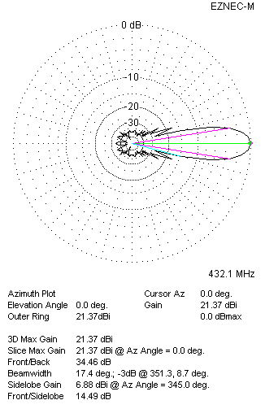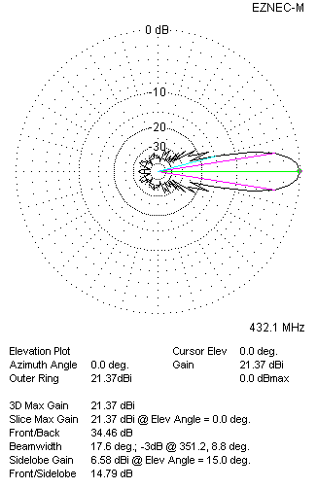
Horizontal and verticall pattern in free space, no loss condition
PERFORMANCES (Loss included for aluminum)
Aluminum |  |  |  |  |  |  | G  (dBi) |  |  | Tloss  (K) |  |  |  |  | T_{A}  (◦K) |  |  |  |  | G/T  (dB) |  |  | Bandwidth for SWR=1.5  (MHz)
After NEC/EZNEC |  |  |  |  |  |  | 21.30 |  |  | 4.9 |  |  |  |  | 24.7 |  |  |  |  | +7.10 |  |  | 423.500 – 438.700
After KF2YN correction |  |  |  |  |  |  | 21.25 |  |  | 4.9 |  |  |  |  | 29.1 |  |  |  |  | +6.62
Remark: Red coloured data are the final antenna data, which means: KF2YN correction formula applied and loss for aluminum included
DIAGRAMS
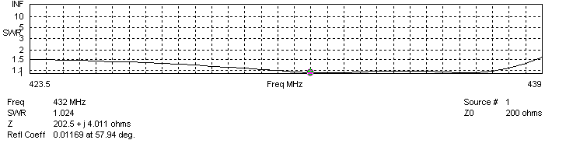
Frequency diagram for SWR better than 1.5
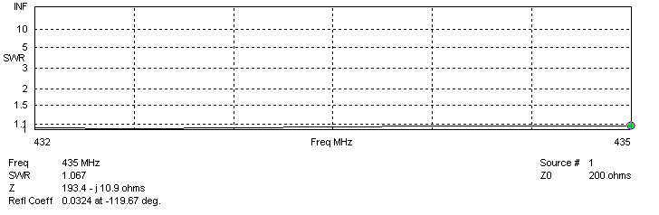
SWR diagram for the range from 432.000 – 435.000 MHz
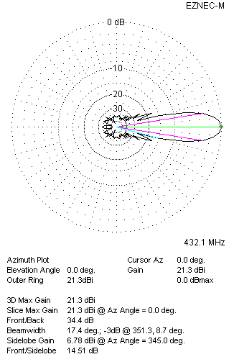 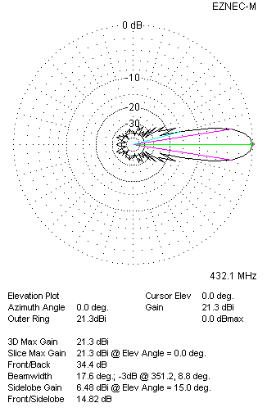Horizontal and vertical pattern in free space, loss included for aluminum
STACKING
(ALL DATA GIVEN IN ACCORDANCE WITH KF2YN CORRECTION, LOSS INCLUDED)
RECOMMENDED STACKING DISTANCES
 |  |  |  |  |  |  | Two antennas vertically  (mm) |  |  |  |  |  |  |  | Two antennas horizontally  (mm) |  |  |  |  |  |  |  | Four antennas in H-stack  (mm)
Horizontal distance |  |  |  |  |  |  |  |  |  |  |  |  |  |  | 2720 |  |  |  |  |  |  |  | 2720
Vertical distance |  |  |  |  |  |  | 2840 |  |  |  |  |  |  |  |  |  |  |  |  |  |  |  | 2840
TWO ANTENNAS STACKED VERTICALLY
DISTANCE  (mm) |  |  |  | G  (dBi) |  |  |  |  |  |  |  | TA  (K) |  |  |  |  |  | Tloss  (K) |  |  |  |  |  |  |  | G/T  (dB)
2840 |  |  |  | 24.30 |  |  |  |  |  |  |  | 29.3 |  |  |  |  |  | 4.9 |  |  |  |  |  |  |  | +9.64
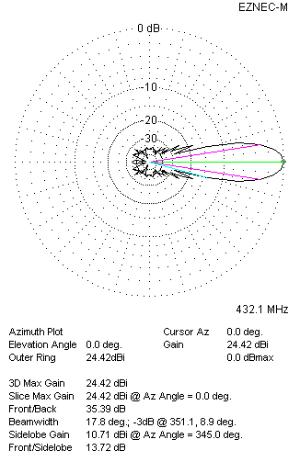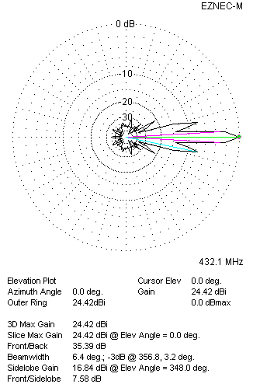
Two antennas stacked vertically
TWO ANTENNAS STACKED HORIZONTALLY
DISTANCE  (mm) |  |  |  | G  (dBi) |  |  |  |  |  |  |  | TA  (K) |  |  |  |  |  |  | Tloss  (K) |  |  |  |  |  |  |  | G/T  (dB)
2720 |  |  |  | 24.28 |  |  |  |  |  |  |  | 28.8 |  |  |  |  |  |  | 4.9 |  |  |  |  |  |  |  | +9.69
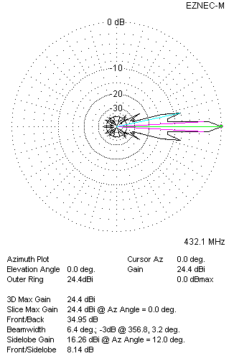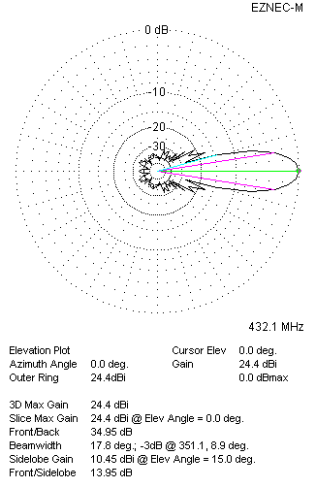
Two antennas stacked horizontally
FOUR ANTENNAS IN H-STACK
DISTANCE  (mm) |  |  |  | G  (dBi) |  |  |  |  |  |  |  | TA  (K) |  |  |  |  |  |  | Tloss  (K) |  |  |  |  |  |  |  | G/T  (dB)
H = 2720 |  |  |  | 27.34 |  |  |  |  |  |  |  | 29.1 |  |  |  |  |  |  | 4.9 |  |  |  |  |  |  |  | +12.71
V = 2840
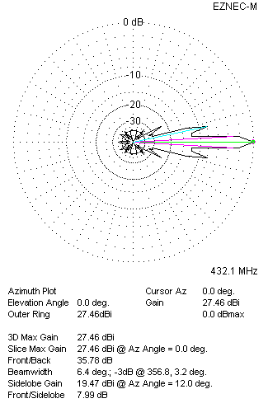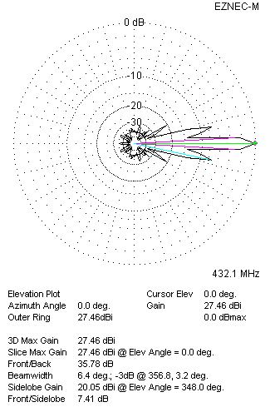
Four antennas in H-stack

