ANTENNA QY73805XL3D31
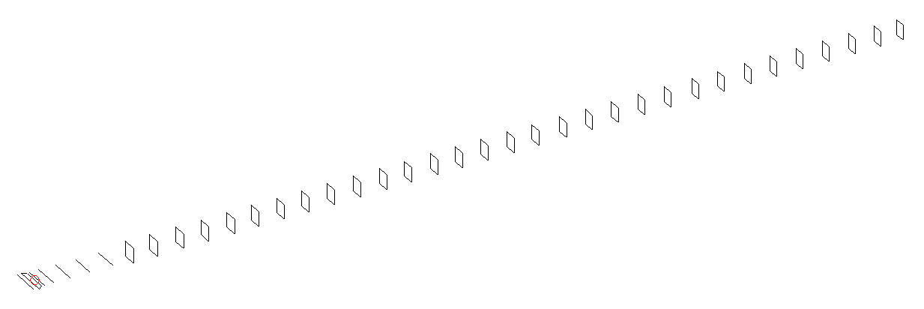
DESCRIPTION
Radiator |  |  |  |  | Number of  yagi elements |  |  |  |  |  | Number of  oblong elements |  |  |  |  |  | Total number  of elements |  |  |  |  |  |  | Boomlength  (mm)
LFA |  |  |  |  | 6 |  |  |  |  |  | 31 |  |  |  |  |  | 38 |  |  |  |  |  |  | 10025
DIMENSIONS
 | Ref |  | De1 |  |  | De2 |  | D1 | D2 |  |  |  | D3 |  | D4 | D5 |  |  |  |  | DQ1 | DQ2 |  |  | DQ3 |  |  | DQ4 |  | DQ5
Position | 0 |  | 50 |  |  | 100 |  | 132 | 233 |  |  |  | 426 |  | 656 | 918 |  |  |  |  | 1190 | 1463 |  |  | 1764 |  |  | 2055 |  | 2352
Length | 336 |  | 349 |  |  | 290 |  | 309 | 310 |  |  |  | 300 |  | 293.5 | 287 |  |  |  |  | 171 | 163 |  |  | 160 |  |  | 158 |  | 157
 | DQ6 |  | DQ7 |  |  | DQ8 |  | DQ9 | DQ10 |  |  |  | DQ11 |  | DQ12 | DQ13 |  |  |  |  | DQ14 | DQ15 |  |  | DQ16 |  |  | DQ17 |  | DQ18
Position | 2632 |  | 2924 |  |  | 3208 |  | 3502 | 3799 |  |  |  | 4098 |  | 4382 | 4688 |  |  |  |  | 4966 | 5262 |  |  | 5558 |  |  | 5846 |  | 6162
Length | 156 |  | 154 |  |  | 153 |  | 150 | 150 |  |  |  | 150 |  | 150 | 150 |  |  |  |  | 150 | 150 |  |  | 150 |  |  | 145 |  | 145
 | DQ19 |  | DQ20 |  |  | DQ21 |  | DQ22 | DQ23 |  |  |  | DQ24 |  | DQ25 | DQ26 |  |  |  |  | DQ27 | DQ28 |  |  | DQ29 |  |  | DQ30 |  | DQ31
Position | 6460 |  | 6754 |  |  | 7062 |  | 7366 | 7678 |  |  |  | 7974 |  | 8282 | 8578 |  |  |  |  | 8876 | 9178 |  |  | 9476 |  |  | 9768 |  | 10025
Length | 145 |  | 145 |  |  | 141 |  | 135 | 135 |  |  |  | 133 |  | 133 | 133 |  |  |  |  | 133 | 133 |  |  | 133 |  |  | 131 |  | 131
Remark | All elements made of Al tubes Ǿ5 mm  The height of rectangles is 170 mm  All dimensions given in milimetres
PERFORMANCES (No loss condition)
G  (dBi) |  | F/B  (dB) |  |  |  |  | F/Sh  (dBi) |  |  | F/Sv  (dBi) |  |  |  | Hor  (◦) |  |  |  |  |  | Ver  (◦) |  |  | Temp  (◦K) |  |  |  |  |  | G/T  (dB)
21.02 |  | 34.30 |  |  |  |  | 17.38 |  |  | 16.15 |  |  |  | 18.2 |  |  |  |  |  | 18.4 |  |  | 24.3 |  |  |  |  |  | +7.96
DIAGRAMS
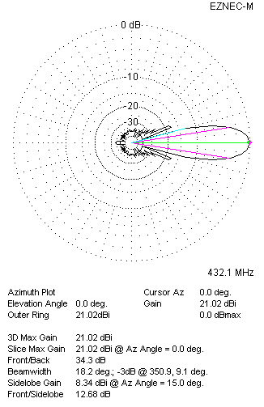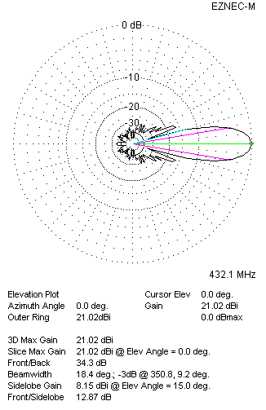
Horizontal and verticall pattern in free space, no loss condition
PERFORMANCES (Loss included for aluminum)
Aluminum |  |  |  |  |  |  | G  (dBi) |  |  | Tloss  (K) |  |  |  | T_{A}  (◦K) |  |  |  |  |  | G/T  (dB) |  |  | Bandwidth for SWR=1.5  (MHz)
After NEC/EZNEC |  |  |  |  |  |  | 20.94 |  |  | 5.7 |  |  |  | 24.4 |  |  |  |  |  | +6.83 |  |  | 424.500 – 438.100
After KF2YN correction |  |  |  |  |  |  | 20.87 |  |  | 5.7 |  |  |  | 29.5 |  |  |  |  |  | +6.17
Remark: Red coloured data are the final antenna data, which means: KF2YN correction formula applied and loss for aluminum included
DIAGRAMS
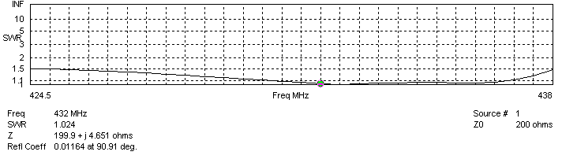
Frequency diagram for SWR better than 1.5
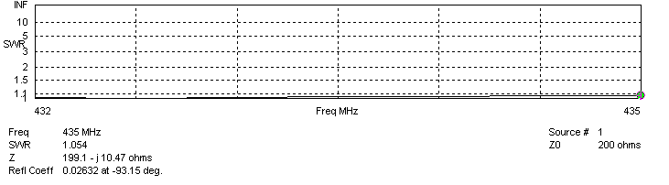
SWR diagram for the range from 432.000 – 435.000 MHz
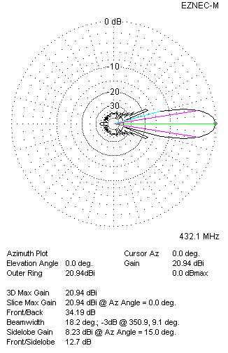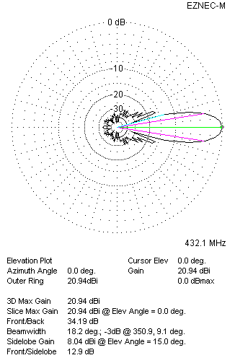
Horizontal and vertical pattern in free space, loss included for aluminum
STACKING
(ALL DATA GIVEN IN ACCORDANCE WITH KF2YN CORRECTION, LOSS INCLUDED)
RECOMMENDED STACKING DISTANCES
 |  |  |  |  |  |  | Two antennas vertically  (mm) |  |  |  |  |  |  | Two antennas horizontally  (mm) |  |  |  |  |  |  |  |  | Four antennas in H-stack  (mm)
Horizontal distance |  |  |  |  |  |  |  |  |  |  |  |  |  | 2660 |  |  |  |  |  |  |  |  | 2660
Vertical distance |  |  |  |  |  |  | 2880 |  |  |  |  |  |  |  |  |  |  |  |  |  |  |  | 2880
TWO ANTENNAS STACKED VERTICALLY
DISTANCE  (mm) |  |  |  | G  (dBi) |  |  |  |  |  |  |  | TA  (K) |  |  |  |  |  | Tloss  (K) |  |  |  |  |  |  |  | G/T  (dB)
2880 |  |  |  | 23.95 |  |  |  |  |  |  |  | 29.4 |  |  |  |  |  | 5.7 |  |  |  |  |  |  |  | +9.26
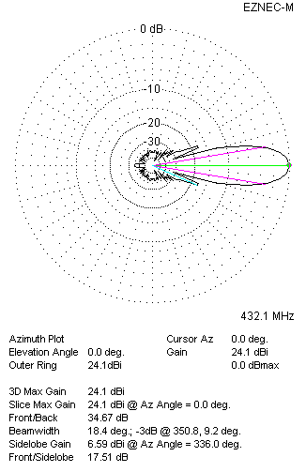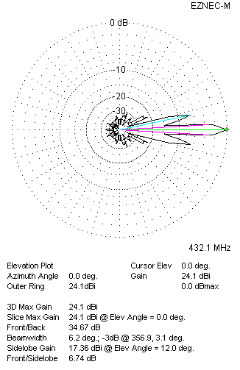
Two antennas stacked vertically
TWO ANTENNAS STACKED HORIZONTALLY
DISTANCE  (mm) |  |  |  | G  (dBi) |  |  |  |  |  |  |  | TA  (K) |  |  |  |  |  |  | Tloss  (K) |  |  |  |  |  |  |  | G/T  (dB)
2660 |  |  |  | 23.92 |  |  |  |  |  |  |  | 29.2 |  |  |  |  |  |  | 5.7 |  |  |  |  |  |  |  | +9.26
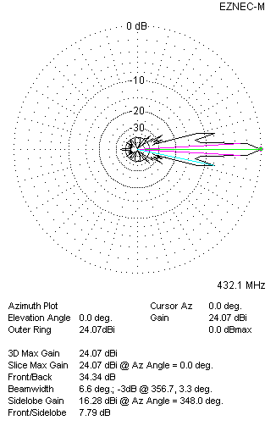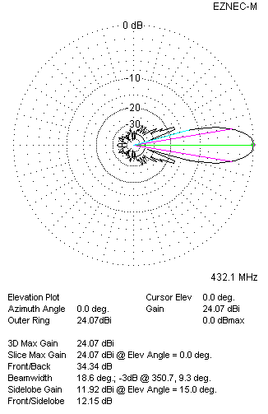
Two antennas stacked horizontally
FOUR ANTENNAS IN H-STACK
DISTANCE  (mm) |  |  |  | G  (dBi) |  |  |  |  |  |  |  | TA  (K) |  |  |  |  |  |  | Tloss  (K) |  |  |  |  |  |  |  | G/T  (dB)
H = 2660 |  |  |  | 26.99 |  |  |  |  |  |  |  | 29.1 |  |  |  |  |  |  | 5.7 |  |  |  |  |  |  |  | +12.34
V = 2880
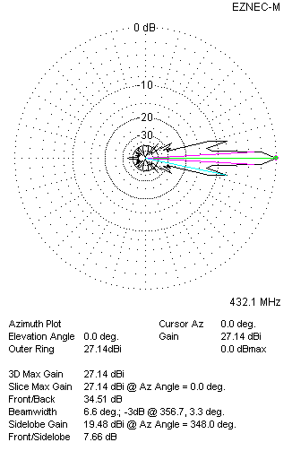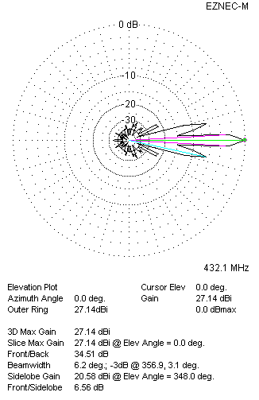
Four antennas in H-stack

