ANTENNA QY73710XL1D30
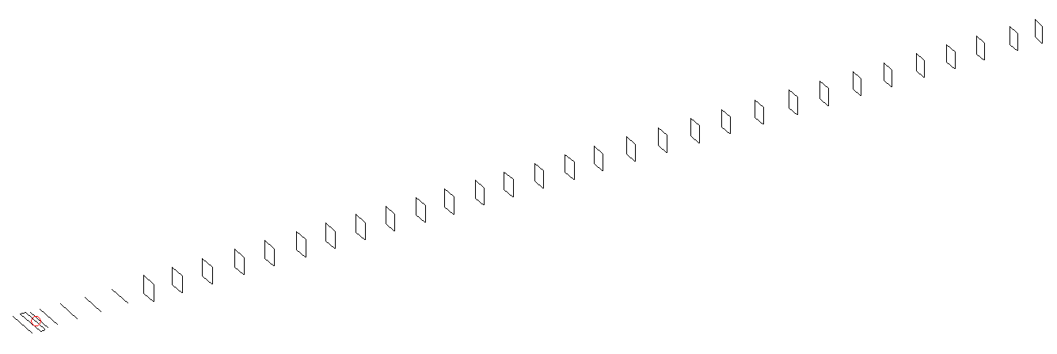
DESCRIPTION
Radiator |  |  |  |  | Number of  yagi elements |  |  |  |  |  | Number of  oblong elements |  |  |  |  |  | Total number  of elements |  |  |  |  |  |  | Boomlength  (mm)
LFA |  |  |  |  | 6 |  |  |  |  |  | 30 |  |  |  |  |  | 37 |  |  |  |  |  |  | 9725
DIMENSIONS
 | Ref |  | De1 |  |  | De2 |  | D1 | D2 |  |  |  | D3 |  | D4 | D5 |  |  |  |  | DQ1 | DQ2 |  |  | DQ3 |  |  | DQ4 |  | DQ5
Position | 0 |  | 70 |  |  | 120 |  | 156 | 247 |  |  |  | 439 |  | 671 | 931 |  |  |  |  | 1201 | 1476 |  |  | 1765 |  |  | 2073 |  | 2363
Length | 330 |  | 330 |  |  | 330 |  | 303 | 303 |  |  |  | 291.5 |  | 284 | 275 |  |  |  |  | 173 | 165 |  |  | 162 |  |  | 159 |  | 157
 | DQ6 |  | DQ7 |  |  | DQ8 |  | DQ9 | DQ10 |  |  |  | DQ11 |  | DQ12 | DQ13 |  |  |  |  | DQ14 | DQ15 |  |  | DQ16 |  |  | DQ17 |  | DQ18
Position | 2661 |  | 2946 |  |  | 3232 |  | 3516 | 3806 |  |  |  | 4081 |  | 4374 | 4649 |  |  |  |  | 4943 | 5233 |  |  | 5512 |  |  | 5824 |  | 6126
Length | 156 |  | 155 |  |  | 154 |  | 153 | 152 |  |  |  | 151 |  | 150 | 149 |  |  |  |  | 148 | 147 |  |  | 146 |  |  | 145 |  | 144
 | DQ19 |  | DQ20 |  |  | DQ21 |  | DQ22 | DQ23 |  |  |  | DQ24 |  | DQ25 | DQ26 |  |  |  |  | DQ27 | DQ28 |  |  | DQ29 |  |  | DQ30
Position | 6432 |  | 6731 |  |  | 7047 |  | 7374 | 7671 |  |  |  | 7986 |  | 8283 | 8591 |  |  |  |  | 8883 | 9168 |  |  | 9486 |  |  | 9725
Length | 143 |  | 142 |  |  | 141 |  | 141 | 139 |  |  |  | 137 |  | 137 | 137 |  |  |  |  | 137 | 131 |  |  | 129 |  |  | 129
Remark | All elements made of Al tubes Ǿ10 mm  The height of rectangles is 170 mm  All dimensions given in milimetres
PERFORMANCES (No loss condition)
G  (dBi) |  | F/B  (dB) |  |  |  |  | F/Sh  (dBi) |  |  | F/Sv  (dBi) |  |  |  | Hor  (◦) |  |  |  |  |  | Ver  (◦) |  |  | Temp  (◦K) |  |  |  |  |  | G/T  (dB)
21.27 |  | 32.21 |  |  |  |  | 16.75 |  |  | 15.79 |  |  |  | 17.2 |  |  |  |  |  | 17.2 |  |  | 24.5 |  |  |  |  |  | +8.05
DIAGRAMS
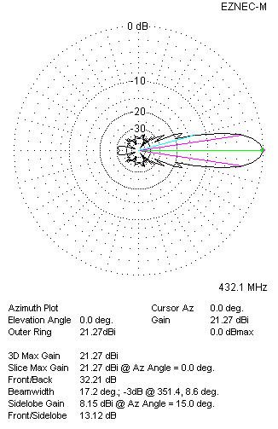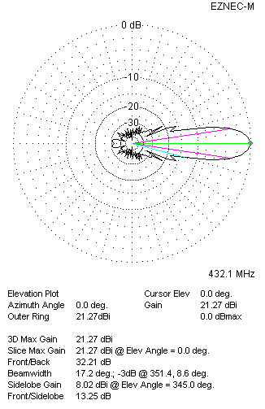
Horizontal and verticall pattern in free space, no loss condition
PERFORMANCES (Loss included for aluminum)
Aluminum |  |  |  |  |  |  | G  (dBi) |  |  | Tloss  (K) |  |  |  | T_{A}  (◦K) |  |  |  |  |  | G/T  (dB) |  |  | Bandwidth for SWR=1.5  (MHz)
After NEC/EZNEC |  |  |  |  |  |  | 21.15 |  |  | 4.3 |  |  |  | 24.5 |  |  |  |  |  | +7.22 |  |  | 426.500 – 436.600
After KF2YN correction |  |  |  |  |  |  | 21.15 |  |  | 4.3 |  |  |  | 28.3 |  |  |  |  |  | +6.63
Remark: Red coloured data are the final antenna data, which means: KF2YN correction formula applied and loss for aluminum included
DIAGRAMS
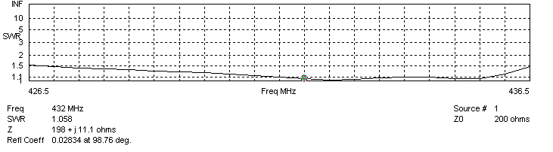
Frequency diagram for SWR better than 1.5
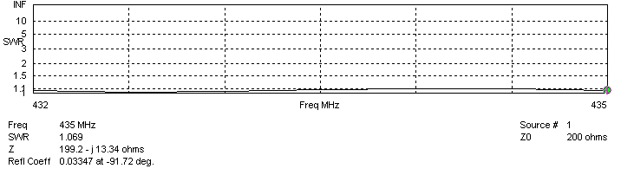
SWR diagram for the range from 432.000 – 435.000 MHz
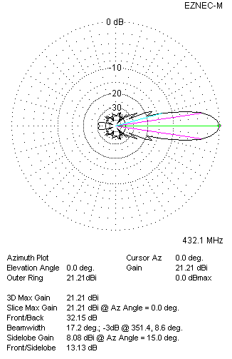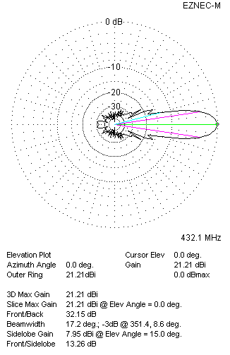
Horizontal and vertical pattern in free space, loss included for aluminum
STACKING
(ALL DATA GIVEN IN ACCORDANCE WITH KF2YN CORRECTION, LOSS INCLUDED)
RECOMMENDED STACKING DISTANCES
 |  |  |  |  |  |  | Two antennas vertically  (mm) |  |  |  |  |  |  | Two antennas horizontally  (mm) |  |  |  |  |  |  |  |  | Four antennas in H-stack  (mm)
Horizontal distance |  |  |  |  |  |  |  |  |  |  |  |  |  | 2720 |  |  |  |  |  |  |  |  | 2720
Vertical distance |  |  |  |  |  |  | 2720 |  |  |  |  |  |  |  |  |  |  |  |  |  |  |  | 2720
TWO ANTENNAS STACKED VERTICALLY
DISTANCE  (mm) |  |  |  | G  (dBi) |  |  |  |  |  |  |  | TA  (K) |  |  |  |  |  | Tloss  (K) |  |  |  |  |  |  |  | G/T  (dB)
2720 |  |  |  | 24.19 |  |  |  |  |  |  |  | 28.6 |  |  |  |  |  | 4.3 |  |  |  |  |  |  |  | +9.62
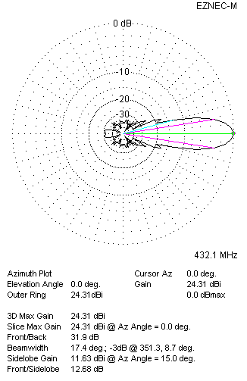
Two antennas stacked vertically
TWO ANTENNAS STACKED HORIZONTALLY
DISTANCE  (mm) |  |  |  | G  (dBi) |  |  |  |  |  |  |  | TA  (K) |  |  |  |  |  |  | Tloss  (K) |  |  |  |  |  |  |  | G/T  (dB)
2720 |  |  |  | 24.19 |  |  |  |  |  |  |  | 28.1 |  |  |  |  |  |  | 4.3 |  |  |  |  |  |  |  | +9.70
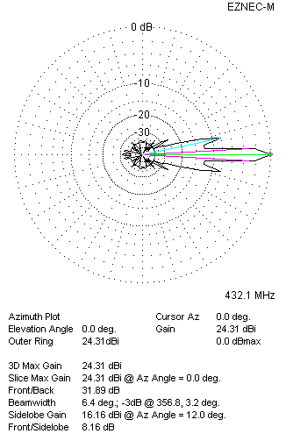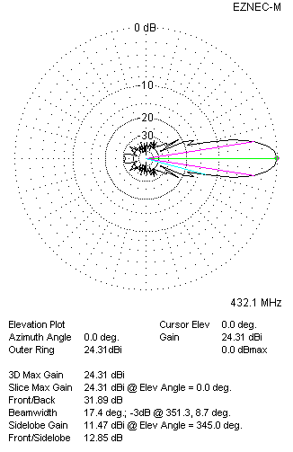
Two antennas stacked horizontally
FOUR ANTENNAS IN H-STACK
DISTANCE  (mm) |  |  |  | G  (dBi) |  |  |  |  |  |  |  | TA  (K) |  |  |  |  |  |  | Tloss  (K) |  |  |  |  |  |  |  | G/T  (dB)
H = 2720 |  |  |  | 27.24 |  |  |  |  |  |  |  | 28.3 |  |  |  |  |  |  | 4.3 |  |  |  |  |  |  |  | +12.72
V = 2720
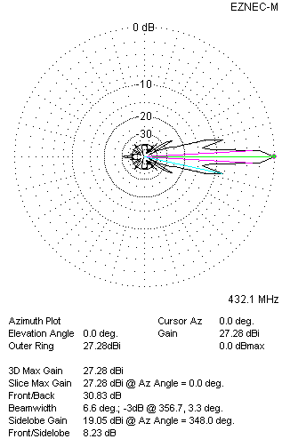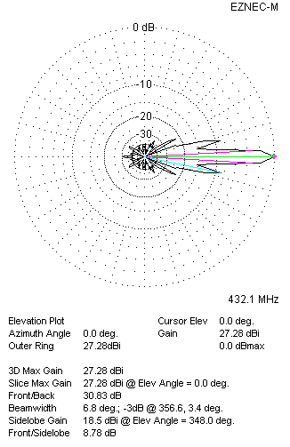
Four antennas in H-stack

