ANTENNA QY73608XL1D29
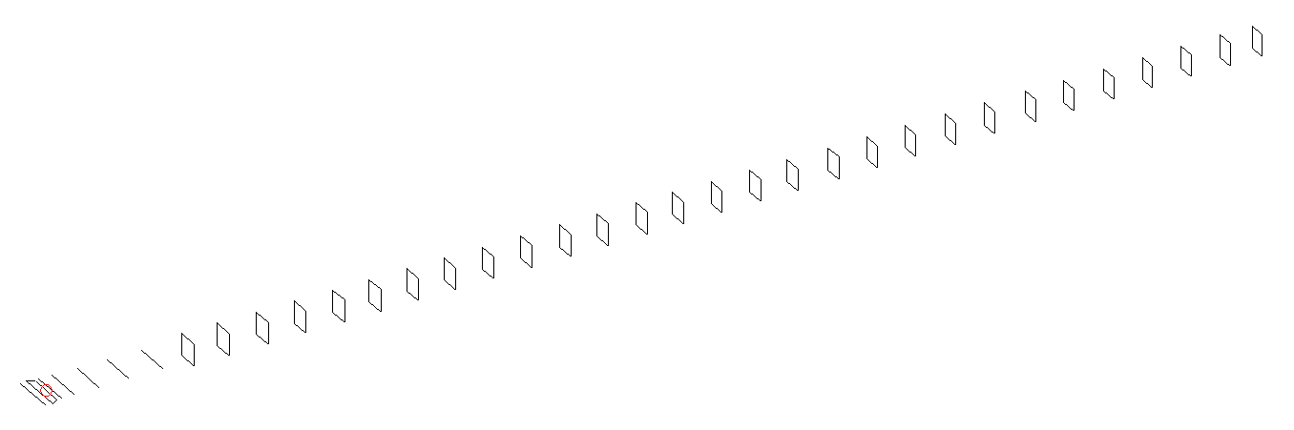
DESCRIPTION
Radiator |  |  |  |  | Number of  yagi elements |  |  |  |  |  | Number of  oblong elements |  |  |  |  |  | Total number  of elements |  |  |  |  |  |  | Boomlength  (mm)
LFA |  |  |  |  | 6 |  |  |  |  |  | 29 |  |  |  |  |  | 36 |  |  |  |  |  |  | 9425
DIMENSIONS
 | Ref |  | De1 |  |  | De2 |  | D1 | D2 |  |  |  | D3 |  | D4 | D5 |  |  |  |  | DQ1 | DQ2 |  |  | DQ3 |  |  | DQ4 |  | DQ5
Position | 0 |  | 70 |  |  | 120 |  | 158 | 257 |  |  |  | 443 |  | 672 | 928 |  |  |  |  | 1201 | 1476 |  |  | 1765 |  |  | 2073 |  | 2363
Length | 332 |  | 331 |  |  | 331 |  | 303.5 | 305 |  |  |  | 295 |  | 288 | 280 |  |  |  |  | 171 | 165 |  |  | 162 |  |  | 159 |  | 157
 | DQ6 |  | DQ7 |  |  | DQ8 |  | DQ9 | DQ10 |  |  |  | DQ11 |  | DQ12 | DQ13 |  |  |  |  | DQ14 | DQ15 |  |  | DQ16 |  |  | DQ17 |  | DQ18
Position | 2661 |  | 2946 |  |  | 3232 |  | 3516 | 3806 |  |  |  | 4081 |  | 4374 | 4649 |  |  |  |  | 4943 | 5233 |  |  | 5512 |  |  | 5824 |  | 6126
Length | 156 |  | 155 |  |  | 154 |  | 153 | 152 |  |  |  | 151 |  | 150 | 149 |  |  |  |  | 148 | 147 |  |  | 146 |  |  | 145 |  | 144
 | DQ19 |  | DQ20 |  |  | DQ21 |  | DQ22 | DQ23 |  |  |  | DQ24 |  | DQ25 | DQ26 |  |  |  |  | DQ27 | DQ28 |  |  | DQ29
Position | 6432 |  | 6731 |  |  | 7047 |  | 7374 | 7671 |  |  |  | 7986 |  | 8283 | 8591 |  |  |  |  | 8886 | 9166 |  |  | 9425
Length | 143 |  | 142 |  |  | 141 |  | 141 | 139 |  |  |  | 139 |  | 139 | 139 |  |  |  |  | 139 | 131 |  |  | 129
Remark | All elements made of Al tubes Ǿ8 mm  The height of rectangles is 170 mm  All dimensions given in milimetres
PERFORMANCES (No loss condition)
G  (dBi) |  | F/B  (dB) |  |  |  |  | F/Sh  (dBi) |  |  | F/Sv  (dBi) |  |  |  | Hor  (◦) |  |  |  |  |  | Ver  (◦) |  |  | Temp  (◦K) |  |  |  |  |  | G/T  (dB)
21.12 |  | 31.97 |  |  |  |  | 17.56 |  |  | 16.39 |  |  |  | 17.8 |  |  |  |  |  | 17.8 |  |  | 24.7 |  |  |  |  |  | +7.77
DIAGRAMS
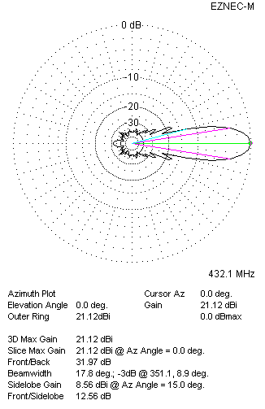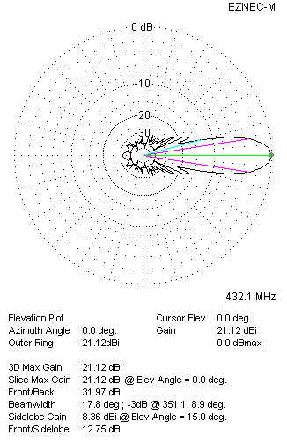
Horizontal and verticall pattern in free space, no loss condition
PERFORMANCES (Loss included for aluminum)
Aluminum |  |  |  |  |  |  | G  (dBi) |  |  | Tloss  (K) |  |  |  | T_{A}  (◦K) |  |  |  |  |  | G/T  (dB) |  |  | Bandwidth for SWR=1.5  (MHz)
After NEC/EZNEC |  |  |  |  |  |  | 21.05 |  |  | 4.9 |  |  |  | 24.8 |  |  |  |  |  | +6.92 |  |  | 424.100 – 437.100
After KF2YN correction |  |  |  |  |  |  | 20.99 |  |  | 4.9 |  |  |  | 29.2 |  |  |  |  |  | +6.35
Remark: Red coloured data are the final antenna data, which means: KF2YN correction formula applied and loss for aluminum included
DIAGRAMS
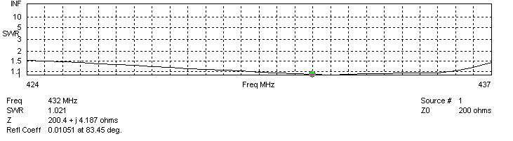
Frequency diagram for SWR better than 1.5
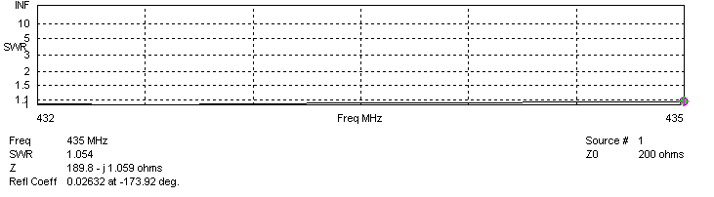
SWR diagram for the range from 432.000 – 435.000 MHz
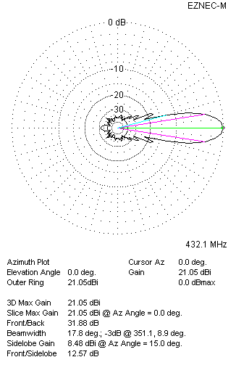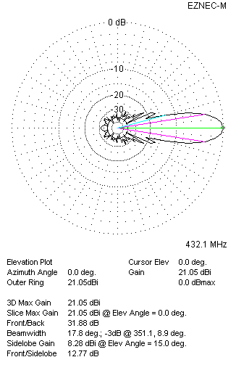
Horizontal and vertical pattern in free space, loss included for aluminum
STACKING
(ALL DATA GIVEN IN ACCORDANCE WITH KF2YN CORRECTION, LOSS INCLUDED)
RECOMMENDED STACKING DISTANCES
 |  |  |  |  |  |  | Two antennas vertically  (mm) |  |  |  |  |  |  | Two antennas horizontally  (mm) |  |  |  |  |  |  |  |  | Four antennas in H-stack  (mm)
Horizontal distance |  |  |  |  |  |  |  |  |  |  |  |  |  | 2640 |  |  |  |  |  |  |  |  | 2640
Vertical distance |  |  |  |  |  |  | 2440 |  |  |  |  |  |  |  |  |  |  |  |  |  |  |  | 2440
TWO ANTENNAS STACKED VERTICALLY
DISTANCE  (mm) |  |  |  | G  (dBi) |  |  |  |  |  |  |  | TA  (K) |  |  |  |  |  | Tloss  (K) |  |  |  |  |  |  |  | G/T  (dB)
2440 |  |  |  | 23.98 |  |  |  |  |  |  |  | 29.2 |  |  |  |  |  | 4.9 |  |  |  |  |  |  |  | +9.34
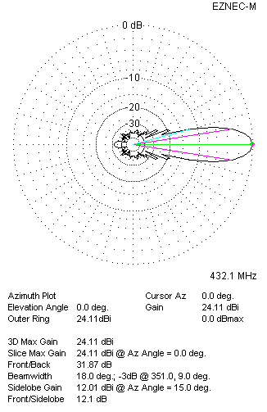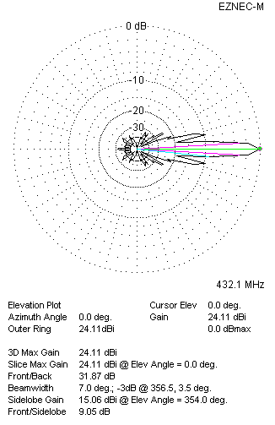
Two antennas stacked vertically
TWO ANTENNAS STACKED HORIZONTALLY
DISTANCE  (mm) |  |  |  | G  (dBi) |  |  |  |  |  |  |  | TA  (K) |  |  |  |  |  |  | Tloss  (K) |  |  |  |  |  |  |  | G/T  (dB)
2640 |  |  |  | 24.03 |  |  |  |  |  |  |  | 28.7 |  |  |  |  |  |  | 4.9 |  |  |  |  |  |  |  | +9.46
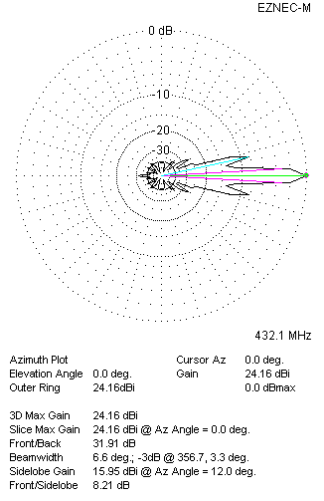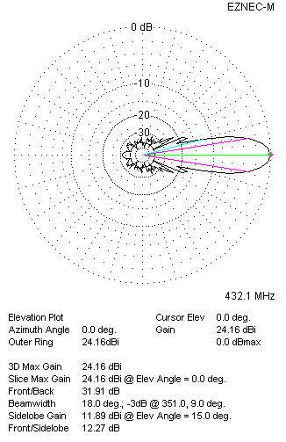
Two antennas stacked horizontally
FOUR ANTENNAS IN H-STACK
DISTANCE  (mm) |  |  |  | G  (dBi) |  |  |  |  |  |  |  | TA  (K) |  |  |  |  |  |  | Tloss  (K) |  |  |  |  |  |  |  | G/T  (dB)
H = 2640 |  |  |  | 27.04 |  |  |  |  |  |  |  | 29.0 |  |  |  |  |  |  | 4.9 |  |  |  |  |  |  |  | +12.43
V = 2440
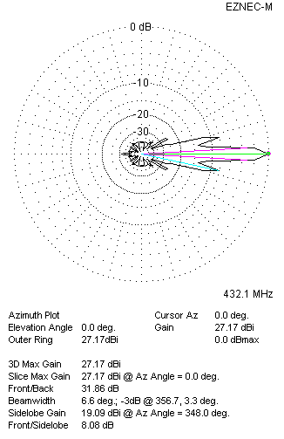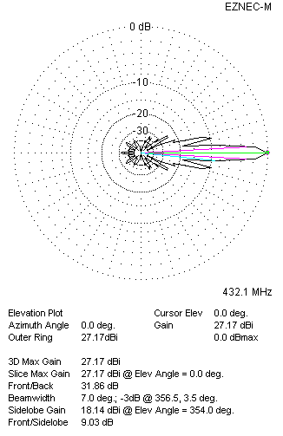
Four antennas in H-stack

