ANTENNA QY73508XL8D28
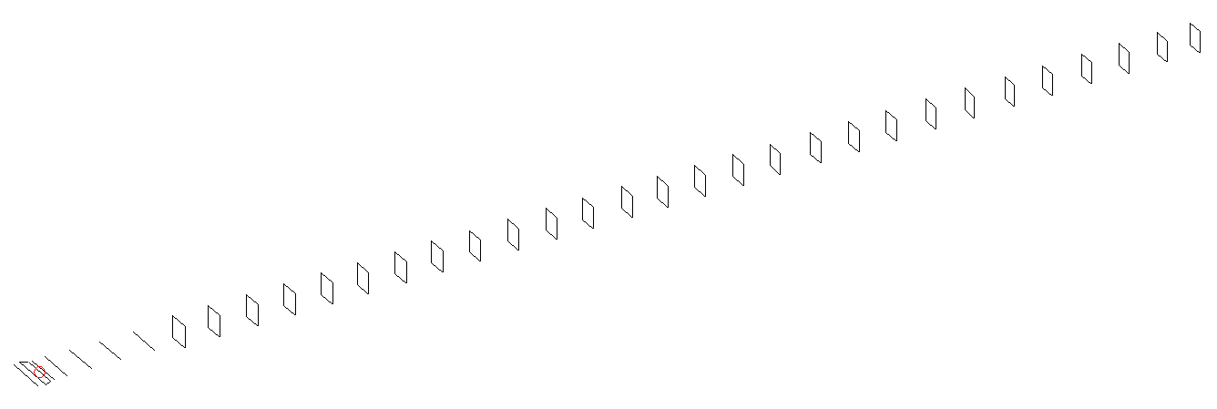
DESCRIPTION
Radiator |  |  | Number of  yagi elements |  |  |  | Number of  oblong elements |  |  | Total number  of elements |  |  |  | Boomlength  (mm)
LFA |  |  | 6 |  |  |  | 28 |  |  | 35 |  |  |  | 9125
DIMENSIONS
 | Ref | De1 |  | De2 | D1 | D2 |  | D3 | D4 |  | D5 | DQ1 | DQ2 |  | DQ3 | DQ4
Position | 0 | 70 |  | 120 | 158 | 259 |  | 443 | 672 |  | 928 | 1201 | 1476 |  | 1765 | 2073
Length | 332 | 330 |  | 330 | 303.5 | 305 |  | 295.5 | 288 |  | 280 | 173 | 165 |  | 162 | 159
 | DQ5 | DQ6 |  | DQ7 | DQ8 | DQ9 |  | DQ10 | DQ11 |  | DQ12 | DQ13 | DQ14 |  | DQ15 | DQ16
Position | 2363 | 2661 |  | 2946 | 3232 | 3516 |  | 3806 | 4081 |  | 4374 | 4649 | 4943 |  | 5233 | 5512
Length | 157 | 156 |  | 155 | 154 | 153 |  | 152 | 151 |  | 150 | 149 | 148 |  | 147 | 146
 | DQ17 | DQ18 |  | DQ19 | DQ20 | DQ21 |  | DQ22 | DQ23 |  | DQ24 | DQ25 | DQ26 |  | DQ27 | DQ28
Position | 5824 | 6126 |  | 6432 | 6731 | 7047 |  | 7374 | 7671 |  | 7986 | 8283 | 8591 |  | 8883 | 9125
Length | 145 | 144 |  | 143 | 142 | 141 |  | 141 | 139 |  | 137 | 137 | 137 |  | 137 | 133

Remark | All elements made of Al tubes Ǿ8 mm  The height of rectangles is 170 mm  All dimensions given in milimetres
PERFORMANCES (No loss condition)
G  (dBi) |  | F/B  (dB) |  | F/Sh  (dBi) | F/Sv  (dBi) |  | Hor  (◦) |  |  | Ver  (◦) | Temp  (◦K) |  |  | G/T  (dB)
20.98 |  | 34.15 |  | 17.89 | 16.61 |  | 18.0 |  |  | 18.2 | 24.8 |  |  | +7.56
DIAGRAMS
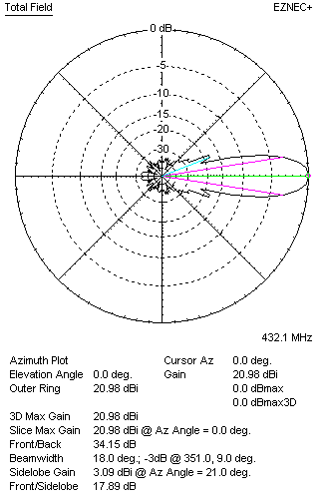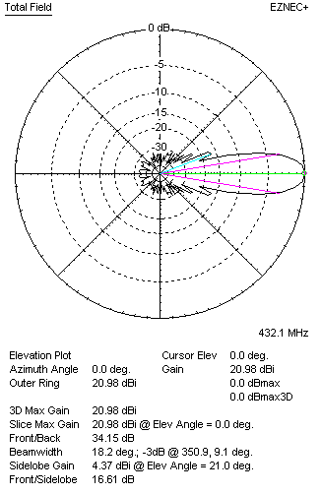
Horizontal and verticall pattern in free space, no loss condition
PERFORMANCES (Loss included for aluminum)
Aluminum |  |  |  | G  (dBi) | Tloss  (K) |  | T_{A}  (◦K) |  |  | G/T  (dB) | Bandwidth for SWR=1.5  (MHz)
After NEC/EZNEC |  |  |  | 20.92 | 4.9 |  | 24.9 |  |  | +6.71 | 425.400 – 437.750
After KF2YN correction |  |  |  | 20.86 | 4.9 |  | 29.3 |  |  | +6.20
Remark: Red coloured data are the final antenna data, which means: KF2YN correction formula applied and loss for aluminum included
DIAGRAMS
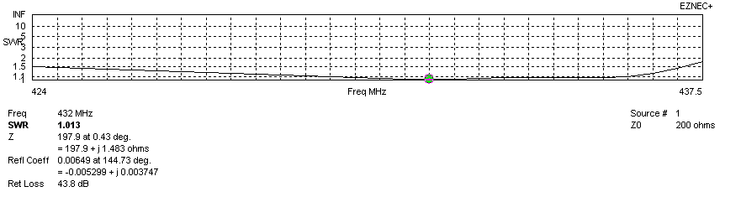
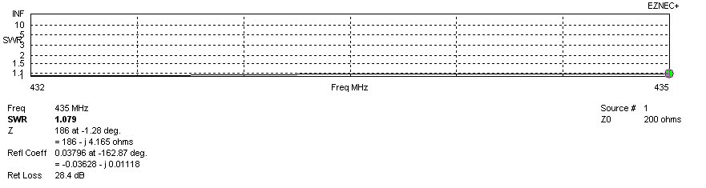
SWR diagram for the range from 432.000 – 435.000 MHz
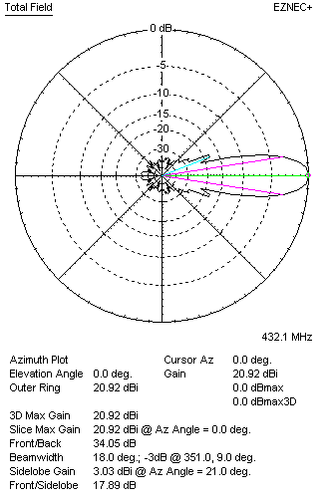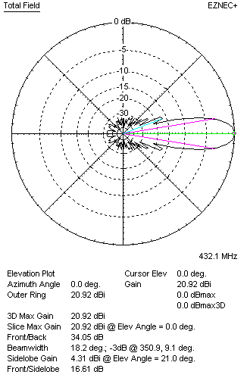
Horizontal and vertical pattern in free space, loss included for aluminum
STACKING
(ALL DATA GIVEN IN ACCORDANCE WITH KF2YN CORRECTION, LOSS INCLUDED)
RECOMMENDED STACKING DISTANCES
 |  |  |  | Two antennas vertically  (mm) |  |  | Two antennas horizontally  (mm) |  |  |  | Four antennas in H-stack  (mm)
Horizontal distance |  |  |  |  |  |  | 2640 |  |  |  | 2640
Vertical distance |  |  |  | 2420 |  |  |  |  |  |  | 2420
TWO ANTENNAS STACKED VERTICALLY
DISTANCE  (mm) |  |  | G  (dBi) |  |  | TA  (K) |  | Tloss  (K) |  |  |  | G/T  (dB)
2420 |  |  | 23.87 |  |  | 29.2 |  | 4.9 |  |  |  | +9.22
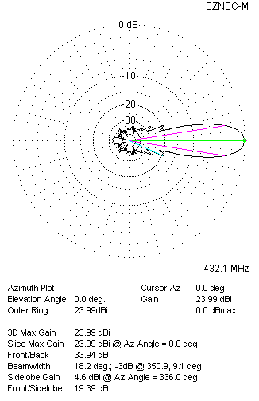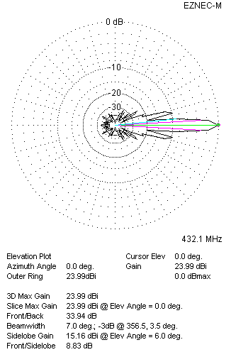
Two antennas stacked vertically
TWO ANTENNAS STACKED HORIZONTALLY
DISTANCE  (mm) |  |  | G  (dBi) |  |  | TA  (K) |  |  | Tloss  (K) |  |  |  | G/T  (dB)
2640 |  |  | 23.92 |  |  | 28.8 |  |  | 4.9 |  |  |  | +9.33
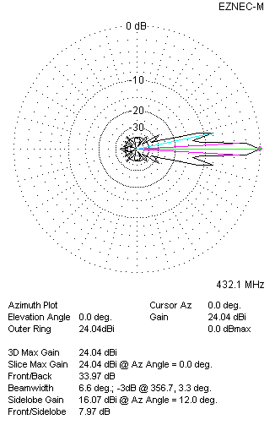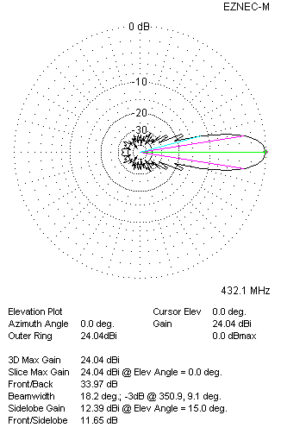
Two antennas stacked horizontally
FOUR ANTENNAS IN H-STACK
DISTANCE  (mm) |  |  | G  (dBi) |  |  | TA  (K) |  |  | Tloss  (K) |  |  |  | G/T  (dB)
H = 2640 |  |  | 26.93 |  |  | 29.1 |  |  | 4.9 |  |  |  | +12.30
V = 2420
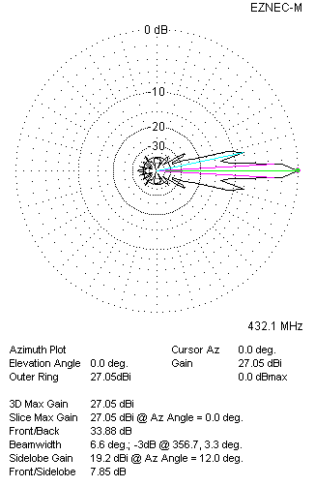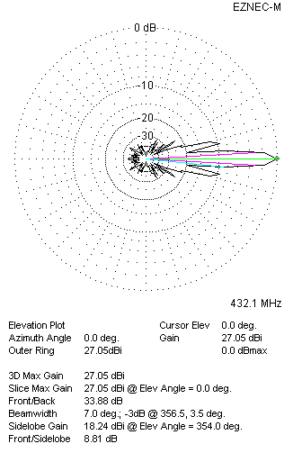
Four antennas in H-stack

