ANTENNA QY73310XL2D26
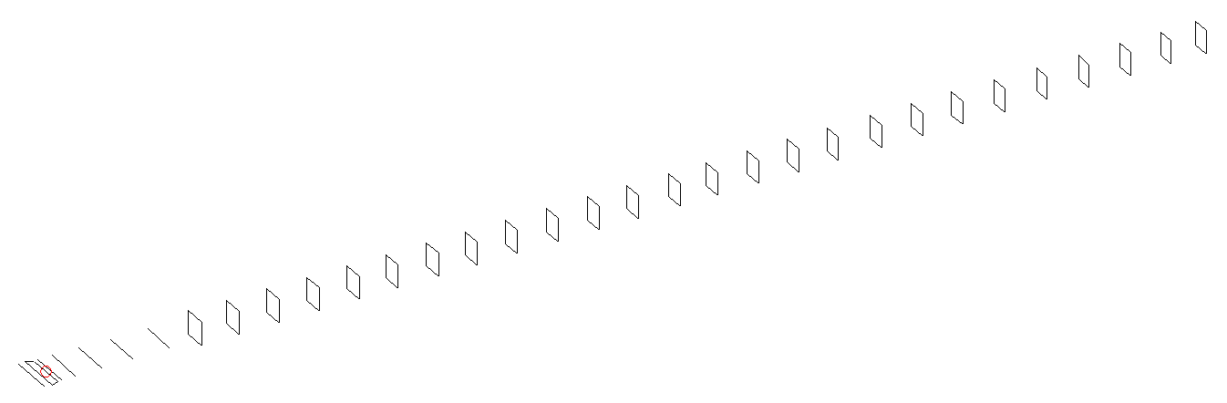
DESCRIPTION
Radiator |  |  | Number of  yagi elements |  |  |  | Number of  oblong elements |  |  | Total number  of elements |  |  |  | Boomlength  (mm)
LFA |  |  | 6 |  |  |  | 26 |  |  | 33 |  |  |  | 8535
DIMENSIONS
 | Ref | De1 |  | De2 | D1 | D2 |  | D3 | D4 |  | D5 | DQ1 | DQ2 |  | DQ3 | DQ4
Position | 0 | 57 |  | 102 | 142 | 243 |  | 429 | 652 |  | 911 | 1175 | 1444 |  | 1743 | 2038
Length | 330 | 332 |  | 332 | 298 | 300 |  | 290.5 | 282.5 |  | 275 | 173 | 165 |  | 159 | 156
 | DQ5 | DQ6 |  | DQ7 | DQ8 | DQ9 |  | DQ10 | DQ11 |  | DQ12 | DQ13 | DQ14 |  | DQ15 | DQ16
Position | 2342 | 2648 |  | 2929 | 3234 | 3507 |  | 3804 | 4078 |  | 4361 | 4666 | 4957 |  | 5266 | 5559
Length | 153 | 152 |  | 151 | 147 | 143 |  | 143 | 143 |  | 143 | 141 | 139 |  | 139 | 139
 | DQ17 | DQ18 |  | DQ19 | DQ20 | DQ21 |  | DQ22 | DQ23 |  | DQ24 | DQ25 | DQ26
Position | 5866 | 6166 |  | 6463 | 6771 | 7056 |  | 7372 | 7686 |  | 7982 | 8284 | 8535
Length | 139 | 139 |  | 133 | 133 | 131 |  | 131 | 131 |  | 127 | 127 | 123

Remark | All elements made of Al tubes Ǿ8 mm  The height of rectangles is 170 mm  All dimensions given in milimetres
PERFORMANCES (No loss condition)
G  (dBi) |  | F/B  (dB) |  | F/Sh  (dBi) | F/Sv  (dBi) |  | Hor  (◦) |  |  | Ver  (◦) | Temp  (◦K) |  |  | G/T  (dB)
20.36 |  | 33.31 |  | 19.28 | 18.04 |  | 19.6 |  |  | 19.8 | 24.0 |  |  | +6.97
DIAGRAMS
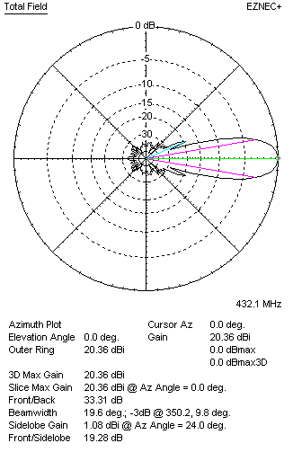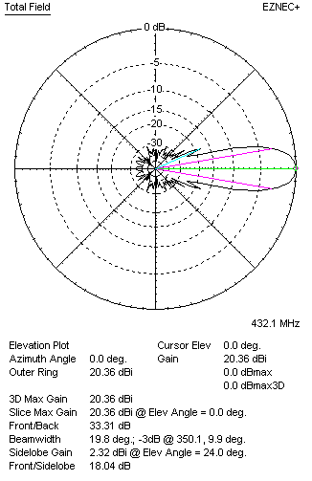
Horizontal and verticall pattern in free space, no loss condition
PERFORMANCES (Loss included for aluminum)
Aluminum |  |  |  | G  (dBi) | Tloss  (K) |  | T_{A}  (◦K) |  |  | G/T  (dB) | Bandwidth for SWR=1.5  (MHz)
After NEC/EZNEC |  |  |  | 20.31 | 3.5 |  | 24.0 |  |  | +6.33 | 425.500 – 439.000
After KF2YN correction |  |  |  | 20.27 | 3.5 |  | 27.2 |  |  | +5.93
Remark: Red coloured data are the final antenna data, which means: KF2YN correction formula applied and loss for aluminum included
DIAGRAMS
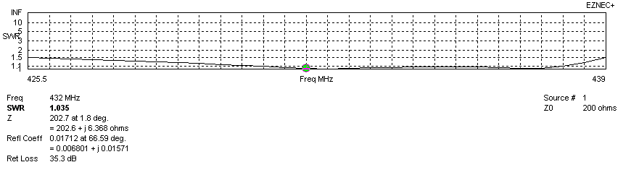
Frequency diagram for SWR better than 1.5
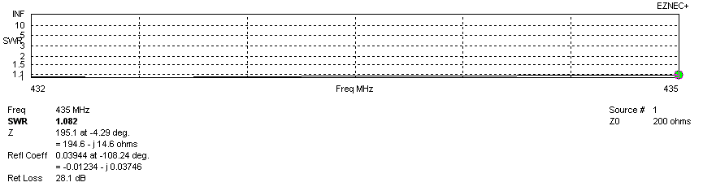
SWR diagram for the range from 432.000 – 435.000 MHz
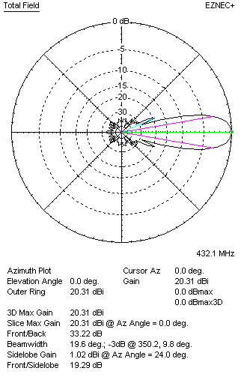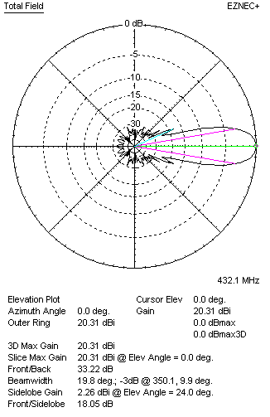
Horizontal and vertical pattern in free space, loss included for aluminum
STACKING
(ALL DATA GIVEN IN ACCORDANCE WITH KF2YN CORRECTION, LOSS INCLUDED)
RECOMMENDED STACKING DISTANCES
 |  |  |  | Two antennas vertically  (mm) |  |  | Two antennas horizontally  (mm) |  |  |  | Four antennas in H-stack  (mm)
Horizontal distance |  |  |  |  |  |  | 2640 |  |  |  | 2640
Vertical distance |  |  |  | 2440 |  |  |  |  |  |  | 2440
TWO ANTENNAS STACKED VERTICALLY
DISTANCE  (mm) |  |  | G  (dBi) |  |  | TA  (K) |  | Tloss  (K) |  |  |  | G/T  (dB)
2440 |  |  | 23.31 |  |  | 27.1 |  | 3.5 |  |  |  | +8.99
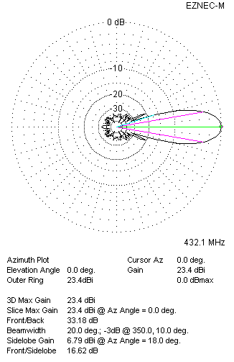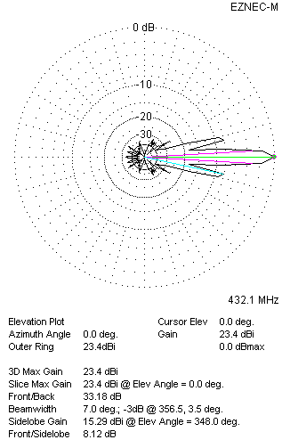
Two antennas stacked vertically
TWO ANTENNAS STACKED HORIZONTALLY
DISTANCE  (mm) |  |  | G  (dBi) |  |  | TA  (K) |  |  | Tloss  (K) |  |  |  | G/T  (dB)
2640 |  |  | 23.34 |  |  | 26.9 |  |  | 3.5 |  |  |  | +9.05
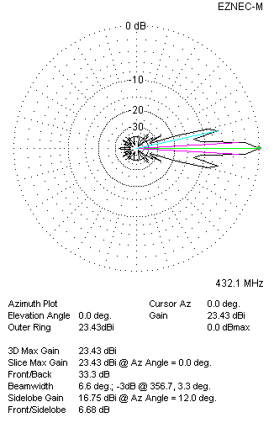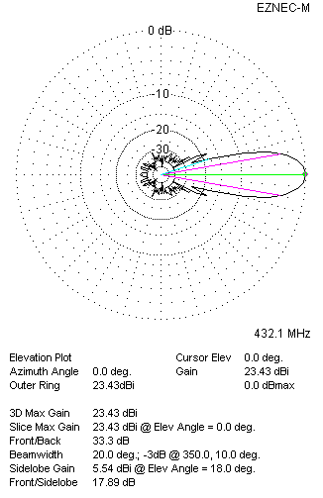
Two antennas stacked horizontally
FOUR ANTENNAS IN H-STACK
DISTANCE  (mm) |  |  | G  (dBi) |  |  | TA  (K) |  |  | Tloss  (K) |  |  |  | G/T  (dB)
H = 2640 |  |  | 26.38 |  |  | 27.0 |  |  | 3.5 |  |  |  | +12.07
V = 2440
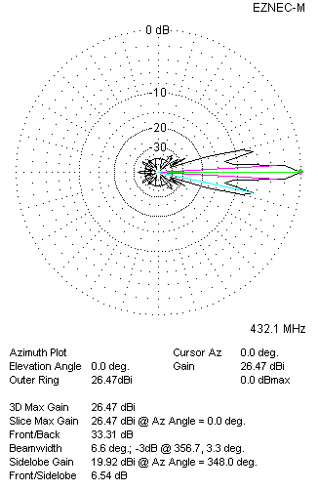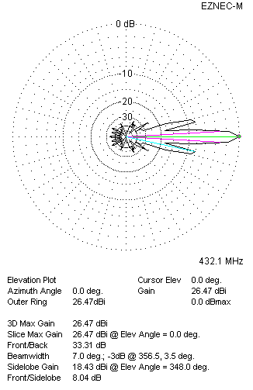
Four antennas in H-stack

