ANTENNA QY73305XL2D26
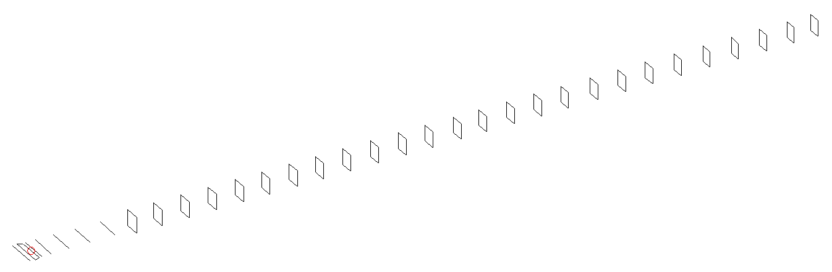
DESCRIPTION
Radiator |  |  | Number of  yagi elements |  |  |  | Number of  oblong elements |  |  | Total number  of elements |  |  |  | Boomlength  (mm)
LFA |  |  | 6 |  |  |  | 26 |  |  | 33 |  |  |  | 8535
DIMENSIONS
 | Ref | De1 |  | De2 | D1 | D2 |  | D3 | D4 |  | D5 | DQ1 | DQ2 |  | DQ3 | DQ4
Position | 0 | 50 |  | 100 | 132 | 236 |  | 428 | 658 |  | 928 | 1188 | 1466 |  | 1758 | 2052
Length | 335 | 348 |  | 300 | 310 | 310 |  | 300.5 | 293.5 |  | 286.5 | 173 | 163 |  | 161 | 159
 | DQ5 | DQ6 |  | DQ7 | DQ8 | DQ9 |  | DQ10 | DQ11 |  | DQ12 | DQ13 | DQ14 |  | DQ15 | DQ16
Position | 2344 | 2628 |  | 2924 | 3208 | 3502 |  | 3799 | 4098 |  | 4382 | 4688 | 4966 |  | 5262 | 5558
Length | 158 | 156 |  | 154 | 153 | 149 |  | 149 | 149 |  | 149 | 149 | 149 |  | 149 | 149
 | DQ17 | DQ18 |  | DQ19 | DQ20 | DQ21 |  | DQ22 | DQ23 |  | DQ24 | DQ25 | DQ26
Position | 5846 | 6162 |  | 6460 | 6754 | 7062 |  | 7372 | 7678 |  | 7982 | 8278 | 8535
Length | 144 | 144 |  | 143 | 143 | 135 |  | 135 | 135 |  | 135 | 131 | 131

Remark | All elements made of Al tubes Ǿ5 mm  The height of rectangles is 170 mm  All dimensions given in milimetres
PERFORMANCES (No loss condition)
G  (dBi) |  | F/B  (dB) |  | F/Sh  (dBi) | F/Sv  (dBi) |  | Hor  (◦) |  |  | Ver  (◦) | Temp  (◦K) |  |  | G/T  (dB)
20.49 |  | 38.25 |  | 16.99 | 15.67 |  | 19.2 |  |  | 19.4 | 24.2 |  |  | +7.63
DIAGRAMS
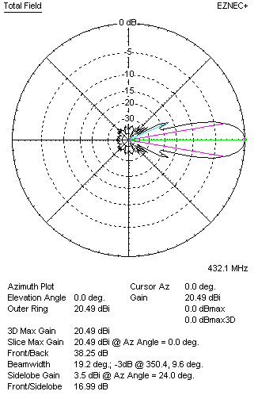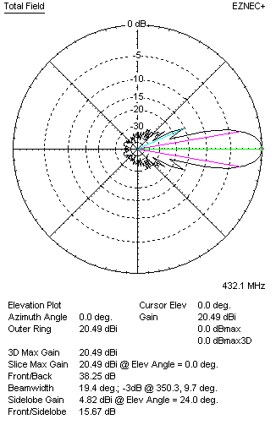
Horizontal and verticall pattern in free space, no loss condition
PERFORMANCES (Loss included for aluminum)
Aluminum |  |  |  | G  (dBi) | Tloss  (K) |  | T_{A}  (◦K) |  |  | G/T  (dB) | Bandwidth for SWR=1.5  (MHz)
After NEC/EZNEC |  |  |  | 20.41 | 6.3 |  | 24.2 |  |  | +6.42 | 423.000 – 437.500
After KF2YN correction |  |  |  | 20.32 | 6.3 |  | 29.7 |  |  | +5.60
Remark: Red coloured data are the final antenna data, which means: KF2YN correction formula applied and loss for aluminum included
DIAGRAMS
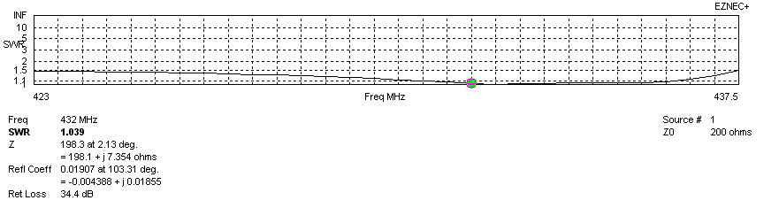
Frequency diagram for SWR better than 1.5
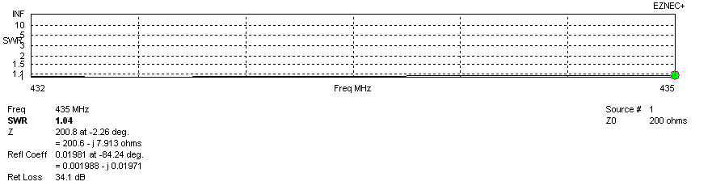
SWR diagram for the range from 432.000 – 435.000 MHz
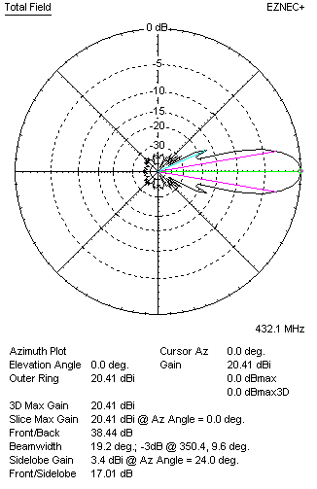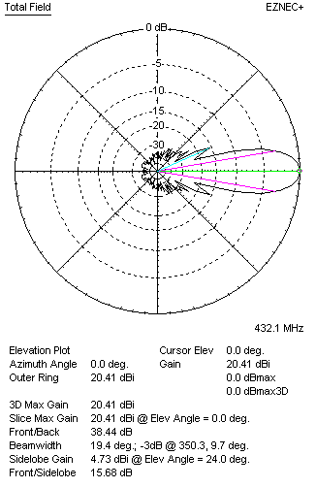
Horizontal and vertical pattern in free space, loss included for aluminum
STACKING
(ALL DATA GIVEN IN ACCORDANCE WITH KF2YN CORRECTION, LOSS INCLUDED)
RECOMMENDED STACKING DISTANCES
 |  |  |  | Two antennas vertically  (mm) |  |  | Two antennas horizontally  (mm) |  |  |  | Four antennas in H-stack  (mm)
Horizontal distance |  |  |  |  |  |  | 2660 |  |  |  | 2660
Vertical distance |  |  |  | 2600 |  |  |  |  |  |  | 2600
TWO ANTENNAS STACKED VERTICALLY
DISTANCE  (mm) |  |  | G  (dBi) |  |  | TA  (K) |  | Tloss  (K) |  |  |  | G/T  (dB)
2600 |  |  | 23.41 |  |  | 29.8 |  | 6.3 |  |  |  | +8.67
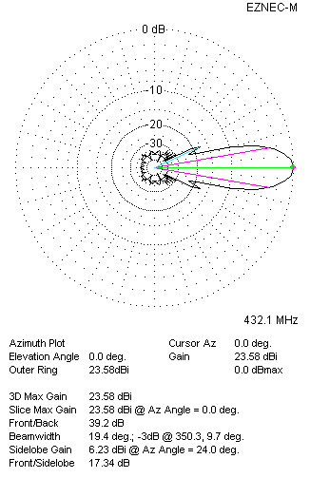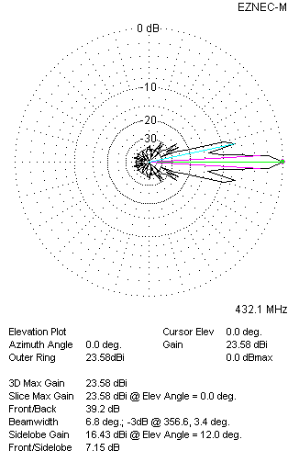
Two antennas stacked vertically
TWO ANTENNAS STACKED HORIZONTALLY
DISTANCE  (mm) |  |  | G  (dBi) |  |  | TA  (K) |  |  | Tloss  (K) |  |  |  | G/T  (dB)
2660 |  |  | 23.41 |  |  | 29.4 |  |  | 6.3 |  |  |  | +8.73
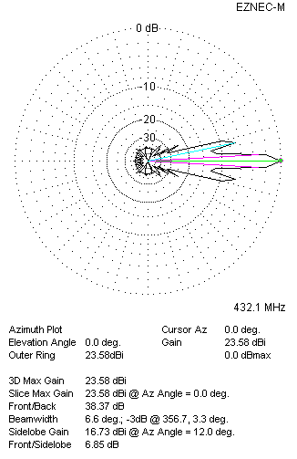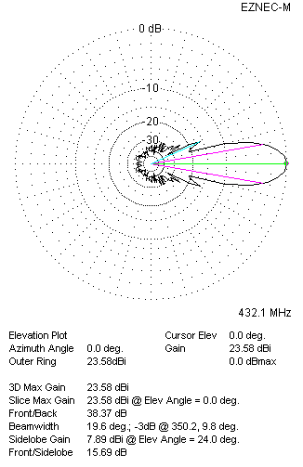
Two antennas stacked horizontally
FOUR ANTENNAS IN H-STACK
DISTANCE  (mm) |  |  | G  (dBi) |  |  | TA  (K) |  |  | Tloss  (K) |  |  |  | G/T  (dB)
H = 2660 |  |  | 26.47 |  |  | 29.6 |  |  | 6.3 |  |  |  | +11.76
V = 2600
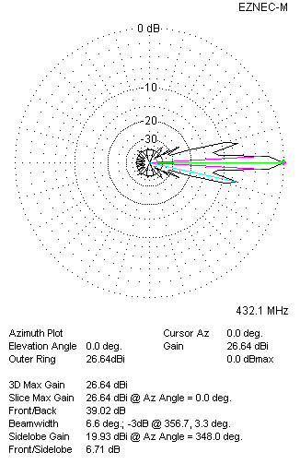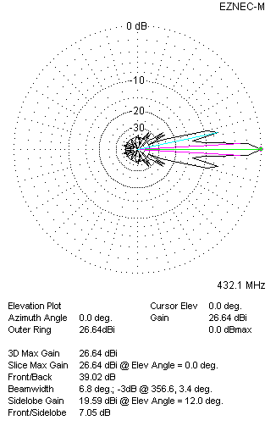
Four antennas in H-stack

