ANTENNA QY73210XL4D25
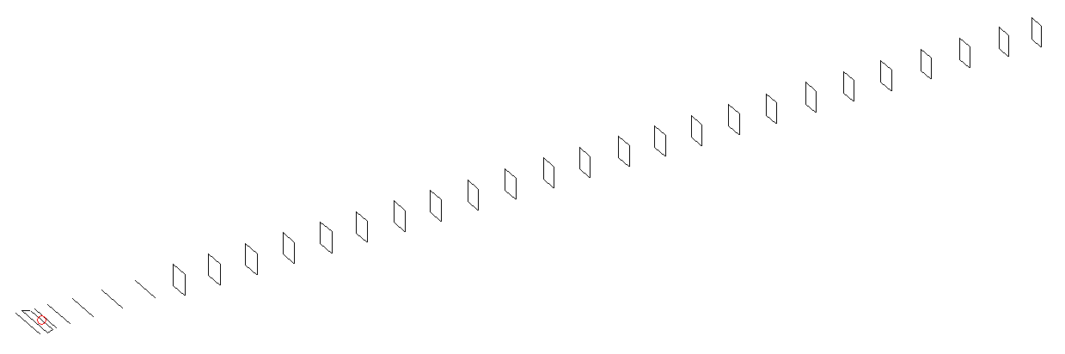
DESCRIPTION
Radiator |  |  | Number of  yagi elements |  |  | Number of  oblong elements |  |  |  | Total number  of elements |  |  | Boomlength  (mm)
LFA |  |  | 6 |  |  | 25 |  |  |  | 32 |  |  | 8235
DIMENSIONS
 | Ref | De1 |  | De2 | D1 |  | D2 | D3 | D4 |  | D5 | DQ1 |  | DQ2 | DQ3
Position | 0 | 57 |  | 102 | 142 |  | 243 | 429 | 652 |  | 911 | 1175 |  | 1444 | 1743
Length | 331 | 332 |  | 332 | 298 |  | 300 | 290.5 | 282.5 |  | 275 | 173 |  | 165 | 159
 | DQ4 | DQ5 |  | DQ6 | DQ7 |  | DQ8 | DQ9 | DQ10 |  | DQ11 | DQ12 |  | DQ13 | DQ14
Position | 2038 | 2342 |  | 2648 | 2929 |  | 3234 | 3507 | 3804 |  | 4078 | 4361 |  | 4666 | 4957
Length | 156 | 153 |  | 152 | 151 |  | 147 | 143 | 143 |  | 143 | 143 |  | 141 | 139
 | DQ15 | DQ16 |  | DQ17 | DQ18 |  | DQ19 | DQ20 | DQ21 |  | DQ22 | DQ23 |  | DQ24 | DQ25
Position | 5266 | 5559 |  | 5866 | 6166 |  | 6463 | 6771 | 7056 |  | 7372 | 7681 |  | 7978 | 8235
Length | 139 | 139 |  | 139 | 139 |  | 133 | 133 | 131 |  | 131 | 129 |  | 127 | 125

Remark | All elements made of Al tubes Ǿ10 mm  The height of rectangles is 170 mm  All dimensions given in milimetres
PERFORMANCES (No loss condition)
G  (dBi) |  | F/B  (dB) |  | F/Sh  (dBi) | F/Sv  (dBi) |  | Hor  (◦) |  |  | Ver  (◦) | Temp  (◦K) |  |  | G/T  (dB)
20.25 |  | 31.55 |  | 19.50 | 18.07 |  | 19.8 |  |  | 20.0 | 24.1 |  |  | +6.85
DIAGRAMS
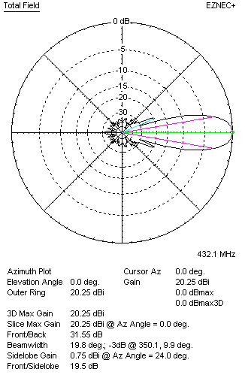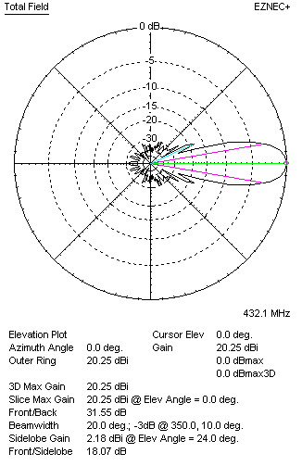
Horizontal and verticall pattern in free space, no loss condition
PERFORMANCES (Loss included for aluminum)
Aluminum |  |  |  | G  (dBi) | Tloss  (K) |  | T_{A}  (◦K) |  |  | G/T  (dB) | Bandwidth for SWR=1.5  (MHz)
After NEC/EZNEC |  |  |  | 20.21 | 3.5 |  | 24.2 |  |  | +6.23 | 425.600 – 439.100
After KF2YN correction |  |  |  | 20.16 | 3.5 |  | 27.3 |  |  | +5.81
Remark: Red coloured data are the final antenna data, which means: KF2YN correction formula applied and loss for aluminum included
DIAGRAMS
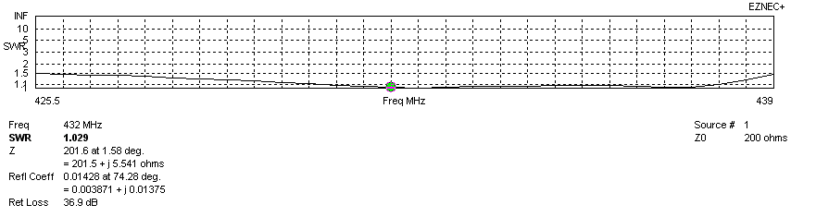
Frequency diagram for SWR better than 1.5
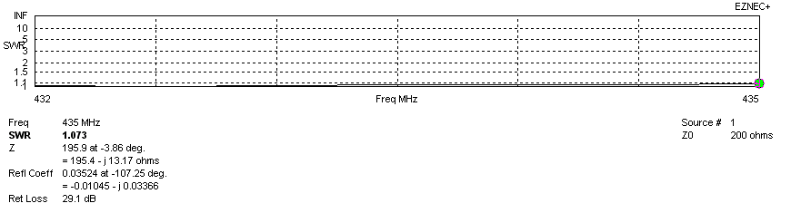
SWR diagram for the range from 432.000 – 435.000 MHz
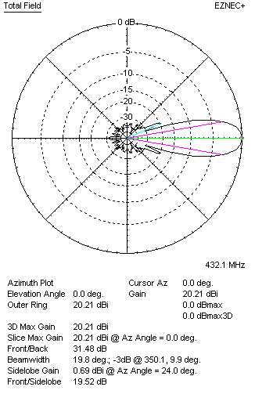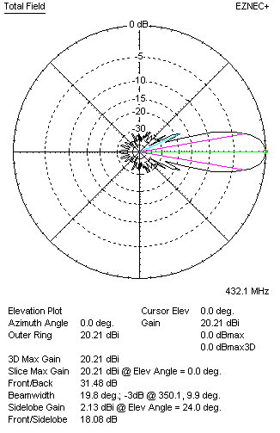
Horizontal and vertical pattern in free space, loss included for aluminum
STACKING
(ALL DATA GIVEN IN ACCORDANCE WITH KF2YN CORRECTION, LOSS INCLUDED)
RECOMMENDED STACKING DISTANCES
 |  |  |  | Two antennas vertically  (mm) |  |  | Two antennas horizontally  (mm) |  |  |  | Four antennas in H-stack  (mm)
Horizontal distance |  |  |  |  |  |  | 2580 |  |  |  | 2580
Vertical distance |  |  |  | 2380 |  |  |  |  |  |  | 2380
TWO ANTENNAS STACKED VERTICALLY
DISTANCE  (mm) |  |  | G  (dBi) |  |  | TA  (K) |  | Tloss  (K) |  |  |  | G/T  (dB)
2380 |  |  | 23.20 |  |  | 27.2 |  | 3.5 |  |  |  | +8.86
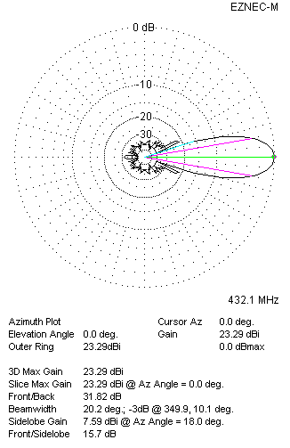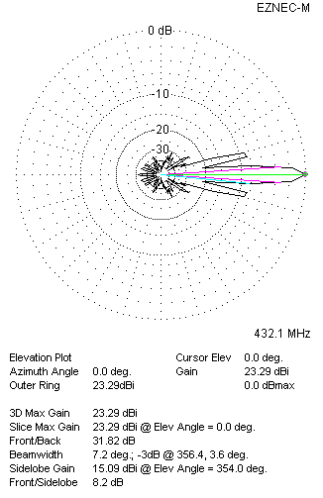
Two antennas stacked vertically
TWO ANTENNAS STACKED HORIZONTALLY
DISTANCE  (mm) |  |  | G  (dBi) |  |  | TA  (K) |  |  | Tloss  (K) |  |  |  | G/T  (dB)
2580 |  |  | 23.24 |  |  | 27.0 |  |  | 3.5 |  |  |  | +8.93
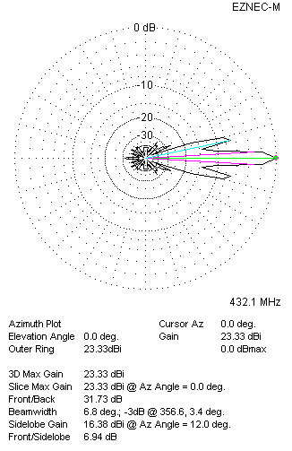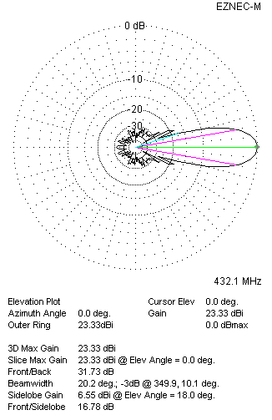
Two antennas stacked horizontally
FOUR ANTENNAS IN H-STACK
DISTANCE  (mm) |  |  | G  (dBi) |  |  | TA  (K) |  |  | Tloss  (K) |  |  |  | G/T  (dB)
H = 2580 |  |  | 26.27 |  |  | 27.0 |  |  | 3.5 |  |  |  | +11.96
V = 2380
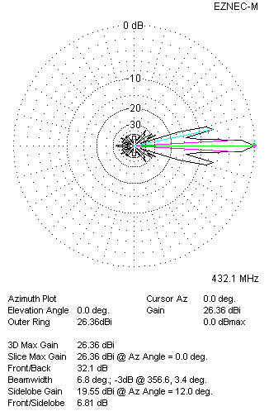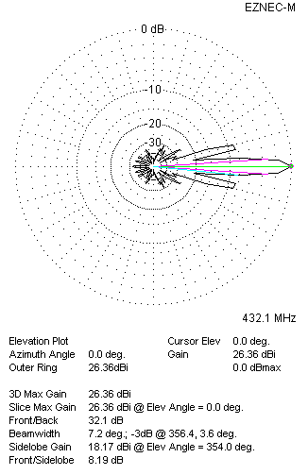
Four antennas in H-stack

