ANTENNA QY73208XL4D25
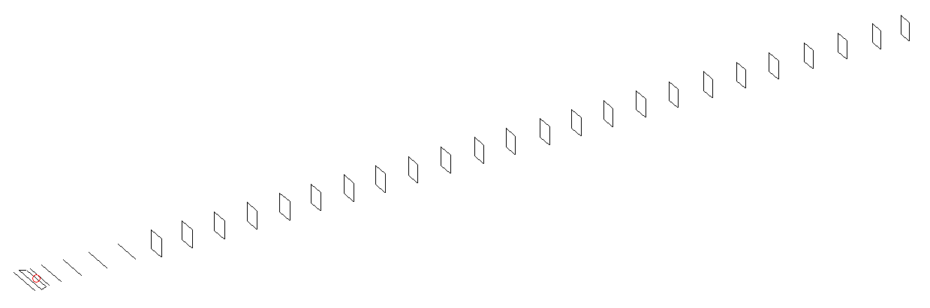
DESCRIPTION
Radiator |  |  | Number of  yagi elements |  |  | Number of  oblong elements |  |  |  | Total number  of elements |  |  | Boomlength  (mm)
LFA |  |  | 6 |  |  | 25 |  |  |  | 32 |  |  | 8235
DIMENSIONS
 | Ref | De1 |  | De2 | D1 |  | D2 | D3 | D4 |  | D5 | DQ1 |  | DQ2 | DQ3
Position | 0 | 70 |  | 120 | 158 |  | 258 | 443 | 672 |  | 928 | 1201 |  | 1476 | 1765
Length | 332 | 300 |  | 300 | 303.5 |  | 305 | 295.5 | 288 |  | 279.5 | 173 |  | 165 | 162
 | DQ4 | DQ5 |  | DQ6 | DQ7 |  | DQ8 | DQ9 | DQ10 |  | DQ11 | DQ12 |  | DQ13 | DQ14
Position | 2073 | 2363 |  | 2661 | 2946 |  | 3232 | 3516 | 3806 |  | 4081 | 4374 |  | 4649 | 4943
Length | 159 | 157 |  | 156 | 155 |  | 154 | 153 | 152 |  | 151 | 150 |  | 149 | 148
 | DQ15 | DQ16 |  | DQ17 | DQ18 |  | DQ19 | DQ20 | DQ21 |  | DQ22 | DQ23 |  | DQ24 | DQ25
Position | 5233 | 5512 |  | 5824 | 6126 |  | 6432 | 6731 | 7047 |  | 7374 | 7671 |  | 7976 | 8235
Length | 147 | 146 |  | 145 | 144 |  | 143 | 142 | 141 |  | 141 | 139 |  | 137 | 137

Remark | All elements made of Al tubes Ǿ8 mm  The height of rectangles is 170 mm  All dimensions given in milimetres
PERFORMANCES (No loss condition)
G  (dBi) |  | F/B  (dB) |  | F/Sh  (dBi) | F/Sv  (dBi) |  | Hor  (◦) |  |  | Ver  (◦) | Temp  (◦K) |  |  | G/T  (dB)
20.63 |  | 29.14 |  | 16.89 | 15.77 |  | 18.6 |  |  | 18.6 | 25.1 |  |  | +7.21
DIAGRAMS
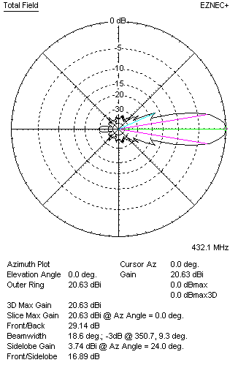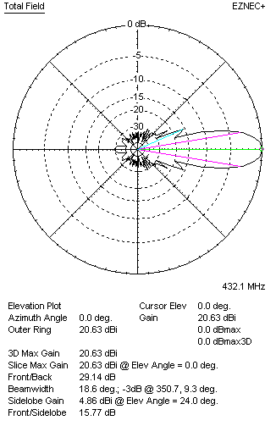
Horizontal and verticall pattern in free space, no loss condition
PERFORMANCES (Loss included for aluminum)
Aluminum |  |  |  | G  (dBi) | Tloss  (K) |  | T_{A}  (◦K) |  |  | G/T  (dB) | Bandwidth for SWR=1.5  (MHz)
After NEC/EZNEC |  |  |  | 20.56 | 4.6 |  | 25.2 |  |  | +6.38 | 425.000 – 437.300
After KF2YN correction |  |  |  | 20.51 | 4.6 |  | 29.3 |  |  | +5.84
Remark: Red coloured data are the final antenna data, which means: KF2YN correction formula applied and loss for aluminum included
DIAGRAMS
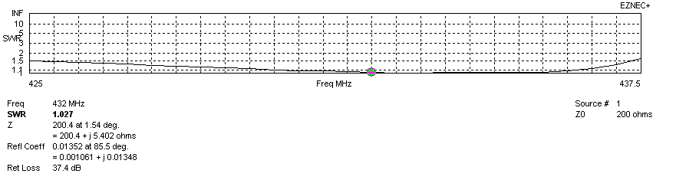
Frequency diagram for SWR better than 1.5
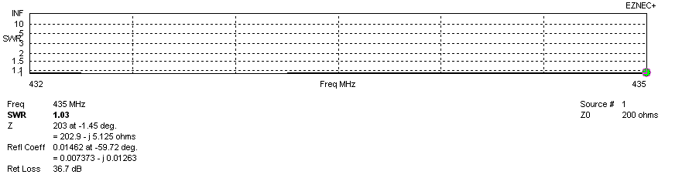
SWR diagram for the range from 432.000 – 435.000 MHz
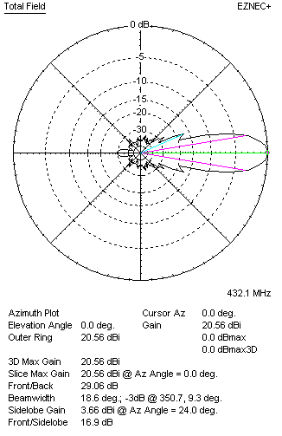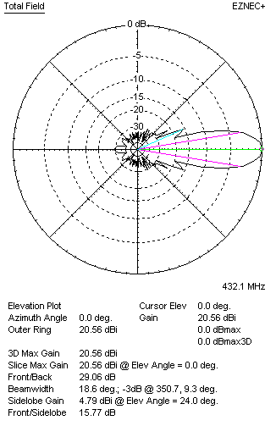
Horizontal and vertical pattern in free space, loss included for aluminum
STACKING
(ALL DATA GIVEN IN ACCORDANCE WITH KF2YN CORRECTION, LOSS INCLUDED)
RECOMMENDED STACKING DISTANCES
 |  |  |  | Two antennas vertically  (mm) |  |  | Two antennas horizontally  (mm) |  |  |  | Four antennas in H-stack  (mm)
Horizontal distance |  |  |  |  |  |  | 2580 |  |  |  | 2580
Vertical distance |  |  |  | 2560 |  |  |  |  |  |  | 2560
TWO ANTENNAS STACKED VERTICALLY
DISTANCE  (mm) |  |  | G  (dBi) |  |  | TA  (K) |  | Tloss  (K) |  |  |  | G/T  (dB)
2560 |  |  | 23.57 |  |  | 29.5 |  | 4.6 |  |  |  | +8.87
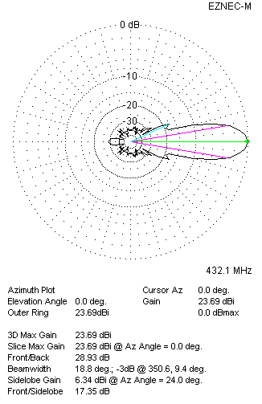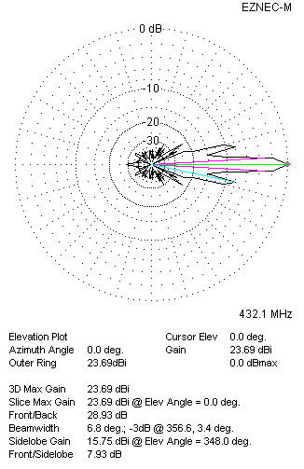
Two antennas stacked vertically
TWO ANTENNAS STACKED HORIZONTALLY
DISTANCE  (mm) |  |  | G  (dBi) |  |  | TA  (K) |  |  | Tloss  (K) |  |  |  | G/T  (dB)
2580 |  |  | 23.57 |  |  | 28.8 |  |  | 4.6 |  |  |  | +8.98
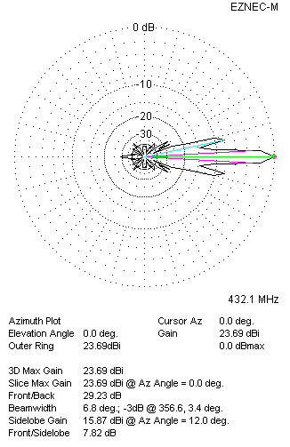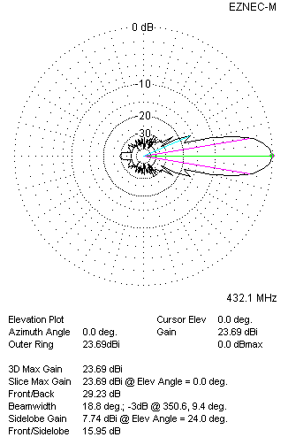
Two antennas stacked horizontally
FOUR ANTENNAS IN H-STACK
DISTANCE  (mm) |  |  | G  (dBi) |  |  | TA  (K) |  |  | Tloss  (K) |  |  |  | G/T  (dB)
H = 2580 |  |  | 26.62 |  |  | 29.3 |  |  | 4.6 |  |  |  | +11.95
V = 2560
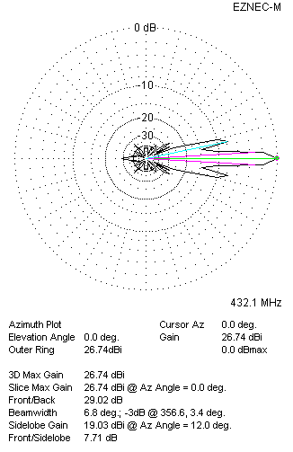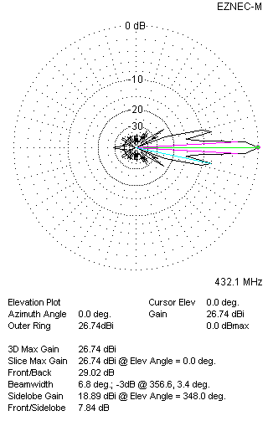
Four antennas in H-stack

