ANTENNA QY73106XL3D24
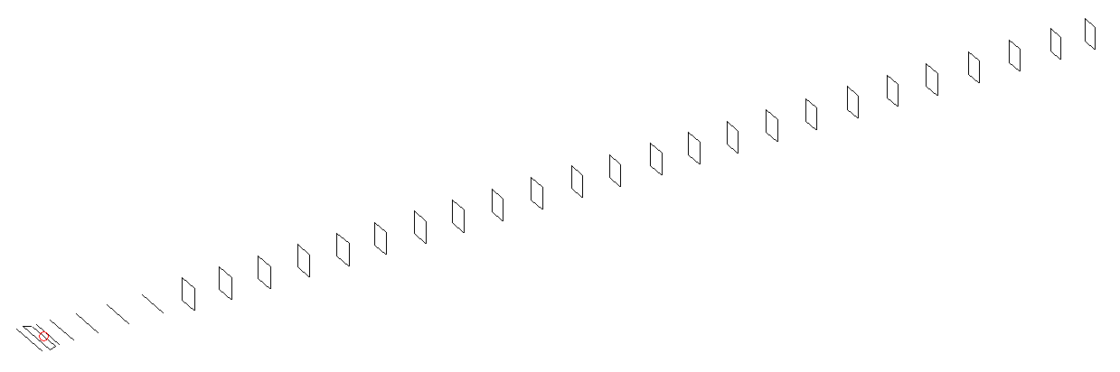
DESCRIPTION
Radiator |  |  | Number of  yagi elements |  |  | Number of  oblong elements |  |  |  | Total number  of elements |  |  | Boomlength  (mm)
LFA |  |  | 6 |  |  | 24 |  |  |  | 31 |  |  | 7935
DIMENSIONS
 | Ref | De1 |  | De2 | D1 |  | D2 | D3 | D4 |  | D5 | DQ1 |  | DQ2 | DQ3
Position | 0 | 50 |  | 105 | 144 |  | 244 | 429 | 665 |  | 920 | 1185 |  | 1466 | 1758
Length | 334 | 355 |  | 288 | 309.5 |  | 308.5 | 298 | 291 |  | 284.5 | 173 |  | 163 | 161
 | DQ4 | DQ5 |  | DQ6 | DQ7 |  | DQ8 | DQ9 | DQ10 |  | DQ11 | DQ12 |  | DQ13 | DQ14
Position | 2052 | 2344 |  | 2628 | 2924 |  | 3208 | 3502 | 3799 |  | 4098 | 4382 |  | 4688 | 4966
Length | 159 | 158 |  | 156 | 155 |  | 153 | 150 | 150 |  | 150 | 150 |  | 150 | 150
 | DQ15 | DQ16 |  | DQ17 | DQ18 |  | DQ19 | DQ20 | DQ21 |  | DQ22 | DQ23 |  | DQ24
Position | 5259 | 5562 |  | 5850 | 6158 |  | 6456 | 6762 | 7064 |  | 7366 | 7668 |  | 7935
Length | 145 | 145 |  | 145 | 143 |  | 143 | 141 | 141 |  | 135 | 133 |  | 133

Remark | All elements made of Al tubes Ǿ6 mm  The height of rectangles is 170 mm  All dimensions given in milimetres
PERFORMANCES (No loss condition)
G  (dBi) |  | F/B  (dB) |  | F/Sh  (dBi) | F/Sv  (dBi) |  | Hor  (◦) |  |  | Ver  (◦) | Temp  (◦K) |  |  | G/T  (dB)
20.34 |  | 34.87 |  | 17.05 | 15.58 |  | 19.4 |  |  | 19.4 | 24.4 |  |  | +7.21
DIAGRAMS
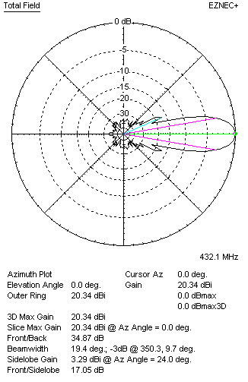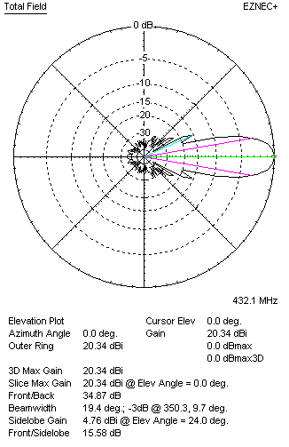
Horizontal and verticall pattern in free space, no loss condition
PERFORMANCES (Loss included for aluminum)
Aluminum |  |  |  | G  (dBi) | Tloss  (K) |  | T_{A}  (◦K) |  |  | G/T  (dB) | Bandwidth for SWR=1.5  (MHz)
After NEC/EZNEC |  |  |  | 20.27 | 5.2 |  | 24.4 |  |  | +6.21 | 424.900 – 438.300
After KF2YN correction |  |  |  | 20.20 | 5.2 |  | 29.1 |  |  | +5.56
Remark: Red coloured data are the final antenna data, which means: KF2YN correction formula applied and loss for aluminum included
DIAGRAMS
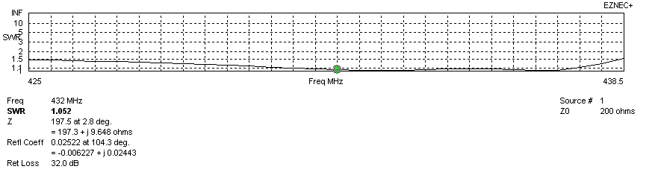
Frequency diagram for SWR better than 1.5
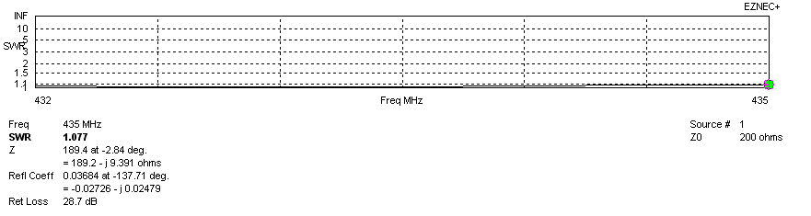
SWR diagram for the range from 432.000 – 435.000 MHz
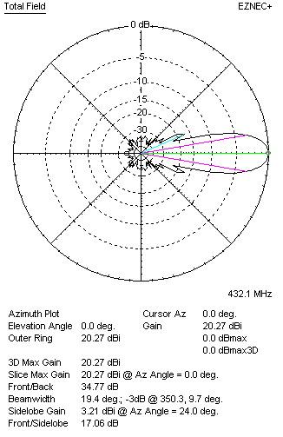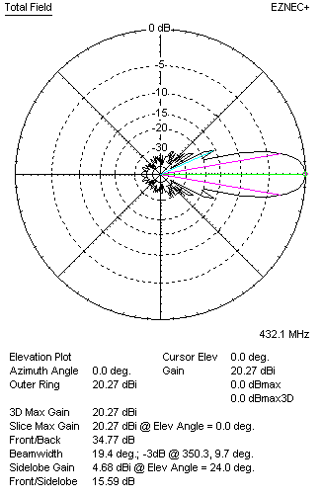
Horizontal and vertical pattern in free space, loss included for aluminum
STACKING
(ALL DATA GIVEN IN ACCORDANCE WITH KF2YN CORRECTION, LOSS INCLUDED)
RECOMMENDED STACKING DISTANCES
 |  |  |  | Two antennas vertically  (mm) |  |  | Two antennas horizontally  (mm) |  |  |  | Four antennas in H-stack  (mm)
Horizontal distance |  |  |  |  |  |  | 2560 |  |  |  | 2560
Vertical distance |  |  |  | 2060 |  |  |  |  |  |  | 2060
TWO ANTENNAS STACKED VERTICALLY
DISTANCE  (mm) |  |  | G  (dBi) |  |  | TA  (K) |  | Tloss  (K) |  |  |  | G/T  (dB)
2060 |  |  | 23.10 |  |  | 28.5 |  | 5.2 |  |  |  | +8.55
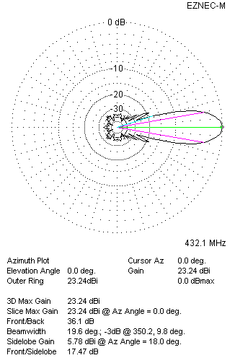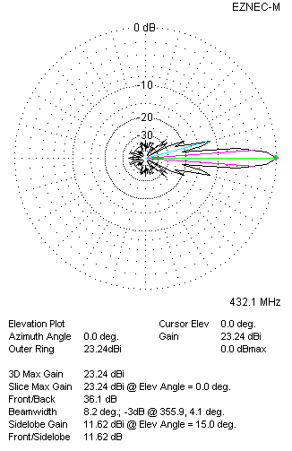
Two antennas stacked vertically
TWO ANTENNAS STACKED HORIZONTALLY
DISTANCE  (mm) |  |  | G  (dBi) |  |  | TA  (K) |  |  | Tloss  (K) |  |  |  | G/T  (dB)
2560 |  |  | 23.28 |  |  | 28.8 |  |  | 5.2 |  |  |  | +8.68
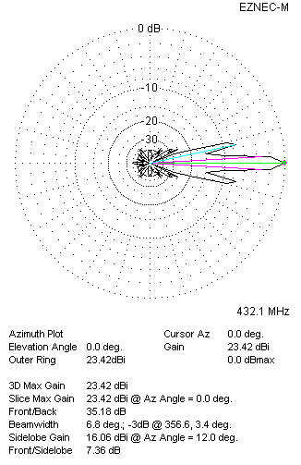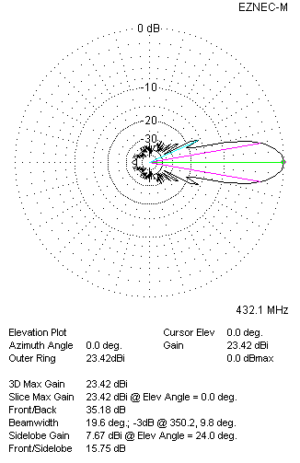
Two antennas stacked horizontally
FOUR ANTENNAS IN H-STACK
DISTANCE  (mm) |  |  | G  (dBi) |  |  | TA  (K) |  |  | Tloss  (K) |  |  |  | G/T  (dB)
H = 2560 |  |  | 26.20 |  |  | 28.1 |  |  | 5.2 |  |  |  | +11.71
V = 2060
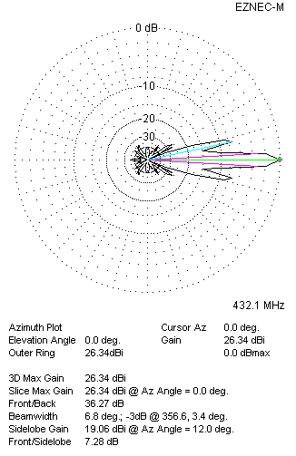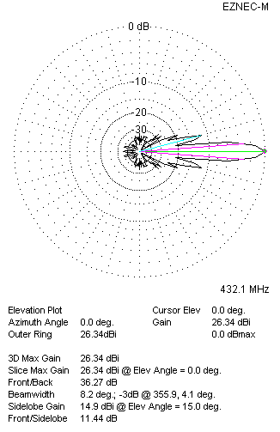
Four antennas in H-stack

