ANTENNA QY73105XL3D24
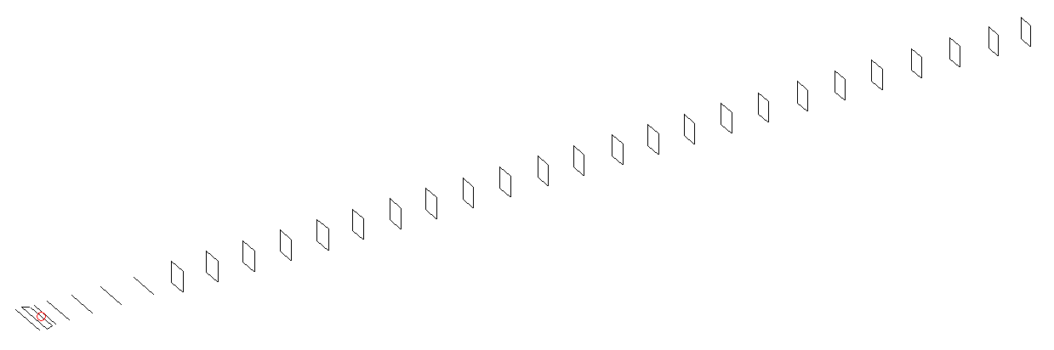
DESCRIPTION
Radiator |  |  | Number of  yagi elements |  |  | Number of  oblong elements |  |  |  | Total number  of elements |  |  | Boomlength  (mm)
LFA |  |  | 6 |  |  | 24 |  |  |  | 31 |  |  | 7935
DIMENSIONS
 | Ref | De1 |  | De2 | D1 |  | D2 | D3 | D4 |  | D5 | DQ1 |  | DQ2 | DQ3
Position | 0 | 50 |  | 105 | 140 |  | 244 | 434 | 665 |  | 925 | 1189 |  | 1464 | 1758
Length | 336 | 345 |  | 296 | 310 |  | 310 | 300 | 293.5 |  | 287.5 | 172 |  | 163 | 161
 | DQ4 | DQ5 |  | DQ6 | DQ7 |  | DQ8 | DQ9 | DQ10 |  | DQ11 | DQ12 |  | DQ13 | DQ14
Position | 2052 | 2344 |  | 2628 | 2924 |  | 3208 | 3502 | 3799 |  | 4098 | 4382 |  | 4688 | 4972
Length | 158 | 158 |  | 156 | 155 |  | 153 | 150 | 149 |  | 149 | 150 |  | 150 | 150
 | DQ15 | DQ16 |  | DQ17 | DQ18 |  | DQ19 | DQ20 | DQ21 |  | DQ22 | DQ23 |  | DQ24
Position | 5262 | 5558 |  | 5852 | 6162 |  | 6460 | 6754 | 7068 |  | 7372 | 7678 |  | 7935
Length | 150 | 150 |  | 145 | 143 |  | 143 | 143 | 133 |  | 133 | 131 |  | 131

Remark | All elements made of Al tubes Ǿ5 mm  The height of rectangles is 170 mm  All dimensions given in milimetres
PERFORMANCES (No loss condition)
G  (dBi) |  | F/B  (dB) |  | F/Sh  (dBi) | F/Sv  (dBi) |  | Hor  (◦) |  |  | Ver  (◦) | Temp  (◦K) |  |  | G/T  (dB)
20.26 |  | 37.16 |  | 16.65 | 15.15 |  | 19.6 |  |  | 19.6 | 24.1 |  |  | +7.21
DIAGRAMS
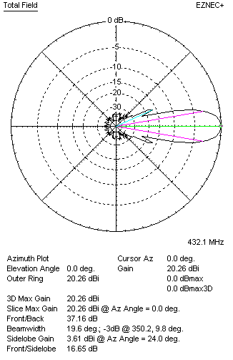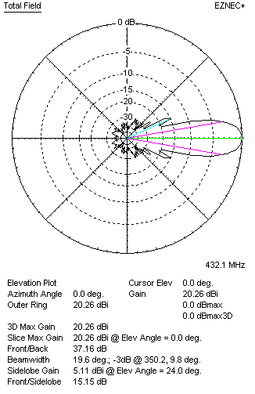
Horizontal and verticall pattern in free space, no loss condition
PERFORMANCES (Loss included for aluminum)
Aluminum |  |  |  | G  (dBi) | Tloss  (K) |  | T_{A}  (◦K) |  |  | G/T  (dB) | Bandwidth for SWR=1.5  (MHz)
After NEC/EZNEC |  |  |  | 20.18 | 5.7 |  | 24.2 |  |  | +6.06 | 423.600 – 438.200
After KF2YN correction |  |  |  | 20.11 | 5.7 |  | 29.3 |  |  | +5.44
Remark: Red coloured data are the final antenna data, which means: KF2YN correction formula applied and loss for aluminum included
DIAGRAMS
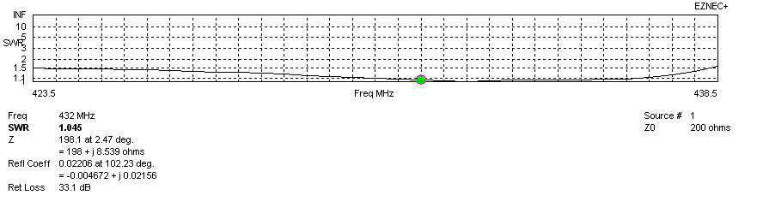
Frequency diagram for SWR better than 1.5
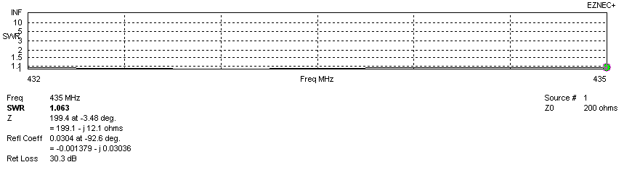
SWR diagram for the range from 432.000 – 435.000 MHz
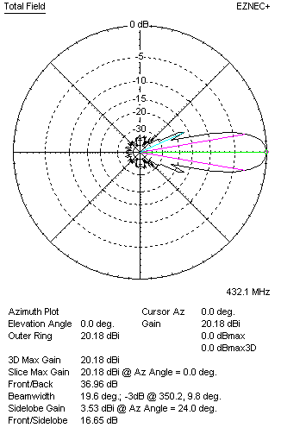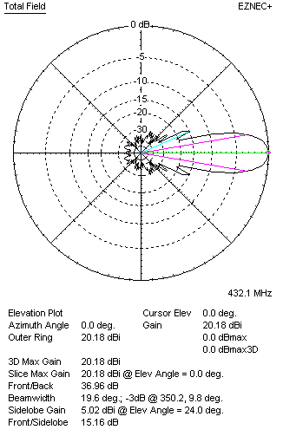
Horizontal and vertical pattern in free space, loss included for aluminum
STACKING
(ALL DATA GIVEN IN ACCORDANCE WITH KF2YN CORRECTION, LOSS INCLUDED)
RECOMMENDED STACKING DISTANCES
 |  |  |  | Two antennas vertically  (mm) |  |  | Two antennas horizontally  (mm) |  |  |  | Four antennas in H-stack  (mm)
Horizontal distance |  |  |  |  |  |  | 2560 |  |  |  | 2560
Vertical distance |  |  |  | 2060 |  |  |  |  |  |  | 2060
TWO ANTENNAS STACKED VERTICALLY
DISTANCE  (mm) |  |  | G  (dBi) |  |  | TA  (K) |  | Tloss  (K) |  |  |  | G/T  (dB)
2060 |  |  | 23.02 |  |  | 28.9 |  | 5.7 |  |  |  | +8.42
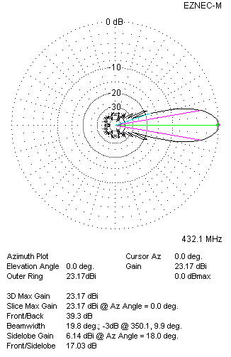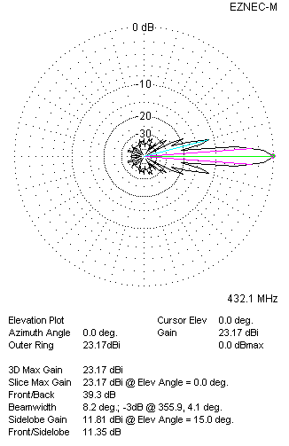
Two antennas stacked vertically
TWO ANTENNAS STACKED HORIZONTALLY
DISTANCE  (mm) |  |  | G  (dBi) |  |  | TA  (K) |  |  | Tloss  (K) |  |  |  | G/T  (dB)
2560 |  |  | 23.00 |  |  | 29.2 |  |  | 5.7 |  |  |  | +8.36
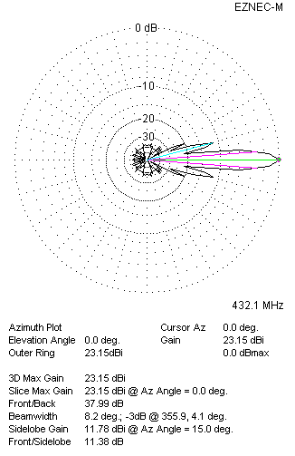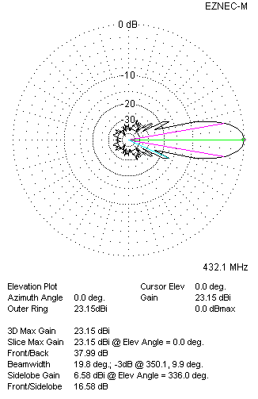
Two antennas stacked horizontally
FOUR ANTENNAS IN H-STACK
DISTANCE  (mm) |  |  | G  (dBi) |  |  | TA  (K) |  |  | Tloss  (K) |  |  |  | G/T  (dB)
H = 2560 |  |  | 25.98 |  |  | 28.9 |  |  | 5.7 |  |  |  | +11.38
V = 2060
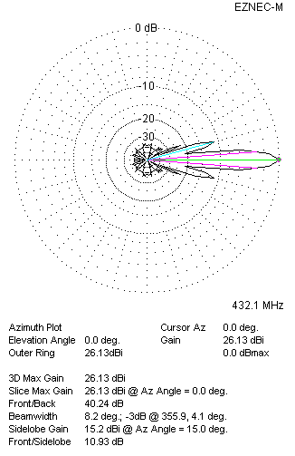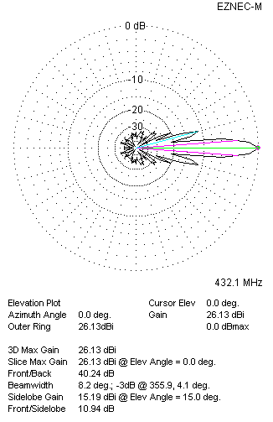
Four antennas in H-stack

