ANTENNA QY73008XL8D23
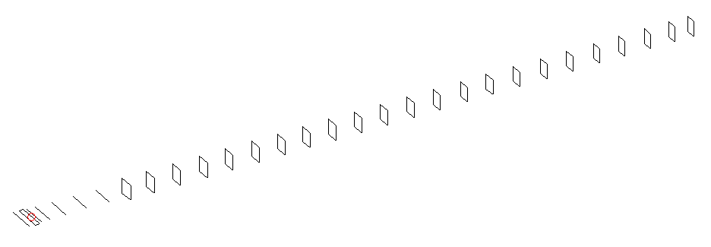
DESCRIPTION
Radiator |  |  | Number of  yagi elements |  |  | Number of  oblong elements |  |  |  | Total number  of elements |  |  | Boomlength  (mm)
LFA |  |  | 6 |  |  | 23 |  |  |  | 30 |  |  | 7615
DIMENSIONS
 | Ref | De1 |  | De2 | D1 |  | D2 | D3 | D4 |  | D5 | DQ1 |  | DQ2 | DQ3
Position | 0 | 55 |  | 111 | 148 |  | 242 | 424 | 653 |  | 905 | 1166 |  | 1452 | 1738
Length | 331 | 335 |  | 335 | 306 |  | 306 | 294.5 | 288.5 |  | 281.5 | 172 |  | 164 | 162
 | DQ4 | DQ5 |  | DQ6 | DQ7 |  | DQ8 | DQ9 | DQ10 |  | DQ11 | DQ12 |  | DQ13 | DQ14
Position | 2035 | 2326 |  | 2615 | 2914 |  | 3193 | 3488 | 3782 |  | 4085 | 4367 |  | 4665 | 4955
Length | 160 | 158 |  | 156 | 155 |  | 151 | 149 | 149 |  | 148 | 148 |  | 147 | 146
 | DQ15 | DQ16 |  | DQ17 | DQ18 |  | DQ19 | DQ20 | DQ21 |  | DQ22 | DQ23
Position | 5252 | 5540 |  | 5857 | 6136 |  | 6460 | 6749 | 7060 |  | 7365 | 7615
Length | 145 | 143 |  | 142 | 141 |  | 140 | 139 | 138 |  | 137 | 135

Remark | All elements made of Al tubes Ǿ8 mm  The height of rectangles is 170 mm  All dimensions given in milimetres
PERFORMANCES (No loss condition)
G  (dBi) |  | F/B  (dB) |  | F/Sh  (dBi) | F/Sv  (dBi) |  | Hor  (◦) |  |  | Ver  (◦) | Temp  (◦K) |  |  | G/T  (dB)
20.23 |  | 38.36 |  | 18.43 | 16.54 |  | 19.6 |  |  | 19.8 | 24.9 |  |  | +7.00
DIAGRAMS
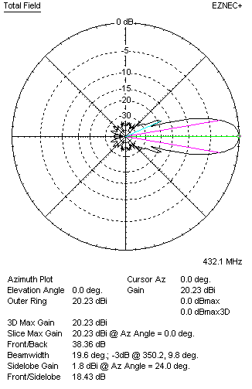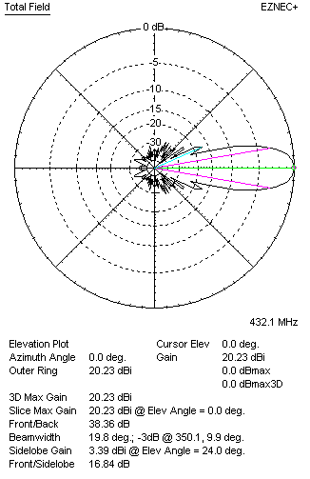
Horizontal and verticall pattern in free space, no loss condition
PERFORMANCES (Loss included for aluminum)
Aluminum |  |  |  | G  (dBi) | Tloss  (K) |  | T_{A}  (◦K) |  |  | G/T  (dB) | Bandwidth for SWR=1.5  (MHz)
After NEC/EZNEC |  |  |  | 20.17 | 4.6 |  | 24.9 |  |  | +6.15 | 424.900 – 437.800
After KF2YN correction |  |  |  | 20.10 | 4.6 |  | 29.1 |  |  | +5.46
Remark: Red coloured data are the final antenna data, which means: KF2YN correction formula applied and loss for aluminum included
DIAGRAMS
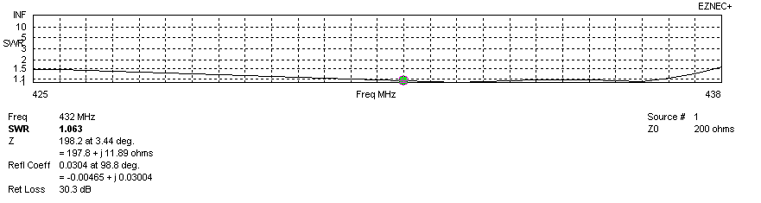
Frequency diagram for SWR better than 1.5
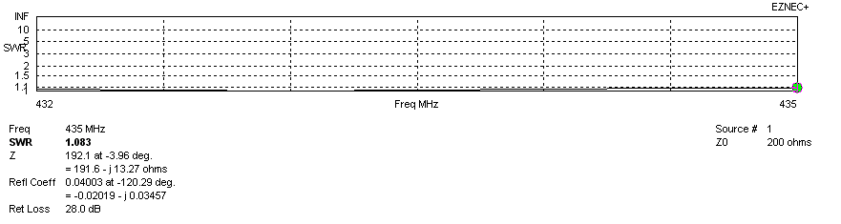
SWR diagram for the range from 432.000 – 435.000 MHz
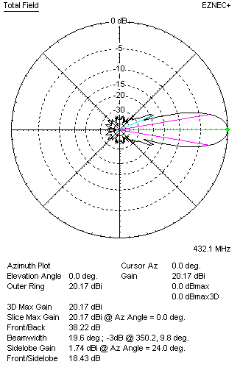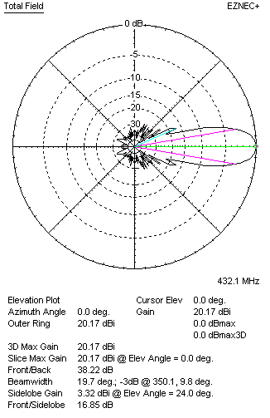
Horizontal and vertical pattern in free space, loss included for aluminum
STACKING
(ALL DATA GIVEN IN ACCORDANCE WITH KF2YN CORRECTION, LOSS INCLUDED)
RECOMMENDED STACKING DISTANCES
 |  |  |  | Two antennas vertically  (mm) |  |  | Two antennas horizontally  (mm) |  |  |  | Four antennas in H-stack  (mm)
Horizontal distance |  |  |  |  |  |  | 2560 |  |  |  | 2560
Vertical distance |  |  |  | 2420 |  |  |  |  |  |  | 2420
TWO ANTENNAS STACKED VERTICALLY
DISTANCE  (mm) |  |  | G  (dBi) |  |  | TA  (K) |  | Tloss  (K) |  |  |  | G/T  (dB)
2420 |  |  | 23.16 |  |  | 29.2 |  | 4.6 |  |  |  | +8.51
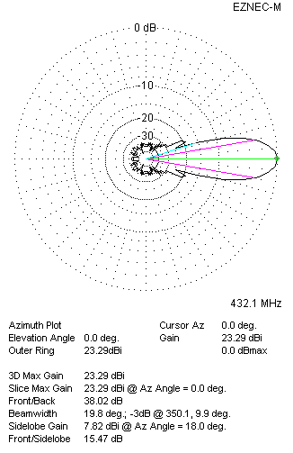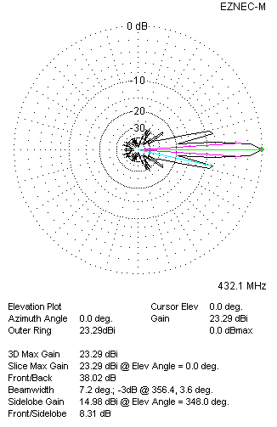
Two antennas stacked vertically
TWO ANTENNAS STACKED HORIZONTALLY
DISTANCE  (mm) |  |  | G  (dBi) |  |  | TA  (K) |  |  | Tloss  (K) |  |  |  | G/T  (dB)
2560 |  |  | 23.18 |  |  | 28.8 |  |  | 4.6 |  |  |  | +8.59
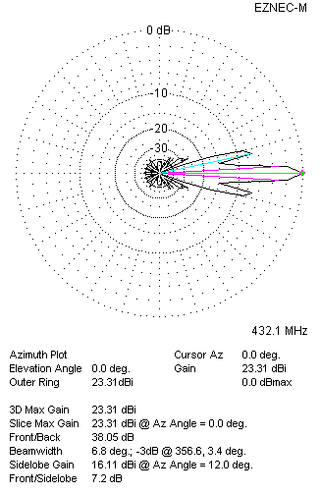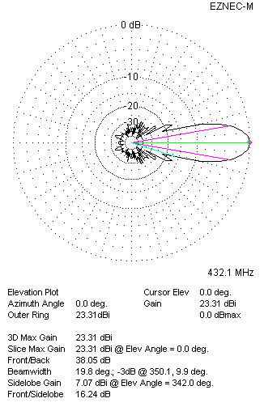
Two antennas stacked horizontally
FOUR ANTENNAS IN H-STACK
DISTANCE  (mm) |  |  | G  (dBi) |  |  | TA  (K) |  |  | Tloss  (K) |  |  |  | G/T  (dB)
H = 2560 |  |  | 26.05 |  |  | 28.7 |  |  | 4.6 |  |  |  | +11.47
V = 2420
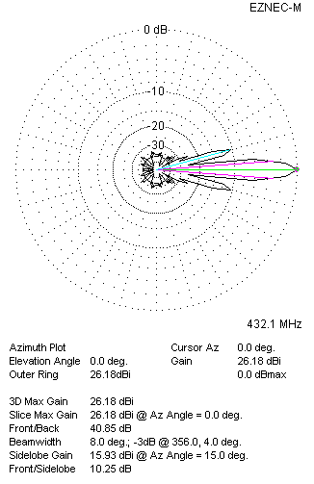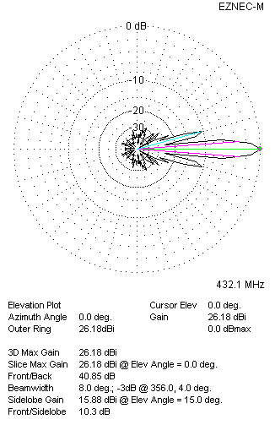
Four antennas in H-stack

