ANTENNA QY72908XL7D22
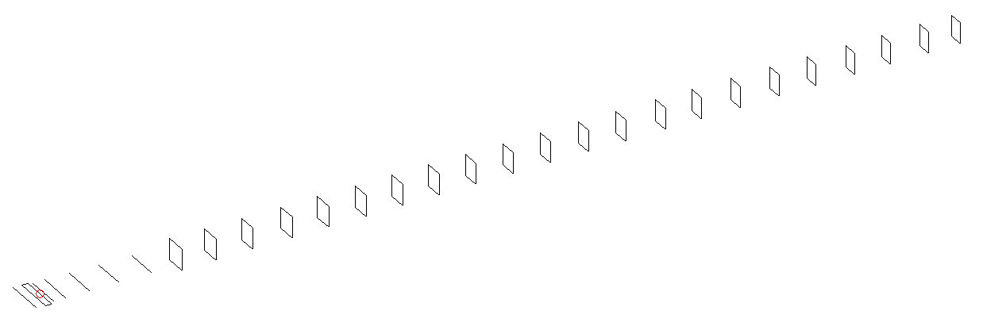
DESCRIPTION
Radiator |  |  | Number of  yagi elements |  |  | Number of  oblong elements |  |  | Total number  of elements |  |  | Boomlength  (mm)
LFA |  |  | 6 |  |  | 22 |  |  | 29 |  |  | 7315
DIMENSIONS
 | Ref | De1 |  | De2 | D1 |  | D2 | D3 |  | D4 | D5 |  | DQ1 | DQ2
Position | 0 | 55 |  | 111 | 148 |  | 240 | 425 |  | 653 | 905 |  | 1168 | 1452
Length | 331 | 335 |  | 335 | 306 |  | 306 | 294 |  | 288 | 281 |  | 173 | 164
 | DQ3 | DQ4 |  | DQ5 | DQ6 |  | DQ7 | DQ8 |  | DQ9 | DQ10 |  | DQ11 | DQ12
Position | 1738 | 2035 |  | 2326 | 2615 |  | 2914 | 3193 |  | 3488 | 3782 |  | 4085 | 4367
Length | 161 | 159 |  | 158 | 156 |  | 155 | 151 |  | 149 | 149 |  | 148 | 148
 | DQ13 | DQ14 |  | DQ15 | DQ16 |  | DQ17 | DQ18 |  | DQ19 | DQ20 |  | DQ21 | DQ22
Position | 4665 | 4955 |  | 5252 | 5540 |  | 5857 | 6142 |  | 6454 | 6746 |  | 7054 | 7315
Length | 147 | 145 |  | 145 | 145 |  | 141 | 141 |  | 139 | 139 |  | 139 | 133

Remark | All elements made of Al tubes Ǿ8 mm  The height of rectangles is 170 mm  All dimensions given in milimetres
PERFORMANCES (No loss condition)
G  (dBi) |  | F/B  (dB) |  | F/Sh  (dBi) | F/Sv  (dBi) |  | Hor  (◦) |  |  | Ver  (◦) | Temp  (◦K) |  |  | G/T  (dB)
20.09 |  | 32.06 |  | 18.58 | 16.83 |  | 19.8 |  |  | 20.0 | 25.1 |  |  | +6.81
DIAGRAMS
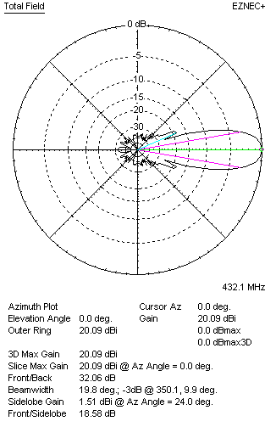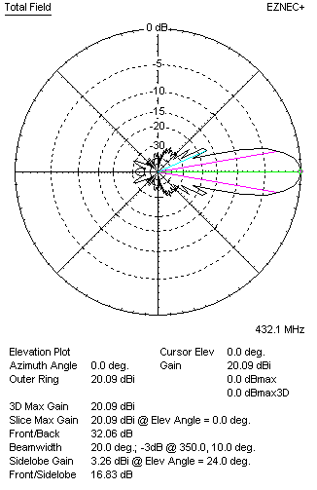
Horizontal and verticall pattern in free space, no loss condition
PERFORMANCES (Loss included for aluminum)
Aluminum |  |  |  | G  (dBi) | Tloss  (K) |  | T_{A}  (◦K) |  |  | G/T  (dB) | Bandwidth for SWR=1.5  (MHz)
After NEC/EZNEC |  |  |  | 20.03 | 4.3 |  | 25.1 |  |  | +5.98 | 424.800 – 437.800
After KF2YN correction |  |  |  | 19.96 | 4.3 |  | 29.0 |  |  | +5.34
Remark: Red coloured data are the final antenna data, which means: KF2YN correction formula applied and loss for aluminum included
DIAGRAMS
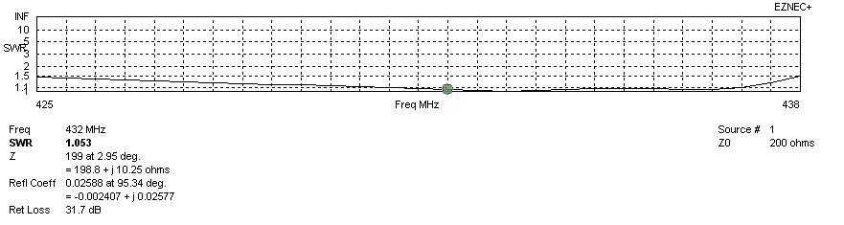
Frequency diagram for SWR better than 1.5
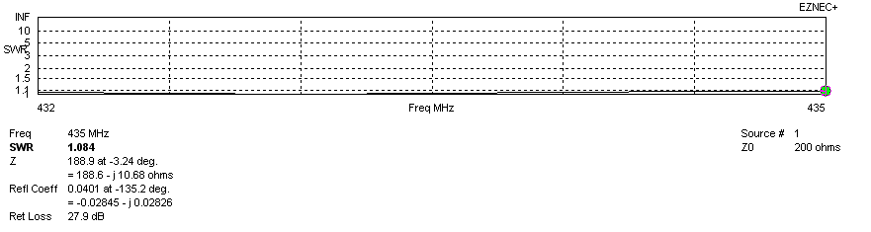
SWR diagram for the range from 432.000 – 435.000 MHz
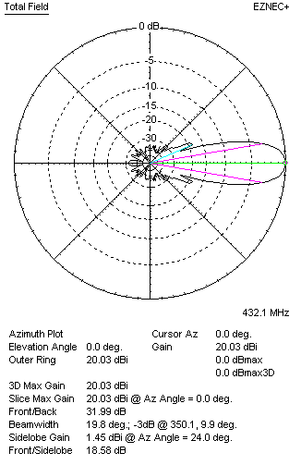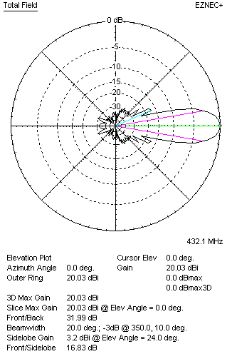
Horizontal and vertical pattern in free space, loss included for aluminum
STACKING
(ALL DATA GIVEN IN ACCORDANCE WITH KF2YN CORRECTION, LOSS INCLUDED)
RECOMMENDED STACKING DISTANCES
 |  |  |  | Two antennas vertically  (mm) |  |  | Two antennas horizontally  (mm) |  |  |  | Four antennas in H-stack  (mm)
Horizontal distance |  |  |  |  |  |  | 2480 |  |  |  | 2480
Vertical distance |  |  |  | 2080 |  |  |  |  |  |  | 2080
TWO ANTENNAS STACKED VERTICALLY
DISTANCE  (mm) |  |  | G  (dBi) |  |  | TA  (K) |  | Tloss  (K) |  |  |  | G/T  (dB)
2080 |  |  | 22.92 |  |  | 28.3 |  | 4.3 |  |  |  | +8.40
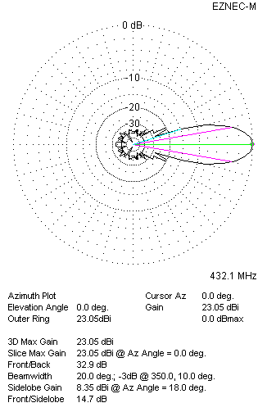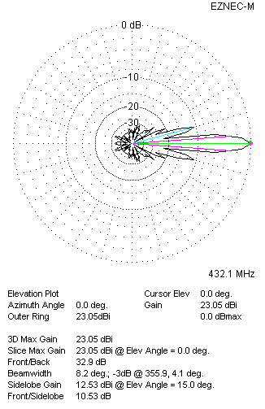
Two antennas stacked vertically
TWO ANTENNAS STACKED HORIZONTALLY
DISTANCE  (mm) |  |  | G  (dBi) |  |  | TA  (K) |  |  | Tloss  (K) |  |  |  | G/T  (dB)
2480 |  |  | 23.03 |  |  | 28.9 |  |  | 4.3 |  |  |  | +8.42
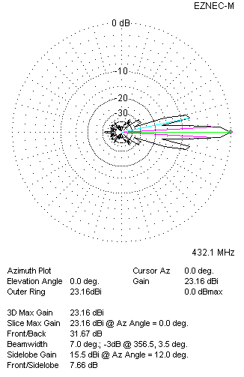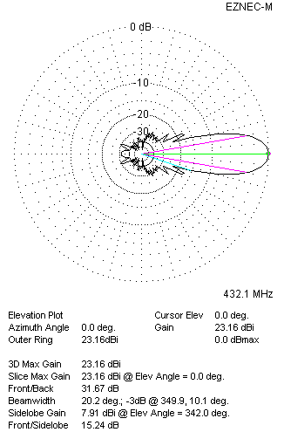
Two antennas stacked horizontally
FOUR ANTENNAS IN H-STACK
DISTANCE  (mm) |  |  | G  (dBi) |  |  | TA  (K) |  |  | Tloss  (K) |  |  |  | G/T  (dB)
H = 2480 |  |  | 26.00 |  |  | 28.1 |  |  | 4.3 |  |  |  | +11.51
V = 2080
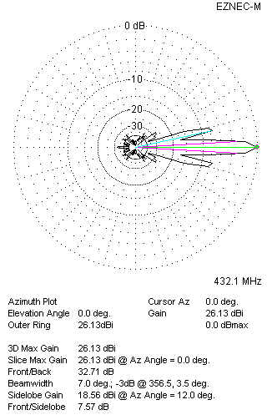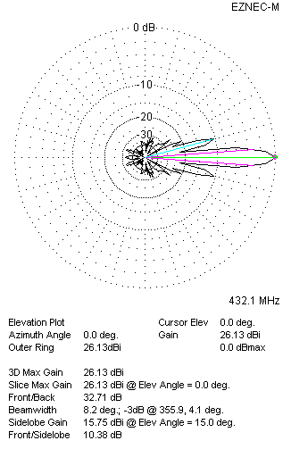
Four antennas in H-stack

