ANTENNA QY72905L617
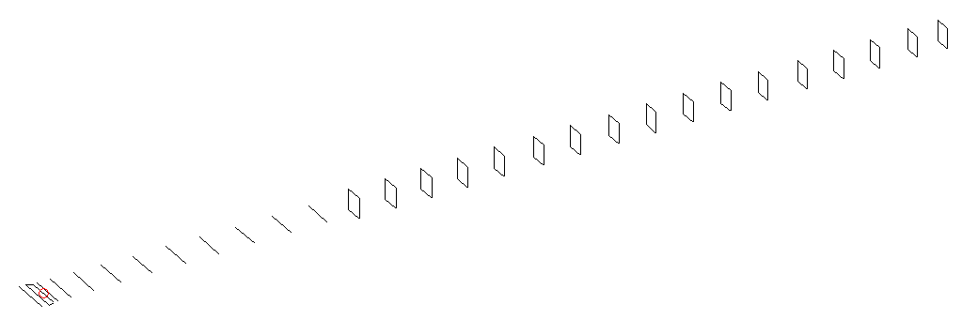
DESCRIPTION
Radiator |  |  | Number of  yagi elements |  |  | Number of  oblong elements |  |  | Total number  of elements |  |  | Boomlength  (mm)
LFA |  |  | 11 |  |  | 17 |  |  | 29 |  |  | 7425
DIMENSIONS
 | Ref | De1 |  | De2 | D1 |  | D2 | D3 |  | D4 | D5 |  | D6 | D7
Position | 0 | 55 |  | 105 | 137 |  | 239 | 431 |  | 660 | 912 |  | 1186 | 1458
Length | 335 | 342 |  | 304 | 310.5 |  | 311 | 301 |  | 295 | 289.5 |  | 287 | 283.5
 | D8 | D9 |  | D10 | DQ1 |  | DQ2 | DQ3 |  | DQ4 | DQ5 |  | DQ6 | DQ7
Position | 1747 | 2039 |  | 2339 | 2631 |  | 2932 | 3221 |  | 3519 | 3821 |  | 4137 | 4444
Length | 279.5 | 276.5 |  | 273 | 161 |  | 157 | 156 |  | 155 | 151 |  | 149 | 147
 | DQ8 | DQ9 |  | DQ10 | DQ11 |  | DQ12 | DQ13 |  | DQ14 | DQ15 |  | DQ16 | DQ17
Position | 4749 | 5051 |  | 5362 | 5654 |  | 5958 | 6268 |  | 6572 | 6882 |  | 7164 | 7425
Length | 145 | 145 |  | 143 | 139 |  | 137 | 135 |  | 133 | 133 |  | 133 | 128

Remark | All elements made of Al tubes Ǿ5 mm  The height of rectangles is 170 mm  All dimensions given in milimetres
PERFORMANCES (No loss condition)
G  (dBi) |  | F/B  (dB) |  | F/Sh  (dBi) | F/Sv  (dBi) |  | Hor  (◦) |  |  | Ver  (◦) | Temp  (◦K) |  |  | G/T  (dB)
19.91 |  | 43.36 |  | 20.33 | 19.18 |  | 20.6 |  |  | 21.0 | 23.4 |  |  | +7.27
DIAGRAMS
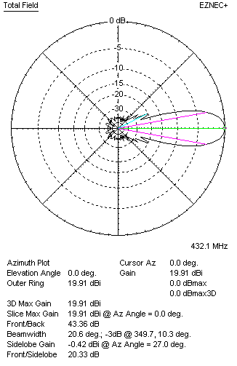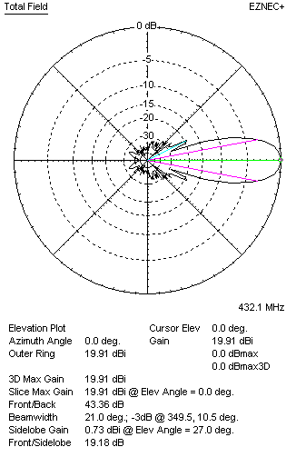
Horizontal and verticall pattern in free space, no loss condition
PERFORMANCES (Loss included for aluminum)
Aluminum |  |  |  | G  (dBi) | Tloss  (K) |  | T_{A}  (◦K) |  |  | G/T  (dB) | Bandwidth for SWR=1.5  (MHz)
After NEC/EZNEC |  |  |  | 19.82 | 6.3 |  | 23.4 |  |  | +5.91 | 425.000 – 437.000
After KF2YN correction |  |  |  | 19.74 | 6.3 |  | 29.2 |  |  | +5.09
Remark: Red coloured data are the final antenna data, which means: KF2YN correction formula applied and loss for aluminum included
DIAGRAMS
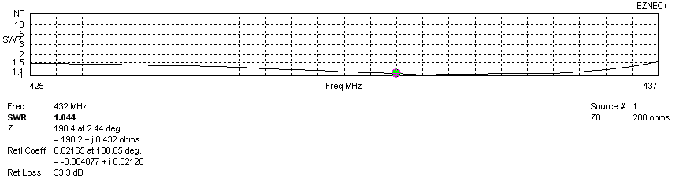
Frequency diagram for SWR better than 1.5
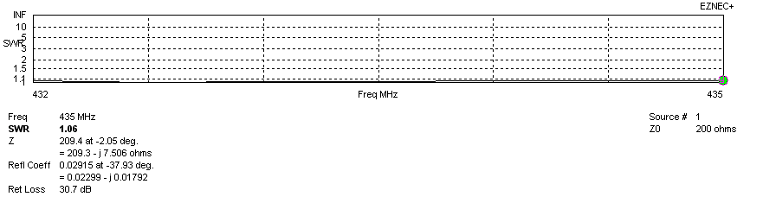
SWR diagram for the range from 432.000 – 435.000 MHz
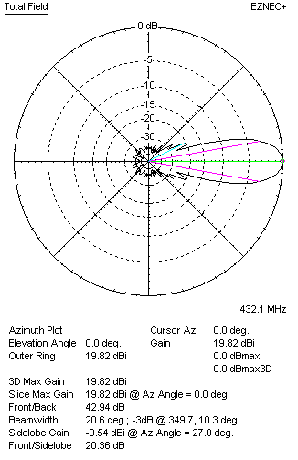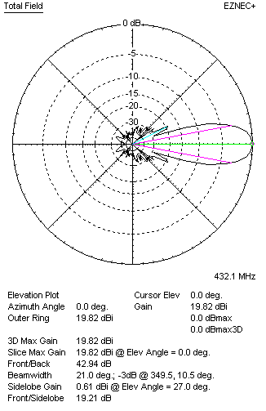
Horizontal and vertical pattern in free space, loss included for aluminum
STACKING
(ALL DATA GIVEN IN ACCORDANCE WITH KF2YN CORRECTION, LOSS INCLUDED)
RECOMMENDED STACKING DISTANCES
 |  |  |  | Two antennas vertically  (mm) |  |  | Two antennas horizontally  (mm) |  |  |  | Four antennas in H-stack  (mm)
Horizontal distance |  |  |  |  |  |  | 2580 |  |  |  | 2580
Vertical distance |  |  |  | 2140 |  |  |  |  |  |  | 2140
TWO ANTENNAS STACKED VERTICALLY
DISTANCE  (mm) |  |  | G  (dBi) |  |  | TA  (K) |  | Tloss  (K) |  |  |  | G/T  (dB)
2140 |  |  | 22.74 |  |  | 29.0 |  | 6.3 |  |  |  | +8.12
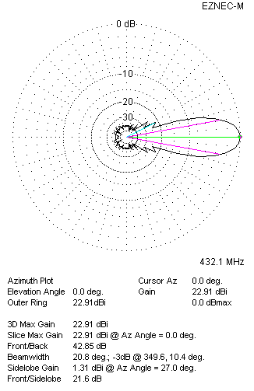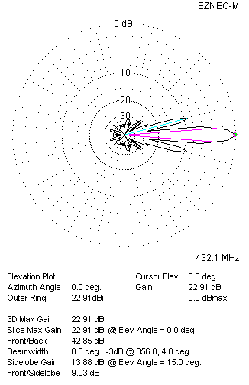
Two antennas stacked vertically
TWO ANTENNAS STACKED HORIZONTALLY
DISTANCE  (mm) |  |  | G  (dBi) |  |  | TA  (K) |  |  | Tloss  (K) |  |  |  | G/T  (dB)
2580 |  |  | 22.80 |  |  | 29.1 |  |  | 6.3 |  |  |  | +8.16
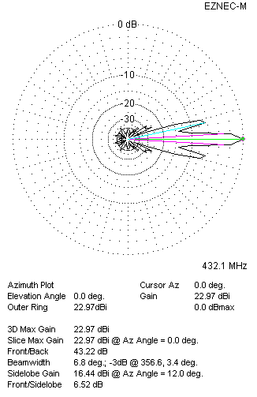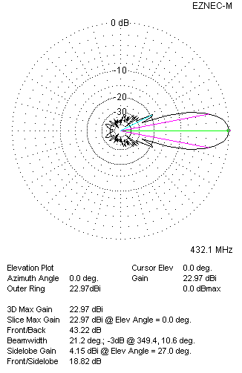
Two antennas stacked horizontally
FOUR ANTENNAS IN H-STACK
DISTANCE  (mm) |  |  | G  (dBi) |  |  | TA  (K) |  |  | Tloss  (K) |  |  |  | G/T  (dB)
H = 2580 |  |  | 25.74 |  |  | 28.9 |  |  | 6.3 |  |  |  | +11.13
V = 2140
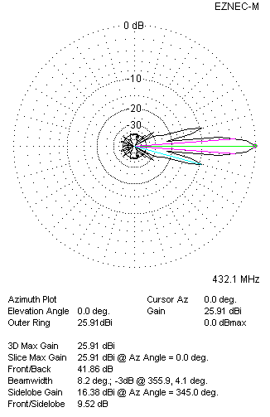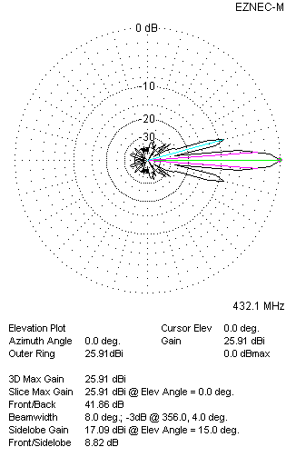
Four antennas in H-stack

