ANTENNA QY72810XL2D21
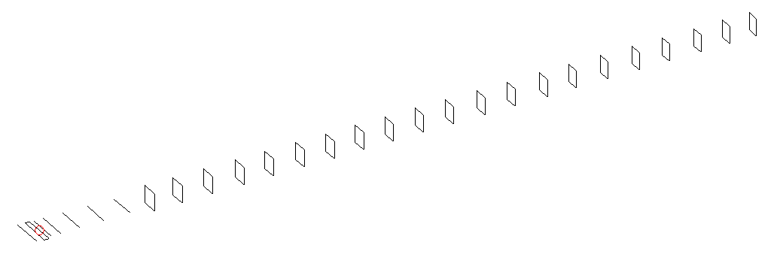
DESCRIPTION
Radiator |  |  | Number of  yagi elements |  |  | Number of  oblong elements |  |  | Total number  of elements |  |  | Boomlength  (mm)
LFA |  |  | 6 |  |  | 21 |  |  | 28 |  |  | 7125
DIMENSIONS
 | Ref | De1 |  | De2 | D1 |  | D2 | D3 |  | D4 | D5 |  | DQ1 | DQ2
Position | 0 | 70 |  | 120 | 152 |  | 246 | 436 |  | 672 | 932 |  | 1204 | 1478
Length | 331 | 326 |  | 326 | 295 |  | 301.5 | 289.5 |  | 282 | 274.5 |  | 171 | 163
 | DQ3 | DQ4 |  | DQ5 | DQ6 |  | DQ7 | DQ8 |  | DQ9 | DQ10 |  | DQ11 | DQ12
Position | 1775 | 2086 |  | 2378 | 2678 |  | 2972 | 3262 |  | 3556 | 3852 |  | 4148 | 4454
Length | 157 | 157 |  | 155 | 153 |  | 151 | 149 |  | 147 | 145 |  | 143 | 141
 | DQ13 | DQ14 |  | DQ15 | DQ16 |  | DQ17 | DQ18 |  | DQ19 | DQ20 |  | DQ21
Position | 4752 | 5068 |  | 5356 | 5666 |  | 5976 | 6272 |  | 6582 | 6866 |  | 7125
Length | 139 | 137 |  | 135 | 131 |  | 127 | 127 |  | 125 | 125 |  | 121

Remark | All elements made of Al tubes Ǿ10 mm  The height of rectangles is 170 mm  All dimensions given in milimetres
PERFORMANCES (No loss condition)
G  (dBi) |  | F/B  (dB) |  | F/Sh  (dBi) | F/Sv  (dBi) |  | Hor  (◦) |  |  | Ver  (◦) | Temp  (◦K) |  |  | G/T  (dB)
19.66 |  | 35.46 |  | 21.20 | 18.78 |  | 21.4 |  |  | 21.6 | 23.6 |  |  | +6.58
DIAGRAMS
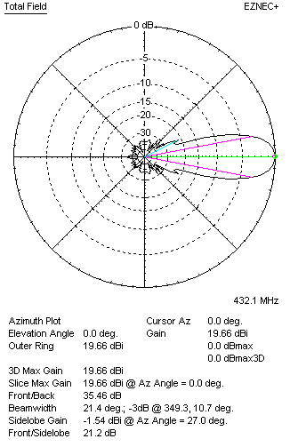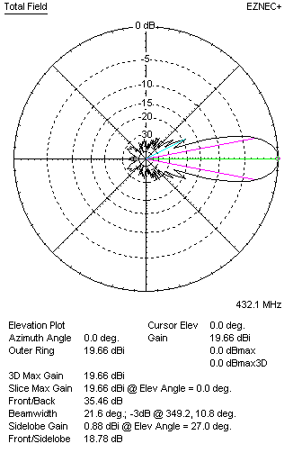
Horizontal and verticall pattern in free space, no loss condition
PERFORMANCES (Loss included for aluminum)
Aluminum |  |  |  | G  (dBi) | Tloss  (K) |  | T_{A}  (◦K) |  |  | G/T  (dB) | Bandwidth for SWR=1.5  (MHz)
After NEC/EZNEC |  |  |  | 19.62 | 3.2 |  | 23.6 |  |  | +5.93 | 427.000 – 437.600
After KF2YN correction |  |  |  | 19.45 | 3.2 |  | 26.7 |  |  | +5.19
Remark: Red coloured data are the final antenna data, which means: KF2YN correction formula applied and loss for aluminum included
DIAGRAMS
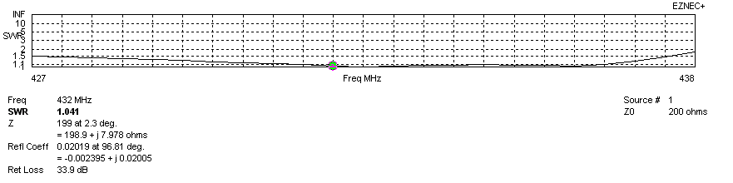
Frequency diagram for SWR better than 1.5
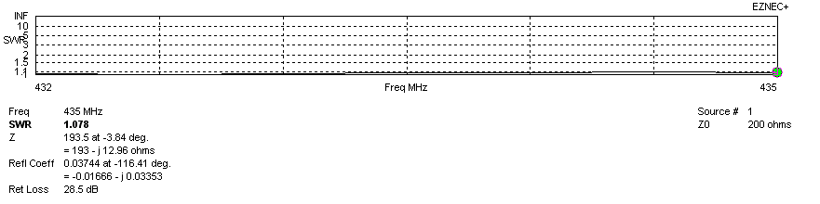
SWR diagram for the range from 432.000 – 435.000 MHz
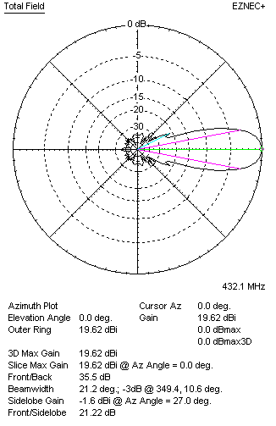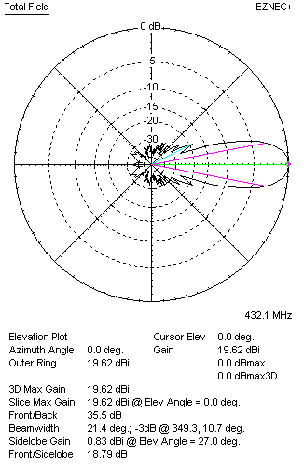
Horizontal and vertical pattern in free space, loss included for aluminum
STACKING
(ALL DATA GIVEN IN ACCORDANCE WITH KF2YN CORRECTION, LOSS INCLUDED)
RECOMMENDED STACKING DISTANCES
 |  |  |  | Two antennas vertically  (mm) |  |  | Two antennas horizontally  (mm) |  |  |  | Four antennas in H-stack  (mm)
Horizontal distance |  |  |  |  |  |  | 2580 |  |  |  | 2580
Vertical distance |  |  |  | 2020 |  |  |  |  |  |  | 2020
TWO ANTENNAS STACKED VERTICALLY
DISTANCE  (mm) |  |  | G  (dBi) |  |  | TA  (K) |  | Tloss  (K) |  |  |  | G/T  (dB)
2020 |  |  | 22.53 |  |  | 26.10 |  | 3.2 |  |  |  | +8.36
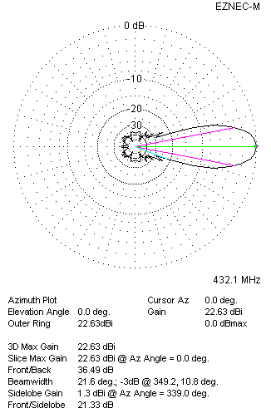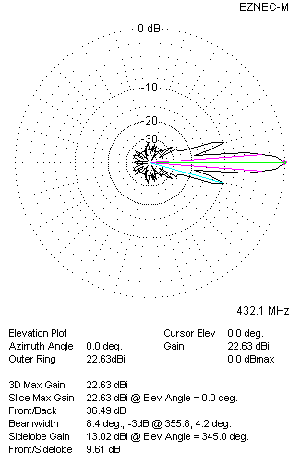
Two antennas stacked vertically
TWO ANTENNAS STACKED HORIZONTALLY
DISTANCE  (mm) |  |  | G  (dBi) |  |  | TA  (K) |  |  | Tloss  (K) |  |  |  | G/T  (dB)
2580 |  |  | 22.63 |  |  | 26.3 |  |  | 3.2 |  |  |  | +8.43
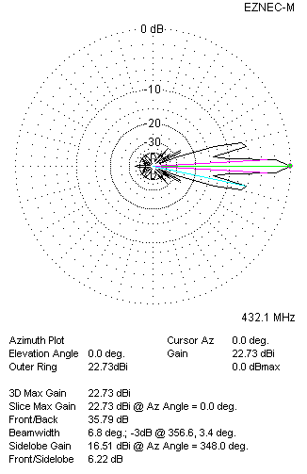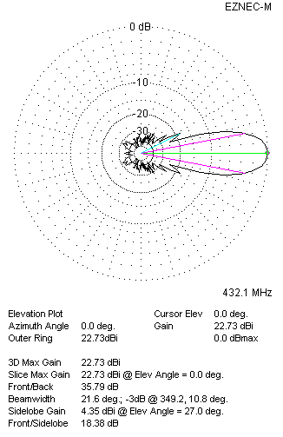
Two antennas stacked horizontally
FOUR ANTENNAS IN H-STACK
DISTANCE  (mm) |  |  | G  (dBi) |  |  | TA  (K) |  |  | Tloss  (K) |  |  |  | G/T  (dB)
H = 2580 |  |  | 25.52 |  |  | 26.1 |  |  | 3.2 |  |  |  | +11.35
V = 2020
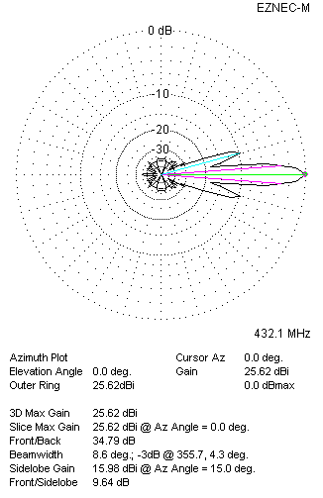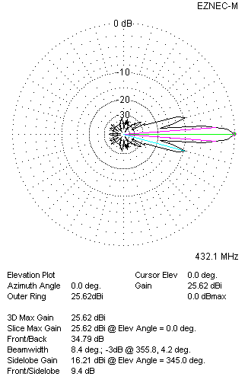
Four antennas in H-stack

