ANTENNA QY72706XL1D15
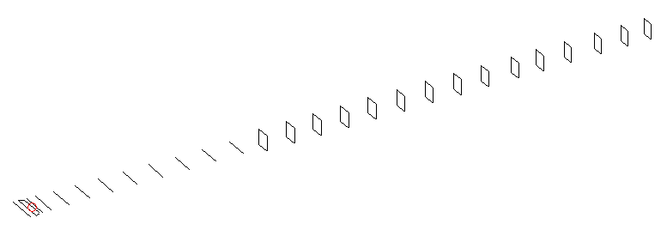
DESCRIPTION
Radiator |  |  | Number of  yagi elements |  |  |  | Number of  oblong elements |  |  |  | Total number  of elements |  |  |  | Boomlength  (mm)
LFA |  |  | 11 |  |  |  | 15 |  |  |  | 27 |  |  |  | 6825
DIMENSIONS
 | Ref | De1 |  | De2 | D1 | D2 |  | D3 | D4 | D5 |  | D6 | D7 | D8 |  | D9 | D10 | DQ1
Position | 0 | 55 |  | 105 | 138 | 243 |  | 434 | 658 | 911 |  | 1184 | 1456 | 1746 |  | 2045 | 2342 | 2634
Length | 334 | 342 |  | 296 | 304 | 307 |  | 297.5 | 291 | 285 |  | 283 | 278.5 | 275 |  | 272.5 | 268.5 | 159
 | DQ2 | DQ3 |  | DQ4 | DQ5 | DQ6 |  | DQ7 | DQ8 | DQ9 |  | DQ10 | DQ11 | DQ12 |  | DQ13 | DQ14 | DQ15
Position | 2932 | 3221 |  | 3519 | 3818 | 4138 |  | 4436 | 4752 | 5052 |  | 5354 | 5662 | 5962 |  | 6284 | 6582 | 6825
Length | 157 | 155 |  | 151 | 147 | 145 |  | 141 | 141 | 141 |  | 141 | 135 | 135 |  | 135 | 135 | 131

Remark | All elements made of Al tubes Ǿ6 mm  The height of rectangles is 170 mm  All dimensions given in milimetres
PERFORMANCES (No loss condition)
G  (dBi) |  | F/B  (dB) |  | F/Sh  (dBi) | F/Sv  (dBi) |  | Hor  (◦) |  |  | Ver  (◦) | Temp  (◦K) |  |  | G/T  (dB)
19.55 |  | 33.31 |  | 19.51 | 18.44 |  | 21.4 |  |  | 21.8 | 24.6 |  |  | +6.52
DIAGRAMS
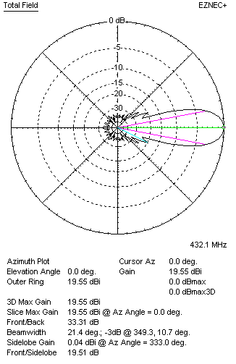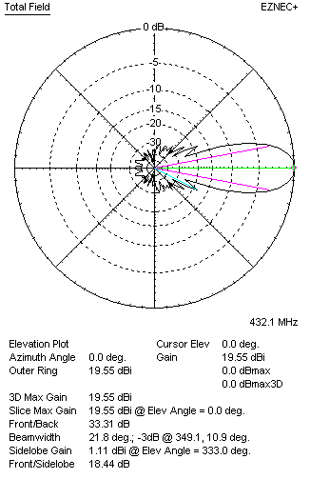
Horizontal and verticall pattern in free space, no loss condition
PERFORMANCES (Loss included for aluminum)
Aluminum |  |  |  | G  (dBi) | Tloss  (K) |  | T_{A}  (◦K) |  |  | G/T  (dB) | Bandwidth for SWR=1.5  (MHz)
After NEC/EZNEC |  |  |  | 19.49 | 4.6 |  | 24.6 |  |  | +5.62 | 423.700 – 438.300
After KF2YN correction |  |  |  | 19.41 | 4.6 |  | 28.8 |  |  | +4.82
Remark: Red coloured data are the final antenna data, which means: KF2YN correction formula applied and loss for aluminum included
DIAGRAMS
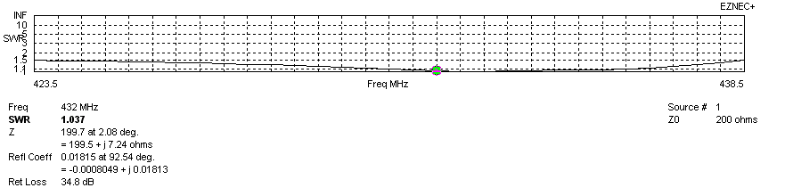
Frequency diagram for SWR better than 1.5
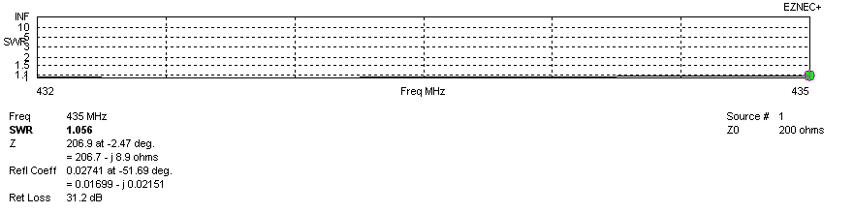
SWR diagram for the range from 432.000 – 435.000 MHz
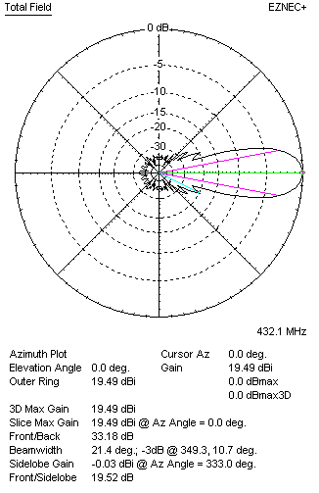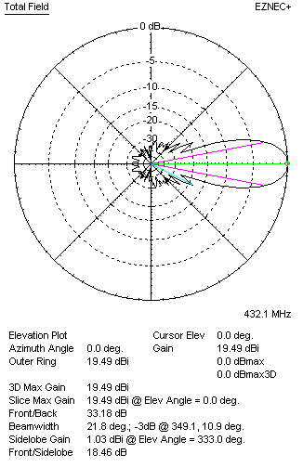
Horizontal and vertical pattern in free space, loss included for aluminum
STACKING
(ALL DATA GIVEN IN ACCORDANCE WITH KF2YN CORRECTION, LOSS INCLUDED)
RECOMMENDED STACKING DISTANCES
 |  |  |  | Two antennas vertically  (mm) |  |  | Two antennas horizontally  (mm) |  |  |  | Four antennas in H-stack  (mm)
Horizontal distance |  |  |  |  |  |  | 2560 |  |  |  | 2560
Vertical distance |  |  |  | 1900 |  |  |  |  |  |  | 1900
TWO ANTENNAS STACKED VERTICALLY
DISTANCE  (mm) |  |  | G  (dBi) |  |  | TA  (K) |  | Tloss  (K) |  |  |  | G/T  (dB)
1900 |  |  | 22.33 |  |  | 28.1 |  | 4.6 |  |  |  | +7.84
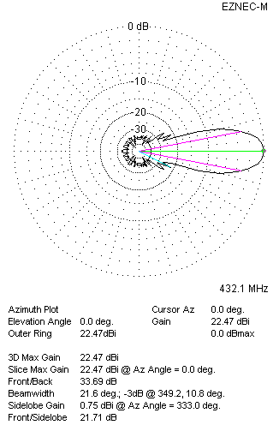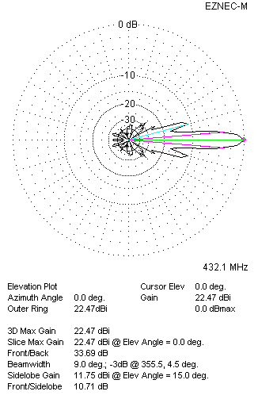
Two antennas stacked vertically
TWO ANTENNAS STACKED HORIZONTALLY
DISTANCE  (mm) |  |  | G  (dBi) |  |  | TA  (K) |  |  | Tloss  (K) |  |  |  | G/T  (dB)
2560 |  |  | 22.48 |  |  | 28.6 |  |  | 4.6 |  |  |  | +7.92
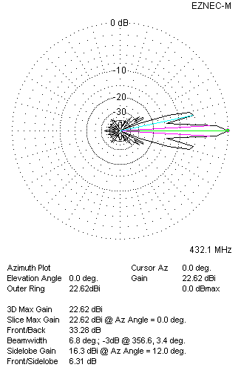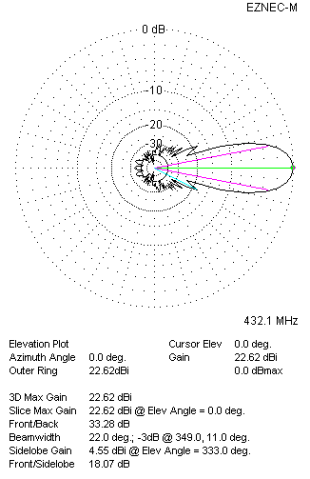
Two antennas stacked horizontally
FOUR ANTENNAS IN H-STACK
DISTANCE  (mm) |  |  | G  (dBi) |  |  | TA  (K) |  |  | Tloss  (K) |  |  |  | G/T  (dB)
H = 2560 |  |  | 25.34 |  |  | 28.1 |  |  | 4.6 |  |  |  | +10.85
V = 1900
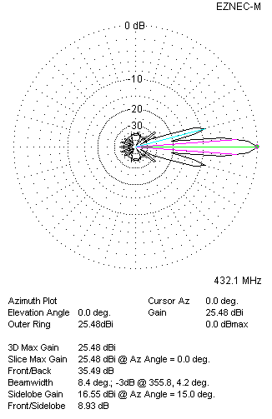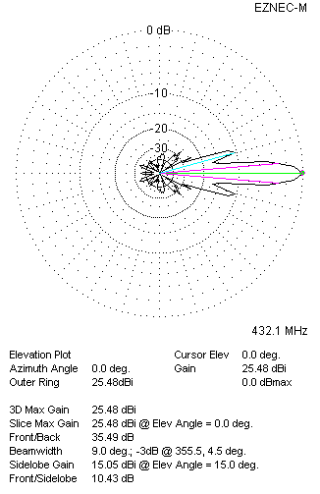
Four antennas in H-stack

