ANTENNA QY72705XL1D15
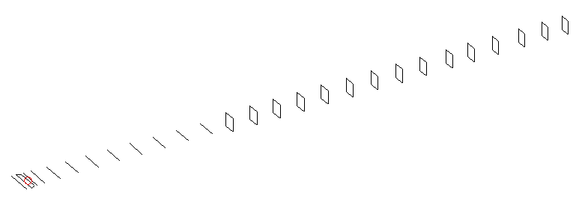
DESCRIPTION
Radiator |  |  | Number of  yagi elements |  |  |  | Number of  oblong elements |  |  |  | Total number  of elements |  |  |  | Boomlength  (mm)
LFA |  |  | 11 |  |  |  | 15 |  |  |  | 27 |  |  |  | 6825
DIMENSIONS
 | Ref | De1 |  | De2 | D1 | D2 |  | D3 | D4 | D5 |  | D6 | D7 | D8 |  | D9 | D10 | DQ1
Position | 0 | 60 |  | 110 | 140 | 239 |  | 434 | 664 | 918 |  | 1182 | 1463 | 1752 |  | 2048 | 2343 | 2632
Length | 334 | 341 |  | 292 | 310 | 311 |  | 301 | 295 | 290 |  | 287 | 282.5 | 279 |  | 276 | 273 | 158
 | DQ2 | DQ3 |  | DQ4 | DQ5 | DQ6 |  | DQ7 | DQ8 | DQ9 |  | DQ10 | DQ11 | DQ12 |  | DQ13 | DQ14 | DQ15
Position | 2932 | 3221 |  | 3519 | 3821 | 4132 |  | 4444 | 4754 | 5051 |  | 5377 | 5650 | 5956 |  | 6284 | 6576 | 6825
Length | 156 | 155 |  | 153 | 151 | 147 |  | 147 | 145 | 145 |  | 145 | 135 | 131 |  | 131 | 131 | 131

Remark | All elements made of Al tubes Ǿ5 mm  The height of rectangles is 170 mm  All dimensions given in milimetres
PERFORMANCES (No loss condition)
G  (dBi) |  | F/B  (dB) |  | F/Sh  (dBi) | F/Sv  (dBi) |  | Hor  (◦) |  |  | Ver  (◦) | Temp  (◦K) |  |  | G/T  (dB)
19.64 |  | 31.02 |  | 18.84 | 17.84 |  | 21.2 |  |  | 21.6 | 23.5 |  |  | +7.08
DIAGRAMS
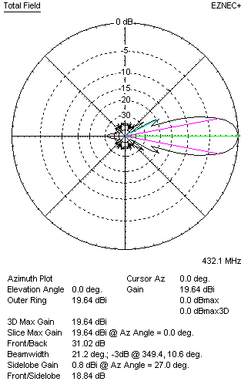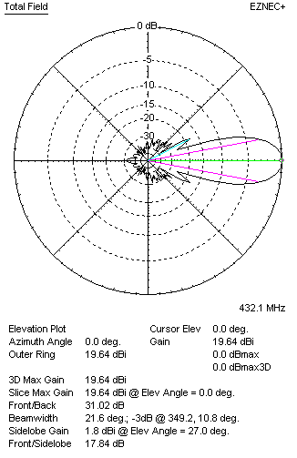
Horizontal and verticall pattern in free space, no loss condition
PERFORMANCES (Loss included for aluminum)
Aluminum |  |  |  | G  (dBi) | Tloss  (K) |  | T_{A}  (◦K) |  |  | G/T  (dB) | Bandwidth for SWR=1.5  (MHz)
After NEC/EZNEC |  |  |  | 19.55 | 6.3 |  | 23.5 |  |  | +5.73 | 428.700 – 437.100
After KF2YN correction |  |  |  | 19.46 | 6.3 |  | 29.3 |  |  | +4.80
Remark: Red coloured data are the final antenna data, which means: KF2YN correction formula applied and loss for aluminum included
DIAGRAMS
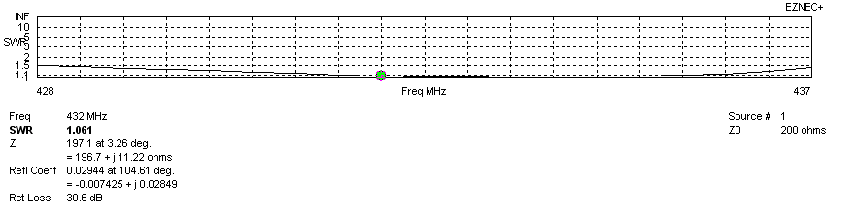
Frequency diagram for SWR better than 1.5
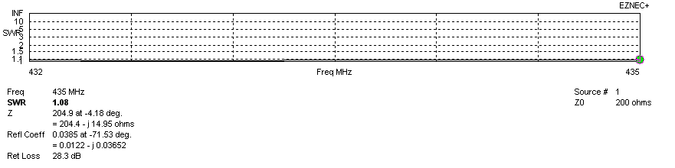
SWR diagram for the range from 432.000 – 435.000 MHz
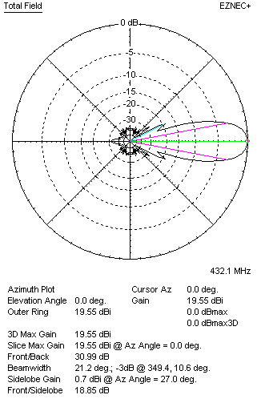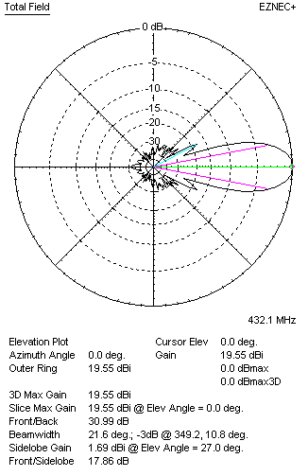
Horizontal and vertical pattern in free space, loss included for aluminum
STACKING
(ALL DATA GIVEN IN ACCORDANCE WITH KF2YN CORRECTION, LOSS INCLUDED)
RECOMMENDED STACKING DISTANCES
 |  |  |  | Two antennas vertically  (mm) |  |  | Two antennas horizontally  (mm) |  |  |  | Four antennas in H-stack  (mm)
Horizontal distance |  |  |  |  |  |  | 2560 |  |  |  | 2560
Vertical distance |  |  |  | 1900 |  |  |  |  |  |  | 1900
TWO ANTENNAS STACKED VERTICALLY
DISTANCE  (mm) |  |  | G  (dBi) |  |  | TA  (K) |  | Tloss  (K) |  |  |  | G/T  (dB)
1900 |  |  | 22.37 |  |  | 28.7 |  | 6.3 |  |  |  | +7.80
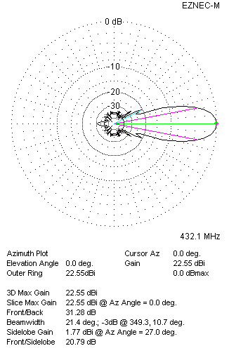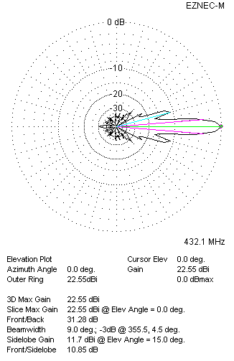
Two antennas stacked vertically
TWO ANTENNAS STACKED HORIZONTALLY
DISTANCE  (mm) |  |  | G  (dBi) |  |  | TA  (K) |  |  | Tloss  (K) |  |  |  | G/T  (dB)
2560 |  |  | 22.53 |  |  | 29.2 |  |  | 6.3 |  |  |  | +7.88
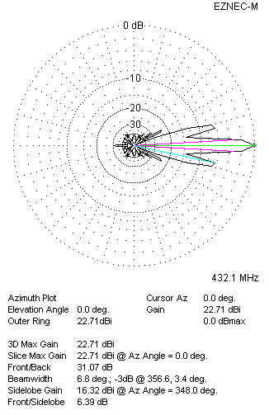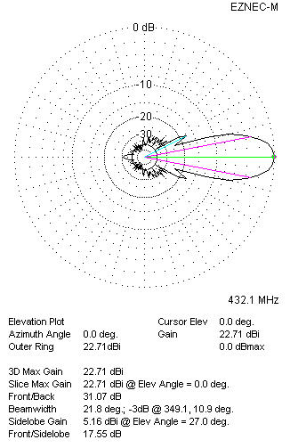
Two antennas stacked horizontally
FOUR ANTENNAS IN H-STACK
DISTANCE  (mm) |  |  | G  (dBi) |  |  | TA  (K) |  |  | Tloss  (K) |  |  |  | G/T  (dB)
H = 2560 |  |  | 25.34 |  |  | 28.1 |  |  | 6.3 |  |  |  | +10.85
V = 1900
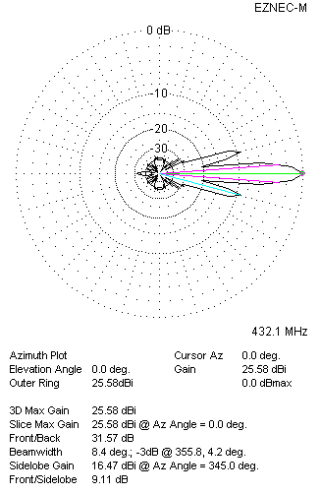
Four antennas in H-stack

