ANTENNA QY72610XL6D19
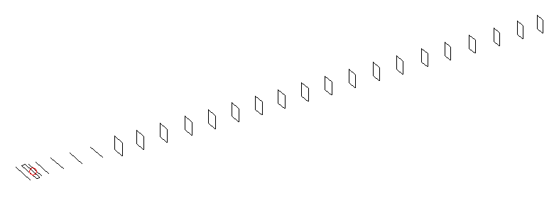
DESCRIPTION
Radiator |  |  | Number of  yagi elements |  |  |  | Number of  oblong elements |  |  |  | Total number  of elements |  |  |  | Boomlength  (mm)
LFA |  |  | 6 |  |  |  | 19 |  |  |  | 26 |  |  |  | 6525
DIMENSIONS
 | Ref | De1 |  | De2 | D1 | D2 |  | D3 | D4 | D5 |  | D6 | D7 | D8 |  | D9 | D10 | DQ1
Position | Ref | De1 |  | De2 | D1 | D2 |  | D3 | D4 | D5 |  | DQ1 | DQ2 | DQ3 |  | DQ4 | DQ5 | DQ6
Length | 0 | 70 |  | 120 | 152 | 246 |  | 435 | 672 | 932 |  | 1203 | 1478 | 1775 |  | 2086 | 2378 | 2678
 | 331 | 327 |  | 327 | 295 | 301.5 |  | 289.5 | 282 | 274.5 |  | 171 | 163 | 157 |  | 157 | 155 | 153
Position | DQ7 | DQ8 |  | DQ9 | DQ10 | DQ11 |  | DQ12 | DQ13 | DQ14 |  | DQ15 | DQ16 | DQ17 |  | DQ18 | DQ19
Length | 2972 | 3262 |  | 3556 | 3852 | 4148 |  | 4454 | 4752 | 5068 |  | 5356 | 5666 | 5976 |  | 6272 | 6525

Remark | All elements made of Al tubes Ǿ10 mm  The height of rectangles is 170 mm  All dimensions given in milimetres
PERFORMANCES (No loss condition)
G  (dBi) |  | F/B  (dB) |  | F/Sh  (dBi) | F/Sv  (dBi) |  | Hor  (◦) |  |  | Ver  (◦) | Temp  (◦K) |  |  | G/T  (dB)
19.42 |  | 31.51 |  | 20.43 | 17.85 |  | 21.8 |  |  | 22.0 | 23.9 |  |  | +6.27
DIAGRAMS
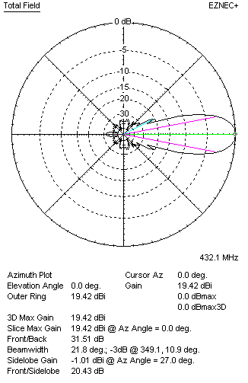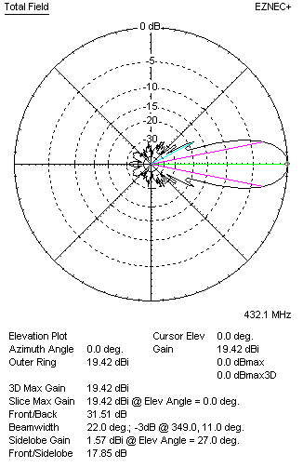
Horizontal and verticall pattern in free space, no loss condition
PERFORMANCES (Loss included for aluminum)
Aluminum |  |  |  | G  (dBi) | Tloss  (K) |  | T_{A}  (◦K) |  |  | G/T  (dB) | Bandwidth for SWR=1.5  (MHz)
After NEC/EZNEC |  |  |  | 19.37 | 3.2 |  | 23.9 |  |  | +5.62 | 426.500 – 437.500
After KF2YN correction |  |  |  | 19.32 | 3.2 |  | 26.8 |  |  | +5.04
Remark: Red coloured data are the final antenna data, which means: KF2YN correction formula applied and loss for aluminum included
DIAGRAMS
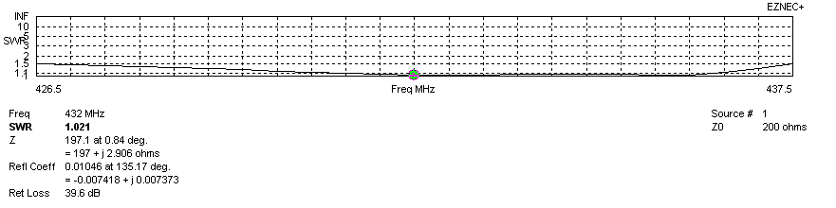
Frequency diagram for SWR better than 1.5
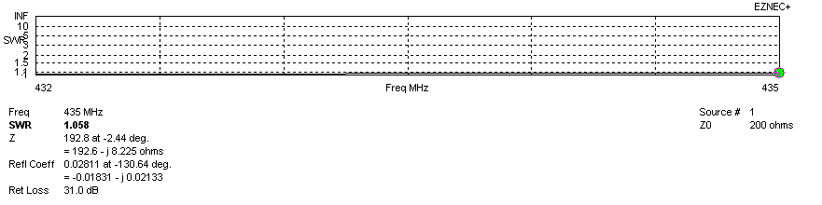
SWR diagram for the range from 432.000 – 435.000 MHz
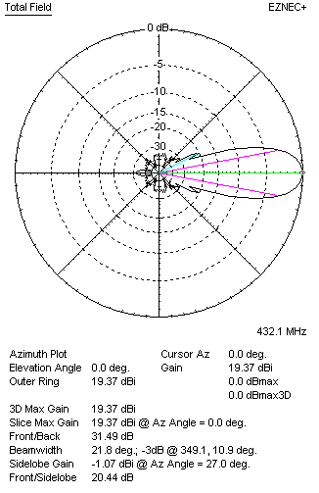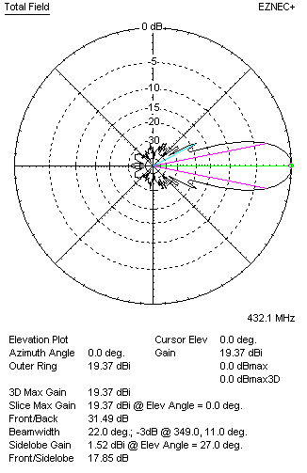
Horizontal and vertical pattern in free space, loss included for aluminum
STACKING
(ALL DATA GIVEN IN ACCORDANCE WITH KF2YN CORRECTION, LOSS INCLUDED)
RECOMMENDED STACKING DISTANCES
 |  |  |  | Two antennas vertically  (mm) |  |  | Two antennas horizontally  (mm) |  |  |  | Four antennas in H-stack  (mm)
Horizontal distance |  |  |  |  |  |  | 2480 |  |  |  | 2480
Vertical distance |  |  |  | 1920 |  |  |  |  |  |  | 1920
TWO ANTENNAS STACKED VERTICALLY
DISTANCE  (mm) |  |  | G  (dBi) |  |  | TA  (K) |  | Tloss  (K) |  |  |  | G/T  (dB)
1920 |  |  | 22.27 |  |  | 26.2 |  | 3.2 |  |  |  | +8.09
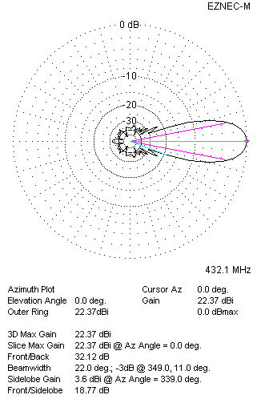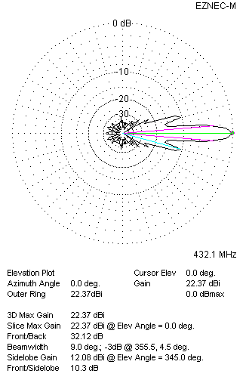
Two antennas stacked vertically
TWO ANTENNAS STACKED HORIZONTALLY
DISTANCE  (mm) |  |  | G  (dBi) |  |  | TA  (K) |  |  | Tloss  (K) |  |  |  | G/T  (dB)
2480 |  |  | 22.39 |  |  | 26.6 |  |  | 3.2 |  |  |  | +8.14
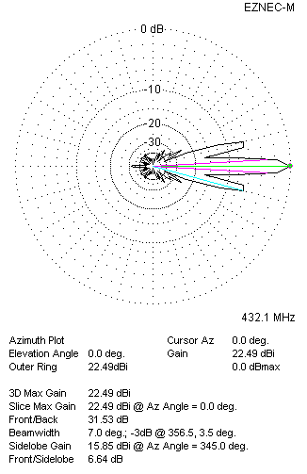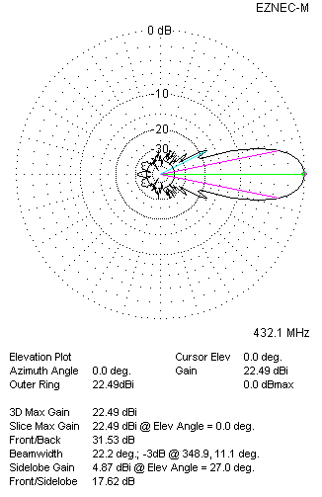
Two antennas stacked horizontally
FOUR ANTENNAS IN H-STACK
DISTANCE  (mm) |  |  | G  (dBi) |  |  | TA  (K) |  |  | Tloss  (K) |  |  |  | G/T  (dB)
H = 2480 |  |  | 25.30 |  |  | 26.2 |  |  | 3.2 |  |  |  | +11.12
V = 1920
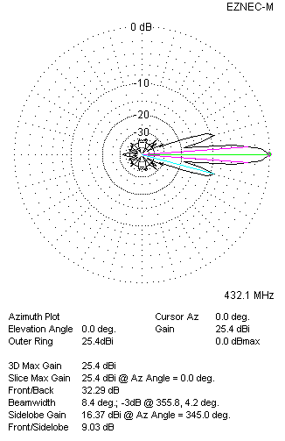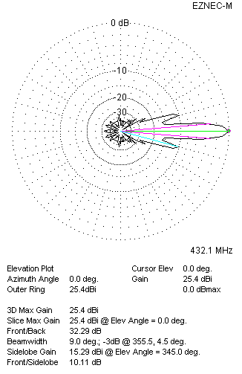
Four antennas in H-stack

