ANTENNA QY72608XL1D19
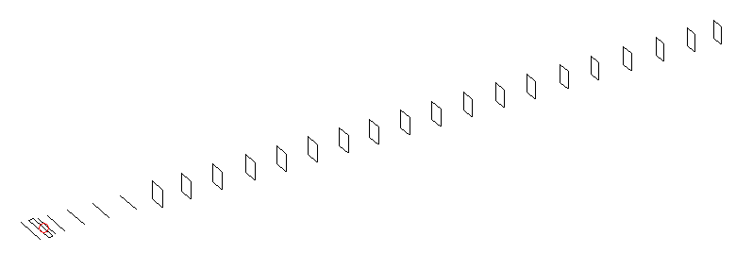
DESCRIPTION
Radiator |  |  | Number of  yagi elements |  |  |  | Number of  oblong elements |  |  |  | Total number  of elements |  |  |  | Boomlength  (mm)
LFA |  |  | 6 |  |  |  | 19 |  |  |  | 26 |  |  |  | 6525
DIMENSIONS
 | Ref | De1 |  | De2 | D1 | D2 |  | D3 | D4 | D5 |  | DQ1 | DQ2 | DQ3 |  | DQ4 | DQ5 | DQ6
Position | 0 | 60 |  | 110 | 148 | 245 |  | 431 | 659 | 919 |  | 1188 | 1472 | 1754 |  | 2056 | 2352 | 2638
Length | 330 | 335 |  | 335 | 307 | 306 |  | 296 | 288 | 279 |  | 172 | 165 | 161 |  | 157 | 157 | 155
 | DQ7 | DQ8 |  | DQ9 | DQ10 | DQ11 |  | DQ12 | DQ13 | DQ14 |  | DQ15 | DQ16 | DQ17 |  | DQ18 | DQ19
Position | 2926 | 3212 |  | 3508 | 3795 | 4108 |  | 4402 | 4706 | 5022 |  | 5337 | 5646 | 5935 |  | 6268 | 6525
Length | 153 | 151 |  | 150 | 149 | 147 |  | 145 | 143 | 143 |  | 141 | 137 | 133 |  | 133 | 131

Remark | All elements made of Al tubes Ǿ8 mm  The height of rectangles is 170 mm  All dimensions given in milimetres
PERFORMANCES (No loss condition)
G  (dBi) |  | F/B  (dB) |  | F/Sh  (dBi) | F/Sv  (dBi) |  | Hor  (◦) |  |  | Ver  (◦) | Temp  (◦K) |  |  | G/T  (dB)
19.52 |  | 31.33 |  | 19.39 | 17.27 |  | 21.4 |  |  | 21.6 | 24.2 |  |  | +6.33
DIAGRAMS
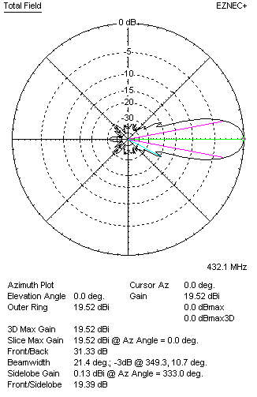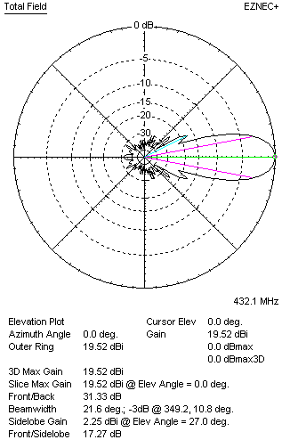
Horizontal and verticall pattern in free space, no loss condition
PERFORMANCES (Loss included for aluminum)
Aluminum |  |  |  | G  (dBi) | Tloss  (K) |  | T_{A}  (◦K) |  |  | G/T  (dB) | Bandwidth for SWR=1.5  (MHz)
After NEC/EZNEC |  |  |  | 19.46 | 4.6 |  | 24.2 |  |  | +5.44 | 426.100 – 436.800
After KF2YN correction |  |  |  | 19.40 | 4.6 |  | 28.4 |  |  | +4.87
Remark: Red coloured data are the final antenna data, which means: KF2YN correction formula applied and loss for aluminum included
DIAGRAMS
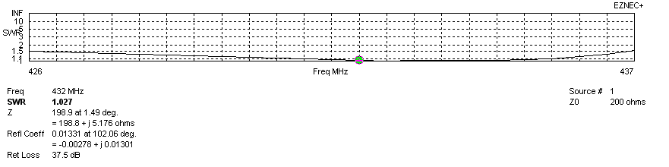
Frequency diagram for SWR better than 1.5
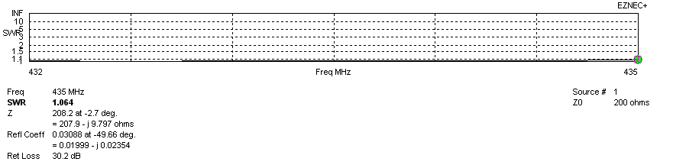
SWR diagram for the range from 432.000 – 435.000 MHz
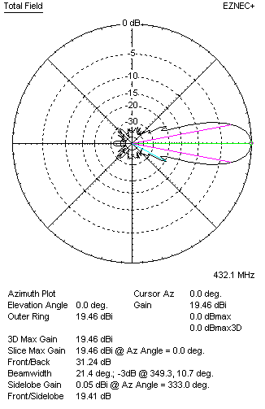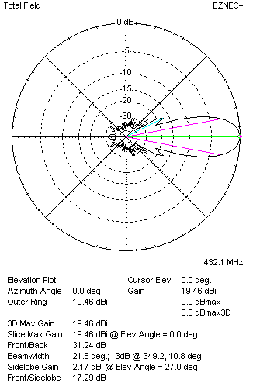
Horizontal and vertical pattern in free space, loss included for aluminum
STACKING
(ALL DATA GIVEN IN ACCORDANCE WITH KF2YN CORRECTION, LOSS INCLUDED)
RECOMMENDED STACKING DISTANCES
 |  |  |  | Two antennas vertically  (mm) |  |  | Two antennas horizontally  (mm) |  |  |  | Four antennas in H-stack  (mm)
Horizontal distance |  |  |  |  |  |  | 2480 |  |  |  | 2480
Vertical distance |  |  |  | 1960 |  |  |  |  |  |  | 1960
TWO ANTENNAS STACKED VERTICALLY
DISTANCE  (mm) |  |  | G  (dBi) |  |  | TA  (K) |  | Tloss  (K) |  |  |  | G/T  (dB)
1960 |  |  | 22.37 |  |  | 27.8 |  | 4.6 |  |  |  | +7.93
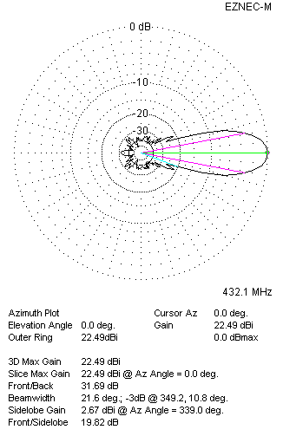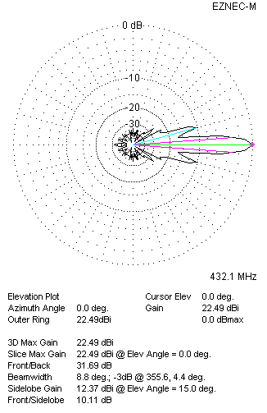
Two antennas stacked vertically
TWO ANTENNAS STACKED HORIZONTALLY
DISTANCE  (mm) |  |  | G  (dBi) |  |  | TA  (K) |  |  | Tloss  (K) |  |  |  | G/T  (dB)
2480 |  |  | 22.47 |  |  | 28.2 |  |  | 4.6 |  |  |  | +7.97
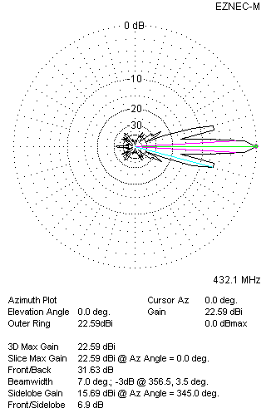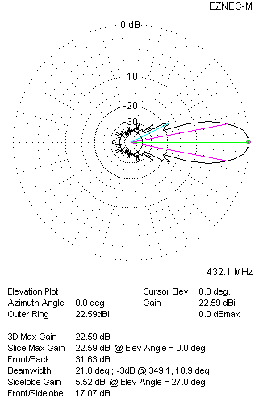
Two antennas stacked horizontally
FOUR ANTENNAS IN H-STACK
DISTANCE  (mm) |  |  | G  (dBi) |  |  | TA  (K) |  |  | Tloss  (K) |  |  |  | G/T  (dB)
H = 2480 |  |  | 25.39 |  |  | 27.7 |  |  | 4.6 |  |  |  | +10.96
V = 1960
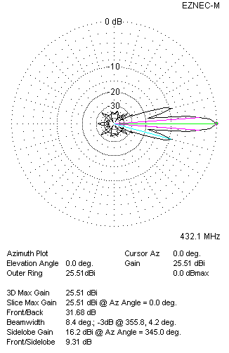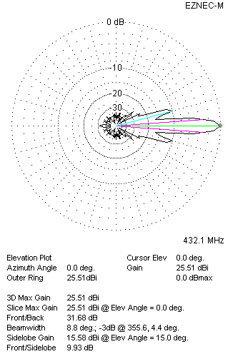
Four antennas in H-stack

