ANTENNA QY72510XL8D18
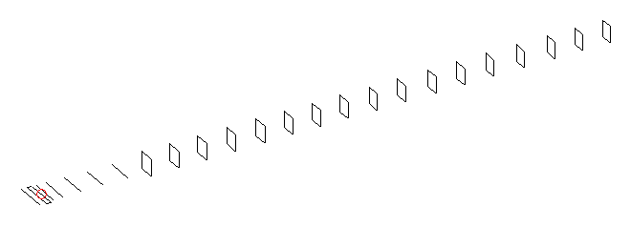
DESCRIPTION
Radiator |  |  | Number of  yagi elements |  |  |  | Number of  oblong elements |  |  |  | Total number  of elements |  |  | Boomlength  (mm)
LFA |  |  | 6 |  |  |  | 18 |  |  |  | 25 |  |  | 6225
DIMENSIONS
 | Ref | De1 |  | De2 | D1 | D2 |  | D3 | D4 | D5 |  | DQ1 | DQ2 |  | DQ3 | DQ4 | DQ5
Position | 0 | 70 |  | 120 | 152 | 245 |  | 435 | 672 | 932 |  | 1203 | 1478 |  | 1775 | 2086 | 2378
Length | 331 | 327 |  | 327 | 295 | 301.5 |  | 289.5 | 281.5 | 274.5 |  | 171 | 163 |  | 157 | 157 | 155
 | DQ6 | DQ7 |  | DQ8 | DQ9 | DQ10 |  | DQ11 | DQ12 | DQ13 |  | DQ14 | DQ15 |  | DQ16 | DQ17 | DQ18
Position | 2678 | 2972 |  | 3262 | 3556 | 3852 |  | 4148 | 4454 | 4752 |  | 5068 | 5356 |  | 5666 | 5972 | 6225
Length | 153 | 151 |  | 149 | 147 | 145 |  | 143 | 141 | 139 |  | 137 | 135 |  | 131 | 127 | 123

Remark | All elements made of Al tubes Ǿ10 mm  The height of rectangles is 170 mm  All dimensions given in milimetres
PERFORMANCES (No loss condition)
G  (dBi) |  | F/B  (dB) |  | F/Sh  (dBi) | F/Sv  (dBi) |  | Hor  (◦) |  |  | Ver  (◦) | Temp  (◦K) |  |  | G/T  (dB)
19.29 |  | 31.65 |  | 20.22 | 17.58 |  | 22.2 |  |  | 22.4 | 24.0 |  |  | +6.11
DIAGRAMS
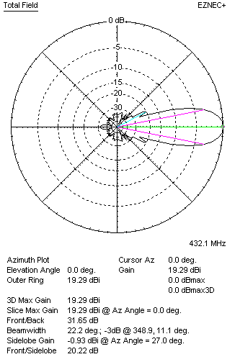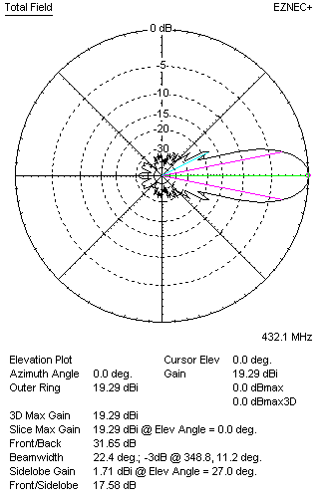
Horizontal and verticall pattern in free space, no loss condition
PERFORMANCES (Loss included for aluminum)
Aluminum |  |  |  | G  (dBi) | Tloss  (K) |  | T_{A}  (◦K) |  |  | G/T  (dB) | Bandwidth for SWR=1.5  (MHz)
After NEC/EZNEC |  |  |  | 19.24 | 3.2 |  | 24.1 |  |  | +5.47 | 426.500 – 437.700
After KF2YN correction |  |  |  | 19.19 | 3.2 |  | 26.9 |  |  | +4.89
Remark: Red coloured data are the final antenna data, which means: KF2YN correction formula applied and loss for aluminum included
DIAGRAMS
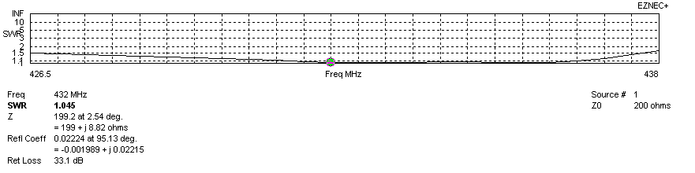
Frequency diagram for SWR better than 1.5
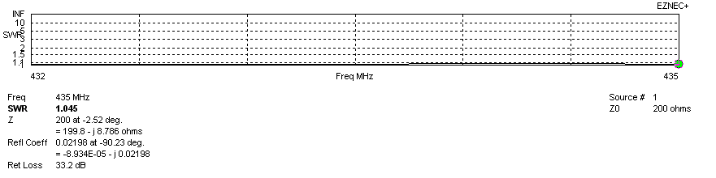
SWR diagram for the range from 432.000 – 435.000 MHz
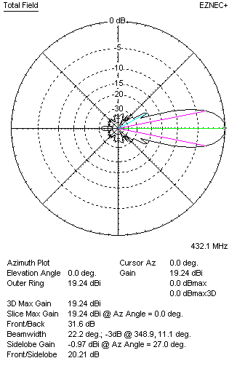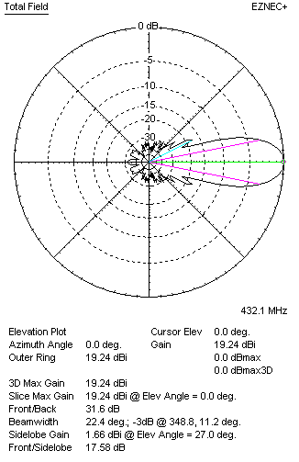
Horizontal and vertical pattern in free space, loss included for aluminum
STACKING
(ALL DATA GIVEN IN ACCORDANCE WITH KF2YN CORRECTION, LOSS INCLUDED)
RECOMMENDED STACKING DISTANCES
 |  |  |  | Two antennas vertically  (mm) |  |  | Two antennas horizontally  (mm) |  |  |  | Four antennas in H-stack  (mm)
Horizontal distance |  |  |  |  |  |  | 1980 |  |  |  | 1980
Vertical distance |  |  |  | 1940 |  |  |  |  |  |  | 1940
TWO ANTENNAS STACKED VERTICALLY
DISTANCE  (mm) |  |  | G  (dBi) |  |  | TA  (K) |  | Tloss  (K) |  |  |  | G/T  (dB)
1940 |  |  | 22.17 |  |  | 26.3 |  | 3.2 |  |  |  | +7.97
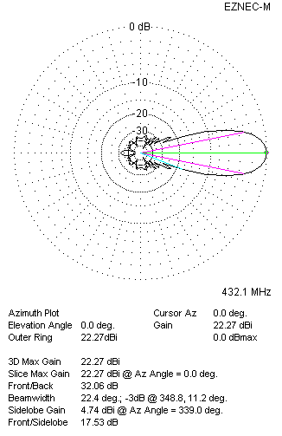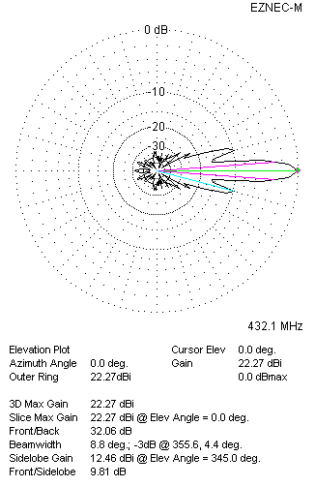
Two antennas stacked vertically
TWO ANTENNAS STACKED HORIZONTALLY
DISTANCE  (mm) |  |  | G  (dBi) |  |  | TA  (K) |  |  | Tloss  (K) |  |  |  | G/T  (dB)
1980 |  |  | 22.18 |  |  | 26.6 |  |  | 3.2 |  |  |  | +7.93
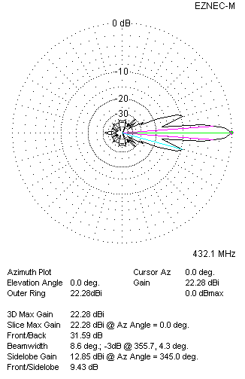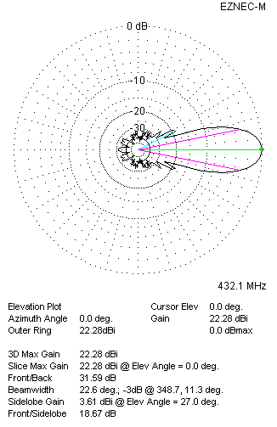
Two antennas stacked horizontally
FOUR ANTENNAS IN H-STACK
DISTANCE  (mm) |  |  | G  (dBi) |  |  | TA  (K) |  |  | Tloss  (K) |  |  |  | G/T  (dB)
H = 1980 |  |  | 25.19 |  |  | 26.1 |  |  | 3.2 |  |  |  | +11.02
V = 1940
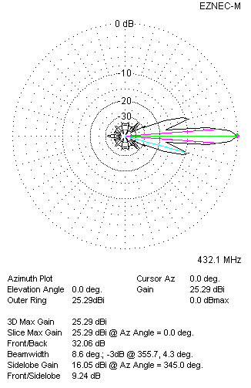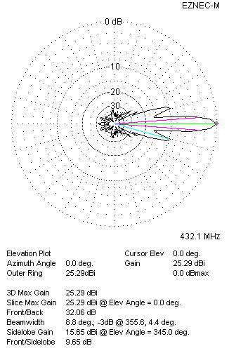
Four antennas in H-stack

