ANTENNA QY72508XL12D18
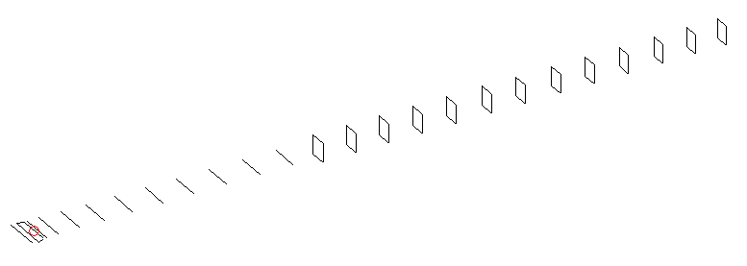
DESCRIPTION
Radiator |  |  | Number of  yagi elements |  |  |  | Number of  oblong elements |  |  |  | Total number  of elements |  |  | Boomlength  (mm)
LFA |  |  | 6 |  |  |  | 18 |  |  |  | 25 |  |  | 6225
DIMENSIONS
 | Ref | De1 |  | De2 | D1 | D2 |  | D3 | D4 | D5 |  | DQ1 | DQ2 |  | DQ3 | DQ4 | DQ5
Position | 0 | 45 |  | 105 | 144 | 243 |  | 429 | 656 | 915 |  | 1188 | 1471 |  | 1762 | 2059 | 2349
Length | 330 | 339 |  | 339 | 306.5 | 305 |  | 295 | 287.5 | 279.5 |  | 171 | 164 |  | 160 | 158 | 156
 | DQ6 | DQ7 |  | DQ8 | DQ9 | DQ10 |  | DQ11 | DQ12 | DQ13 |  | DQ14 | DQ15 |  | DQ16 | DQ17 | DQ18
Position | 2637 | 2922 |  | 3197 | 3484 | 3777 |  | 4079 | 4399 | 4702 |  | 5021 | 5330 |  | 5636 | 5948 | 6225
Length | 154 | 152 |  | 151 | 149 | 148 |  | 146 | 145 | 144 |  | 143 | 140 |  | 137 | 131 | 131

Remark | All elements made of Al tubes Ǿ8 mm  The height of rectangles is 170 mm  All dimensions given in milimetres
PERFORMANCES (No loss condition)
G  (dBi) |  | F/B  (dB) |  | F/Sh  (dBi) | F/Sv  (dBi) |  | Hor  (◦) |  |  | Ver  (◦) | Temp  (◦K) |  |  | G/T  (dB)
19.38 |  | 34.40 |  | 19.10 | 16.89 |  | 21.8 |  |  | 22.0 | 24.5 |  |  | +6.04
DIAGRAMS
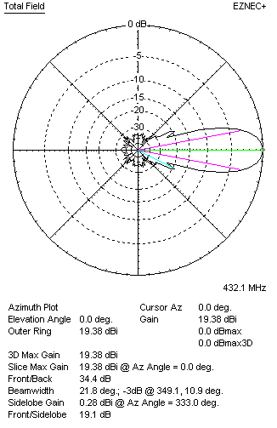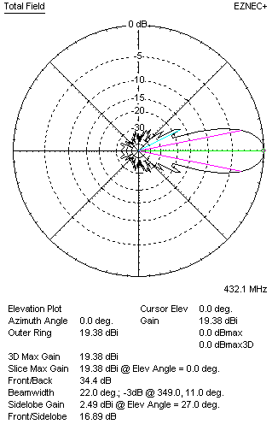
Horizontal and verticall pattern in free space, no loss condition
PERFORMANCES (Loss included for aluminum)
Aluminum |  |  |  | G  (dBi) | Tloss  (K) |  | T_{A}  (◦K) |  |  | G/T  (dB) | Bandwidth for SWR=1.5  (MHz)
After NEC/EZNEC |  |  |  | 19.32 | 4.3 |  | 24.5 |  |  | +5.23 | 422.000 – 437.800
After KF2YN correction |  |  |  | 19.27 | 4.3 |  | 28.4 |  |  | +4.73
Remark: Red coloured data are the final antenna data, which means: KF2YN correction formula applied and loss for aluminum included
DIAGRAMS
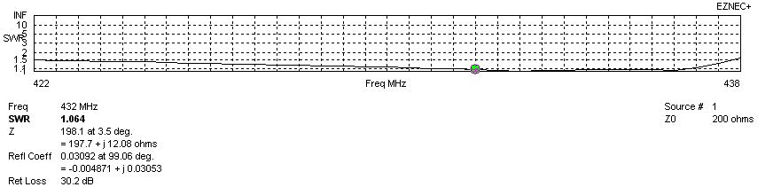
Frequency diagram for SWR better than 1.5
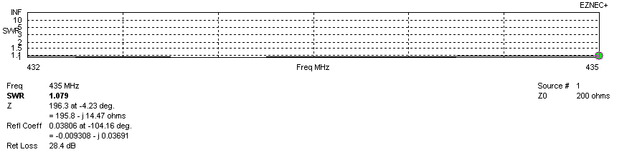
SWR diagram for the range from 432.000 – 435.000 MHz
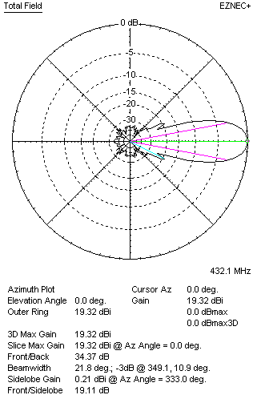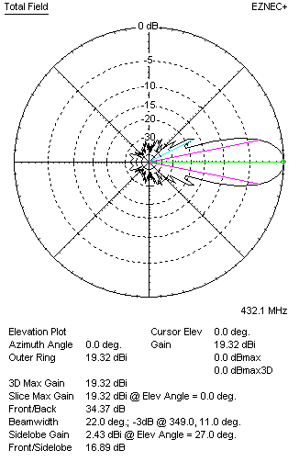
Horizontal and vertical pattern in free space, loss included for aluminum
STACKING
(ALL DATA GIVEN IN ACCORDANCE WITH KF2YN CORRECTION, LOSS INCLUDED)
RECOMMENDED STACKING DISTANCES
 |  |  |  | Two antennas vertically  (mm) |  |  | Two antennas horizontally  (mm) |  |  |  | Four antennas in H-stack  (mm)
Horizontal distance |  |  |  |  |  |  | 1980 |  |  |  | 1980
Vertical distance |  |  |  | 1940 |  |  |  |  |  |  | 1940
TWO ANTENNAS STACKED VERTICALLY
DISTANCE  (mm) |  |  | G  (dBi) |  |  | TA  (K) |  | Tloss  (K) |  |  |  | G/T  (dB)
1940 |  |  | 22.24 |  |  | 27.7 |  | 4.3 |  |  |  | +7.82
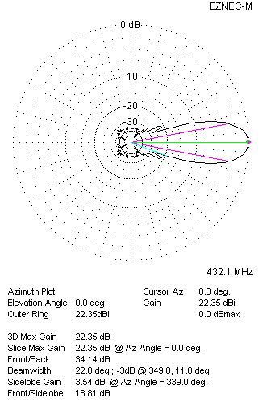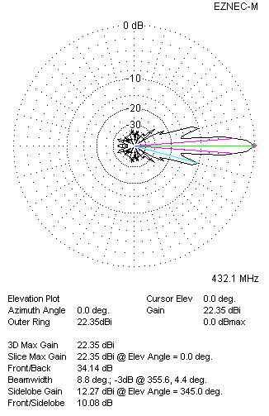
Two antennas stacked vertically
TWO ANTENNAS STACKED HORIZONTALLY
DISTANCE  (mm) |  |  | G  (dBi) |  |  | TA  (K) |  |  | Tloss  (K) |  |  |  | G/T  (dB)
1980 |  |  | 22.25 |  |  | 28.1 |  |  | 4.3 |  |  |  | +7.77
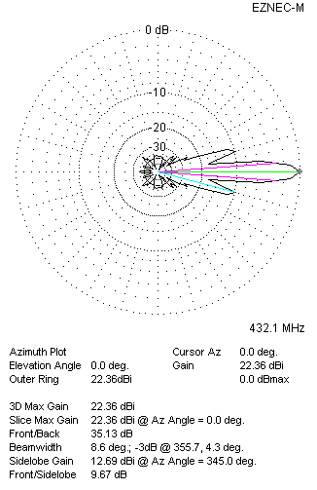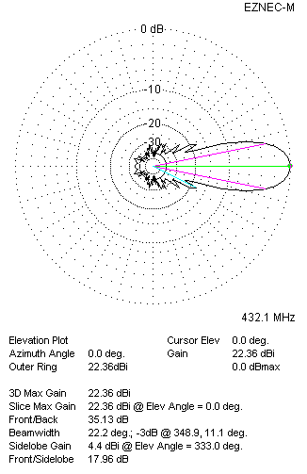
Two antennas stacked horizontally
FOUR ANTENNAS IN H-STACK
DISTANCE  (mm) |  |  | G  (dBi) |  |  | TA  (K) |  |  | Tloss  (K) |  |  |  | G/T  (dB)
H = 1980 |  |  | 25.26 |  |  | 27.5 |  |  | 4.3 |  |  |  | +10.87
V = 1940
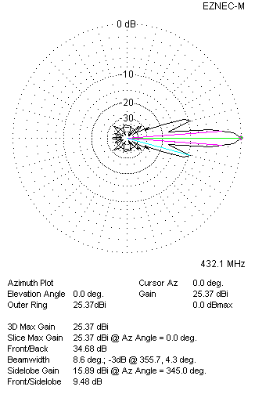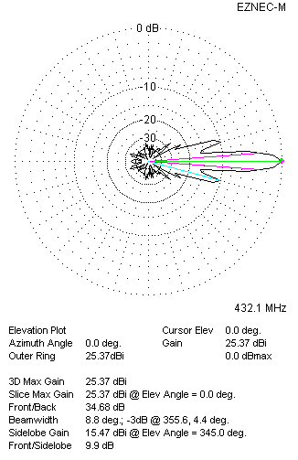
Four antennas in H-stack

