ANTENNA QY72505XL2D13
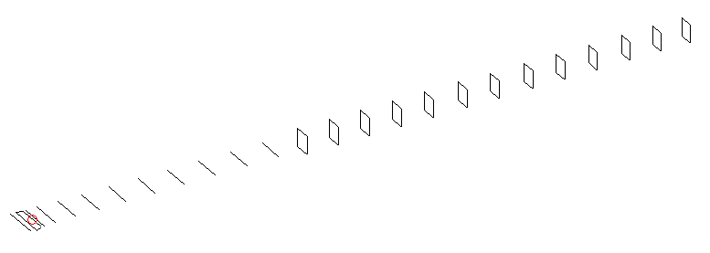
DESCRIPTION
Radiator |  |  | Number of  yagi elements |  |  |  | Number of  oblong elements |  |  |  | Total number  of elements |  |  | Boomlength  (mm)
LFA |  |  | 11 |  |  |  | 13 |  |  |  | 25 |  |  | 6225
DIMENSIONS
 | Ref | De1 |  | De2 | D1 | D2 |  | D3 | D4 | D5 |  | D6 | D7 |  | D8 | D9 | D10
Position | 0 | 55 |  | 105 | 137 | 239 |  | 432 | 661 | 914 |  | 1186 | 1458 |  | 1748 | 2043 | 2343
Length | 336 | 345 |  | 292 | 311 | 311 |  | 301 | 295 | 289.5 |  | 286.5 | 283 |  | 279.5 | 276.5 | 274
 | DQ1 | DQ2 |  | DQ3 | DQ4 | DQ5 |  | DQ6 | DQ7 | DQ8 |  | DQ9 | DQ10 |  | DQ11 | DQ12 | DQ13
Position | 2632 | 2932 |  | 3221 | 3519 | 3821 |  | 4132 | 4444 | 4754 |  | 5051 | 5377 |  | 5652 | 5944 | 6225
Length | 159 | 157 |  | 155 | 153 | 150 |  | 146 | 142 | 142 |  | 140 | 140 |  | 140 | 131 | 131

Remark | All elements made of Al tubes Ǿ5 mm  The height of rectangles is 170 mm  All dimensions given in milimetres
PERFORMANCES (No loss condition)
G  (dBi) |  | F/B  (dB) |  | F/Sh  (dBi) | F/Sv  (dBi) |  | Hor  (◦) |  |  | Ver  (◦) | Temp  (◦K) |  |  | G/T  (dB)
19.28 |  | 29.77 |  | 19.72 | 19.27 |  | 22.2 |  |  | 22.8 | 23.8 |  |  | +6.49
DIAGRAMS
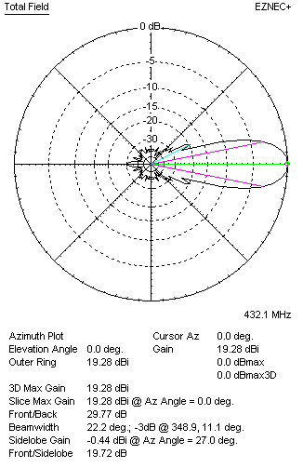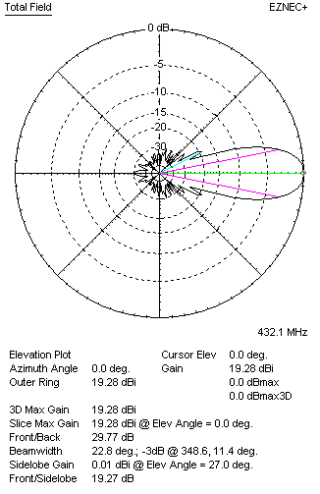
Horizontal and verticall pattern in free space, no loss condition
PERFORMANCES (Loss included for aluminum)
Aluminum |  |  |  | G  (dBi) | Tloss  (K) |  | T_{A}  (◦K) |  |  | G/T  (dB) | Bandwidth for SWR=1.5  (MHz)
After NEC/EZNEC |  |  |  | 19.19 | 6.3 |  | 23.9 |  |  | +5.21 | 426.500 – 437.200
After KF2YN correction |  |  |  | 19.11 | 6.3 |  | 29.6 |  |  | +4.40
Remark: Red coloured data are the final antenna data, which means: KF2YN correction formula applied and loss for aluminum included
DIAGRAMS
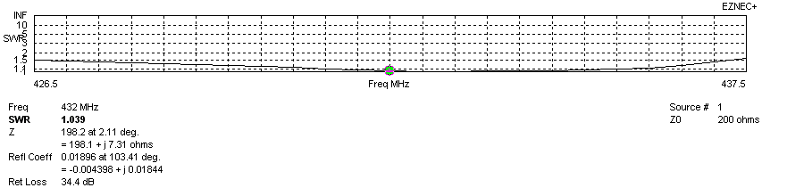
Frequency diagram for SWR better than 1.5
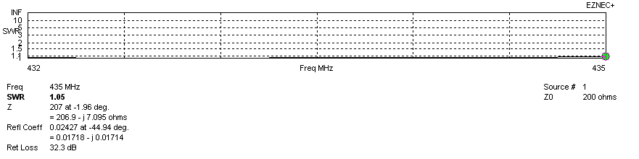
SWR diagram for the range from 432.000 – 435.000 MHz
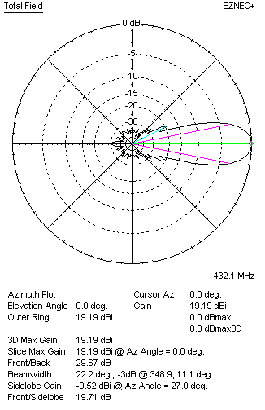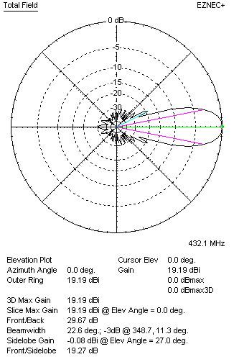
Horizontal and vertical pattern in free space, loss included for aluminum
STACKING
(ALL DATA GIVEN IN ACCORDANCE WITH KF2YN CORRECTION, LOSS INCLUDED)
RECOMMENDED STACKING DISTANCES
 |  |  |  | Two antennas vertically  (mm) |  |  | Two antennas horizontally  (mm) |  |  |  | Four antennas in H-stack  (mm)
Horizontal distance |  |  |  |  |  |  | 2040 |  |  |  | 2040
Vertical distance |  |  |  | 1880 |  |  |  |  |  |  | 1880
TWO ANTENNAS STACKED VERTICALLY
DISTANCE  (mm) |  |  | G  (dBi) |  |  | TA  (K) |  | Tloss  (K) |  |  |  | G/T  (dB)
1880 |  |  | 22.06 |  |  | 29.2 |  | 6.3 |  |  |  | +7.41
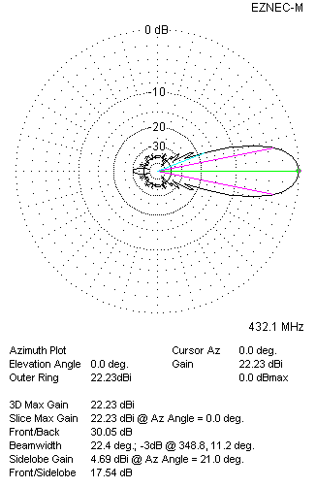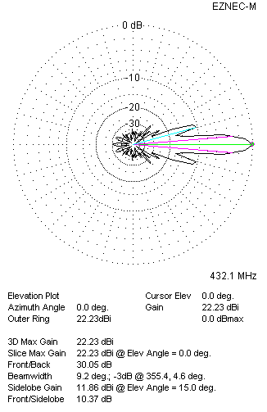
Two antennas stacked vertically
TWO ANTENNAS STACKED HORIZONTALLY
DISTANCE  (mm) |  |  | G  (dBi) |  |  | TA  (K) |  |  | Tloss  (K) |  |  |  | G/T  (dB)
2040 |  |  | 22.11 |  |  | 29.4 |  |  | 6.3 |  |  |  | +7.43
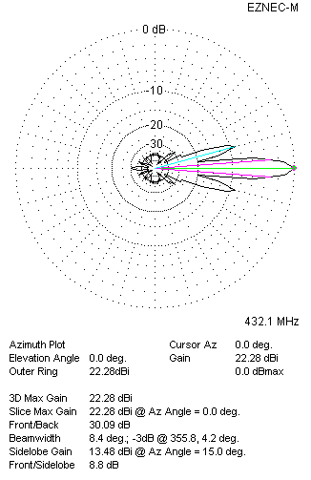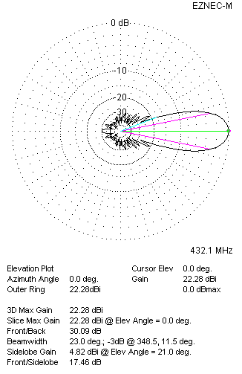
Two antennas stacked horizontally
FOUR ANTENNAS IN H-STACK
DISTANCE  (mm) |  |  | G  (dBi) |  |  | TA  (K) |  |  | Tloss  (K) |  |  |  | G/T  (dB)
H = 2040 |  |  | 25.10 |  |  | 29.1 |  |  | 6.3 |  |  |  | +10.46
V = 1880
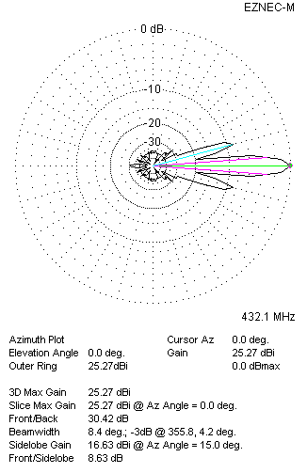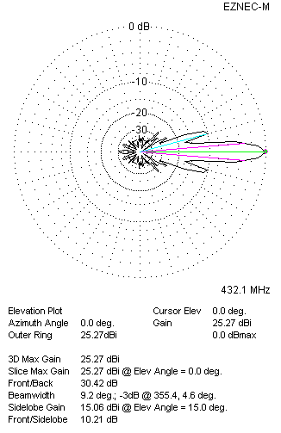
Four antennas in H-stack

