ANTENNA QY72410XL5D17
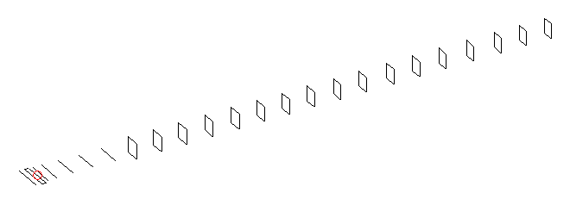
DESCRIPTION
Radiator |  |  | Number of  yagi elements |  |  |  | Number of  oblong elements |  |  |  | Total number  of elements |  |  | Boomlength  (mm)
LFA |  |  | 6 |  |  |  | 17 |  |  |  | 24 |  |  | 5895
DIMENSIONS
 | Ref | De1 |  | De2 | D1 | D2 |  | D3 | D4 | D5 |  | DQ1 | DQ2 |  | DQ3 | DQ4 | DQ5
Position | 0 | 65 |  | 105 | 138 | 237 |  | 427 | 658 | 911 |  | 1186 | 1458 |  | 1751 | 2059 | 2362
Length | 331 | 327 |  | 327 | 296 | 301.5 |  | 290.5 | 283.5 | 275 |  | 171 | 165 |  | 157 | 155 | 153
 | DQ6 | DQ7 |  | DQ8 | DQ9 | DQ10 |  | DQ11 | DQ12 | DQ13 |  | DQ14 | DQ15 |  | DQ16 | DQ17
Position | 2658 | 2955 |  | 3248 | 3539 | 3844 |  | 4142 | 4444 | 4743 |  | 5038 | 5338 |  | 5634 | 5895
Length | 151 | 149 |  | 145 | 141 | 139 |  | 137 | 137 | 137 |  | 135 | 133 |  | 131 | 125

Remark | All elements made of Al tubes Ǿ10 mm  The height of rectangles is 170 mm  All dimensions given in milimetres
PERFORMANCES (No loss condition)
G  (dBi) |  | F/B  (dB) |  | F/Sh  (dBi) | F/Sv  (dBi) |  | Hor  (◦) |  |  | Ver  (◦) | Temp  (◦K) |  |  | G/T  (dB)
18.94 |  | 31.46 |  | 23.05 | 20.07 |  | 23.4 |  |  | 23.8 | 23.9 |  |  | +5.78
DIAGRAMS
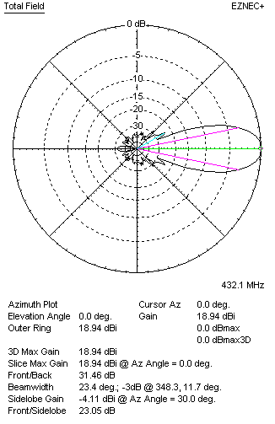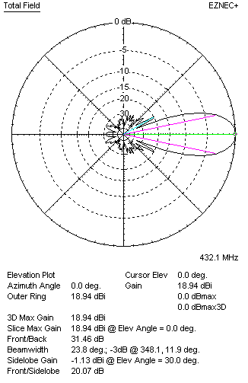
Horizontal and verticall pattern in free space, no loss condition
PERFORMANCES (Loss included for aluminum)
Aluminum |  |  |  | G  (dBi) | Tloss  (K) |  | T_{A}  (◦K) |  |  | G/T  (dB) | Bandwidth for SWR=1.5  (MHz)
After NEC/EZNEC |  |  |  | 18.89 | 3.4 |  | 24.0 |  |  | +5.10 | 427.000 – 437.400
After KF2YN correction |  |  |  | 18.84 | 3.4 |  | 27.1 |  |  | +4.51
Remark: Red coloured data are the final antenna data, which means: KF2YN correction formula applied and loss for aluminum included
DIAGRAMS
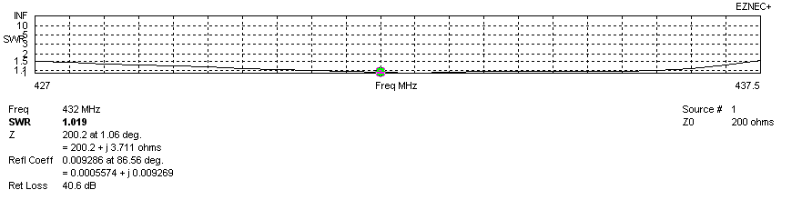
Frequency diagram for SWR better than 1.5
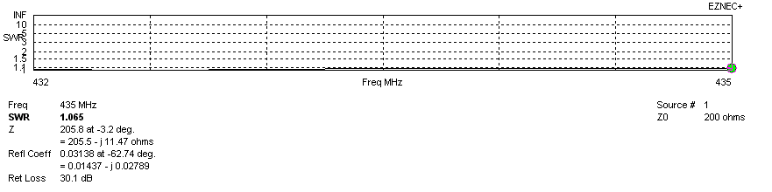
SWR diagram for the range from 432.000 – 435.000 MHz
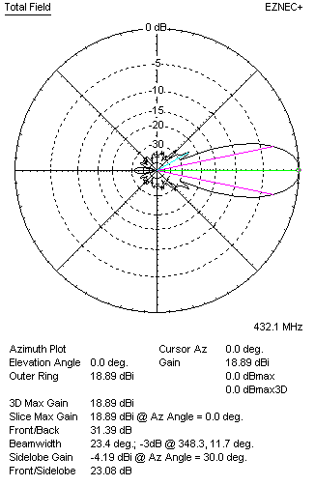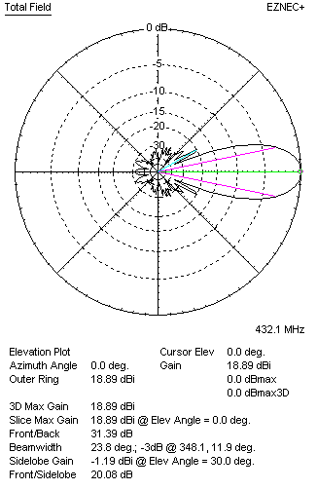
Horizontal and vertical pattern in free space, loss included for aluminum
STACKING
(ALL DATA GIVEN IN ACCORDANCE WITH KF2YN CORRECTION, LOSS INCLUDED)
RECOMMENDED STACKING DISTANCES
 |  |  |  | Two antennas vertically  (mm) |  |  | Two antennas horizontally  (mm) |  |  |  | Four antennas in H-stack  (mm)
Horizontal distance |  |  |  |  |  |  | 1960 |  |  |  | 1960
Vertical distance |  |  |  | 1920 |  |  |  |  |  |  | 1920
TWO ANTENNAS STACKED VERTICALLY
DISTANCE  (mm) |  |  | G  (dBi) |  |  | TA  (K) |  | Tloss  (K) |  |  |  | G/T  (dB)
1920 |  |  | 21.84 |  |  | 26.6 |  | 3.4 |  |  |  | +7.59
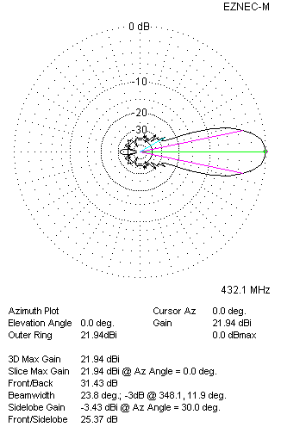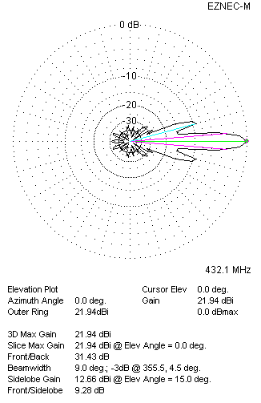
Two antennas stacked vertically
TWO ANTENNAS STACKED HORIZONTALLY
DISTANCE  (mm) |  |  | G  (dBi) |  |  | TA  (K) |  |  | Tloss  (K) |  |  |  | G/T  (dB)
1960 |  |  | 21.85 |  |  | 26.7 |  |  | 3.4 |  |  |  | +7.59
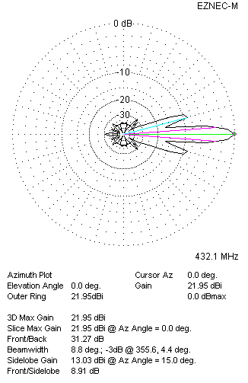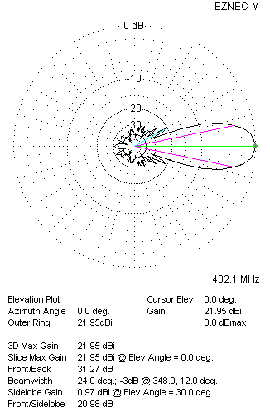
Two antennas stacked horizontally
FOUR ANTENNAS IN H-STACK
DISTANCE  (mm) |  |  | G  (dBi) |  |  | TA  (K) |  |  | Tloss  (K) |  |  |  | G/T  (dB)
H = 2.42 |  |  | 24.87 |  |  | 26.3 |  |  | 3.4 |  |  |  | +10.67
V = 1920
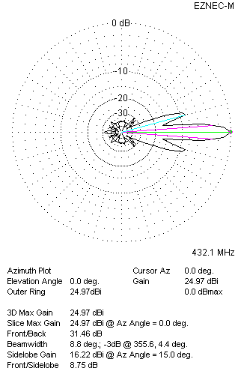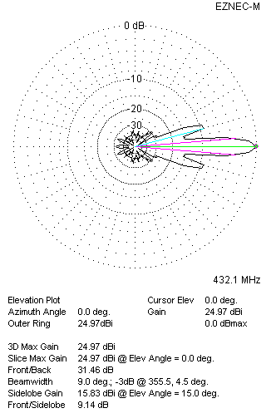
Four antennas in H-stack

