ANTENNA QY72406XL4D12
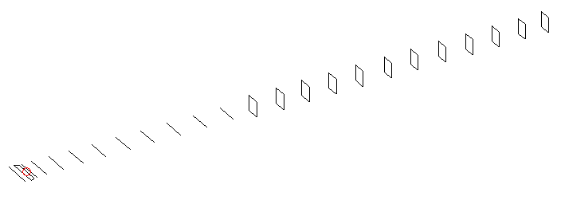
DESCRIPTION
Radiator |  |  | Number of  yagi elements |  |  |  | Number of  oblong elements |  |  |  | Total number  of elements |  |  | Boomlength  (mm)
LFA |  |  | 11 |  |  |  | 12 |  |  |  | 24 |  |  | 5895
DIMENSIONS
 | Ref | De1 |  | De2 | D1 | D2 |  | D3 | D4 | D5 |  | D6 | D7 |  | D8 | D9 | D10
Position | 0 | 55 |  | 105 | 138 | 245 |  | 434 | 658 | 911 |  | 1184 | 1456 |  | 1746 | 2044 | 2342
Length | 334 | 341 |  | 296 | 304 | 307 |  | 298 | 291 | 285 |  | 283 | 279 |  | 275 | 273 | 268
 | DQ1 | DQ2 |  | DQ3 | DQ4 | DQ5 |  | DQ6 | DQ7 | DQ8 |  | DQ9 | DQ10 |  | DQ11 | DQ12
Position | 2633 | 2932 |  | 3221 | 3519 | 3818 |  | 4138 | 4436 | 4744 |  | 5046 | 5339 |  | 5638 | 5895
Length | 159 | 157 |  | 155 | 151 | 147 |  | 145 | 141 | 141 |  | 141 | 135 |  | 135 | 133

Remark | All elements made of Al tubes Ǿ6 mm  The height of rectangles is 170 mm  All dimensions given in milimetres
PERFORMANCES (No loss condition)
G  (dBi) |  | F/B  (dB) |  | F/Sh  (dBi) | F/Sv  (dBi) |  | Hor  (◦) |  |  | Ver  (◦) | Temp  (◦K) |  |  | G/T  (dB)
19.08 |  | 32.46 |  | 18.94 | 18.42 |  | 22.6 |  |  | 23.2 | 24.8 |  |  | +6.00
DIAGRAMS
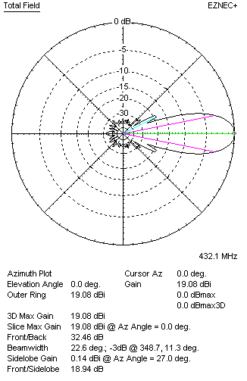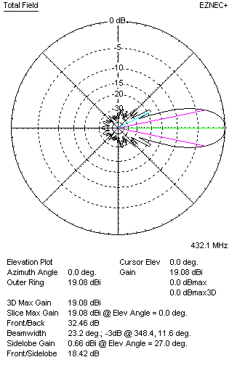
Horizontal and verticall pattern in free space, no loss condition
PERFORMANCES (Loss included for aluminum)
Aluminum |  |  |  | G  (dBi) | Tloss  (K) |  | T_{A}  (◦K) |  |  | G/T  (dB) | Bandwidth for SWR=1.5  (MHz)
After NEC/EZNEC |  |  |  | 19.02 | 4.9 |  | 24.9 |  |  | +5.10 | 424.000 – 438.400
After KF2YN correction |  |  |  | 18.93 | 4.9 |  | 29.2 |  |  | +4.27
Remark: Red coloured data are the final antenna data, which means: KF2YN correction formula applied and loss for aluminum included
DIAGRAMS
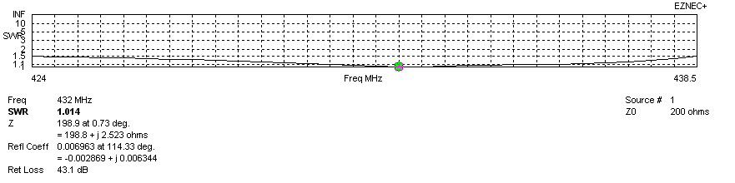
Frequency diagram for SWR better than 1.5
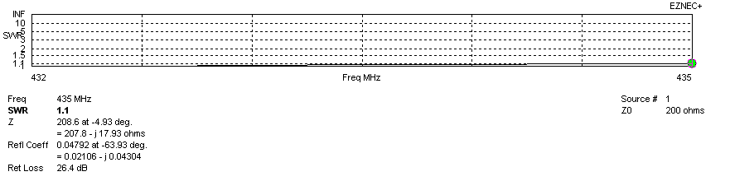
SWR diagram for the range from 432.000 – 435.000 MHz
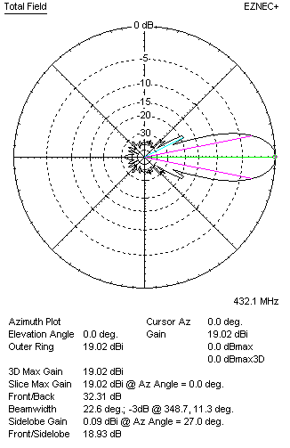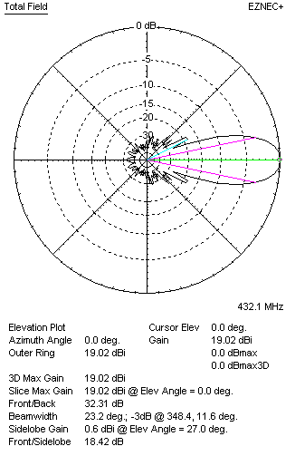
Horizontal and vertical pattern in free space, loss included for aluminum
STACKING
(ALL DATA GIVEN IN ACCORDANCE WITH KF2YN CORRECTION, LOSS INCLUDED)
RECOMMENDED STACKING DISTANCES
 |  |  |  | Two antennas vertically  (mm) |  |  | Two antennas horizontally  (mm) |  |  |  | Four antennas in H-stack  (mm)
Horizontal distance |  |  |  |  |  |  | 2020 |  |  |  | 2020
Vertical distance |  |  |  | 1920 |  |  |  |  |  |  | 1920
TWO ANTENNAS STACKED VERTICALLY
DISTANCE  (mm) |  |  | G  (dBi) |  |  | TA  (K) |  | Tloss  (K) |  |  |  | G/T  (dB)
1920 |  |  | 21.93 |  |  | 28.7 |  | 4.9 |  |  |  | +7.35
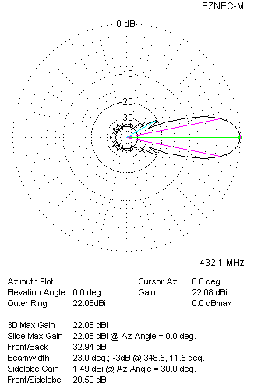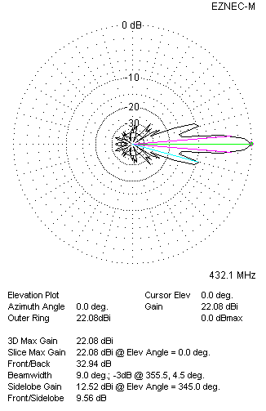
Two antennas stacked vertically
TWO ANTENNAS STACKED HORIZONTALLY
DISTANCE  (mm) |  |  | G  (dBi) |  |  | TA  (K) |  |  | Tloss  (K) |  |  |  | G/T  (dB)
2020 |  |  | 21.95 |  |  | 28.9 |  |  | 4.9 |  |  |  | +7.34
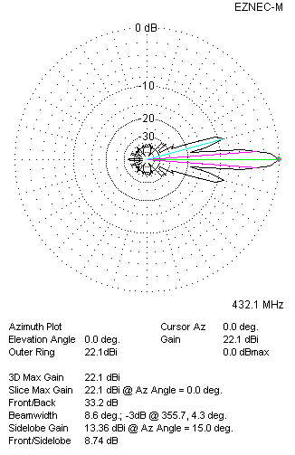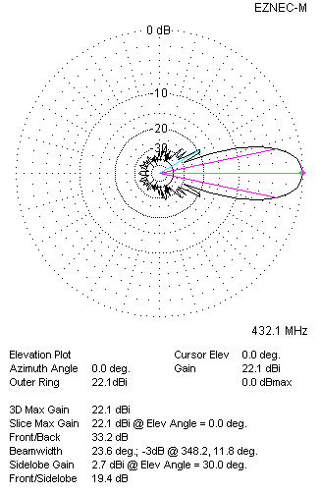
Two antennas stacked horizontally
FOUR ANTENNAS IN H-STACK
DISTANCE  (mm) |  |  | G  (dBi) |  |  | TA  (K) |  |  | Tloss  (K) |  |  |  | G/T  (dB)
H = 2020 |  |  | 24.96 |  |  | 28.7 |  |  | 4.9 |  |  |  | +10.38
V = 1920
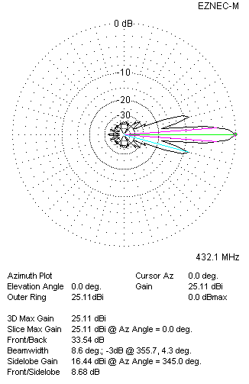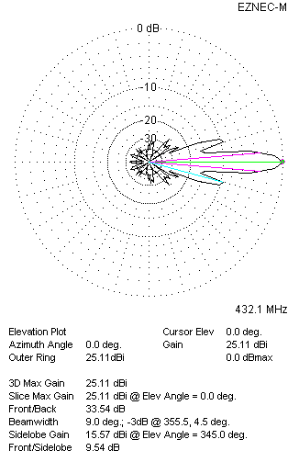
Four antennas in H-stack

