ANTENNA QY72405XL3D12
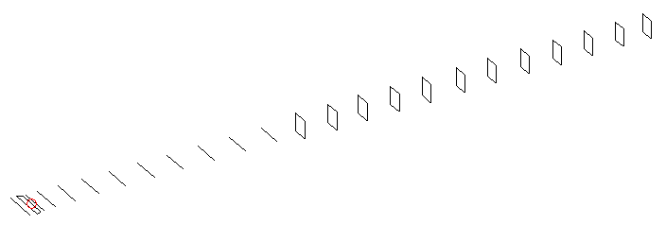
DESCRIPTION
Radiator |  |  | Number of  yagi elements |  |  |  | Number of  oblong elements |  |  |  | Total number  of elements |  |  | Boomlength  (mm)
LFA |  |  | 11 |  |  |  | 12 |  |  |  | 24 |  |  | 5895
DIMENSIONS
 | Ref | De1 |  | De2 | D1 | D2 |  | D3 | D4 | D5 |  | D6 | D7 |  | D8 | D9 | D10
Position | 0 | 55 |  | 105 | 137 | 240 |  | 432 | 660 | 912 |  | 1186 | 1458 |  | 1748 | 2043 | 2342
Length | 336 | 342 |  | 304 | 310 | 310.5 |  | 301.5 | 294.5 | 290 |  | 287 | 283.5 |  | 280 | 277 | 274
 | DQ1 | DQ2 |  | DQ3 | DQ4 | DQ5 |  | DQ6 | DQ7 | DQ8 |  | DQ9 | DQ10 |  | DQ11 | DQ12
Position | 2631 | 2932 |  | 3221 | 3519 | 3821 |  | 4137 | 4434 | 4739 |  | 5041 | 5352 |  | 5638 | 5895
Length | 159 | 157 |  | 155 | 153 | 149 |  | 147 | 143 | 141 |  | 139 | 137 |  | 135 | 133

Remark | All elements made of Al tubes Ǿ5 mm  The height of rectangles is 170 mm  All dimensions given in milimetres
PERFORMANCES (No loss condition)
G  (dBi) |  | F/B  (dB) |  | F/Sh  (dBi) | F/Sv  (dBi) |  | Hor  (◦) |  |  | Ver  (◦) | Temp  (◦K) |  |  | G/T  (dB)
19.09 |  | 30.22 |  | 19.74 | 19.56 |  | 22.6 |  |  | 23.2 | 24.0 |  |  | +6.27
DIAGRAMS
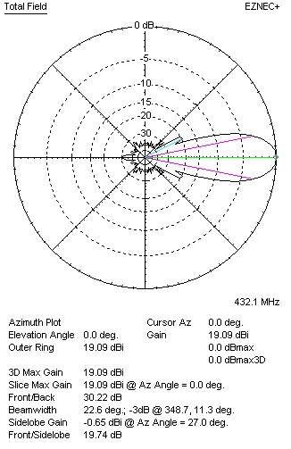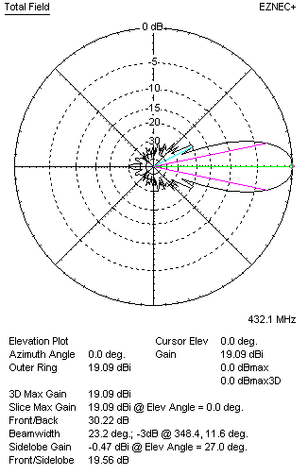
Horizontal and verticall pattern in free space, no loss condition
PERFORMANCES (Loss included for aluminum)
Aluminum |  |  |  | G  (dBi) | Tloss  (K) |  | T_{A}  (◦K) |  |  | G/T  (dB) | Bandwidth for SWR=1.5  (MHz)
After NEC/EZNEC |  |  |  | 19.00 | 6.3 |  | 24.0 |  |  | +5.02 | 425.200 – 437.200
After KF2YN correction |  |  |  | 18.92 | 6.3 |  | 29.8 |  |  | +4.18
Remark: Red coloured data are the final antenna data, which means: KF2YN correction formula applied and loss for aluminum included
DIAGRAMS
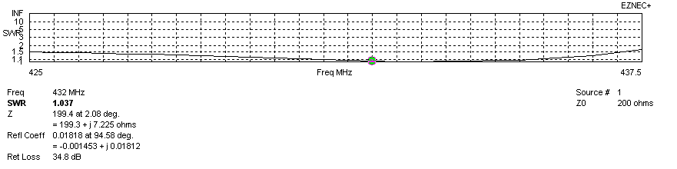
Frequency diagram for SWR better than 1.5
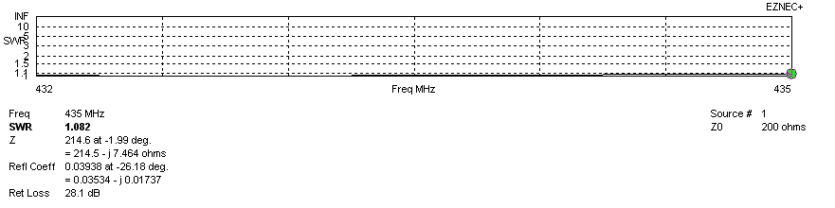
SWR diagram for the range from 432.000 – 435.000 MHz
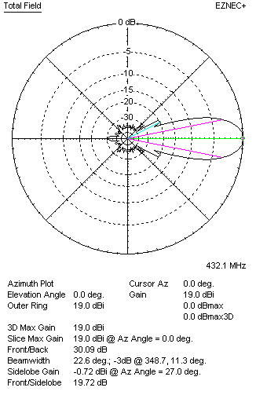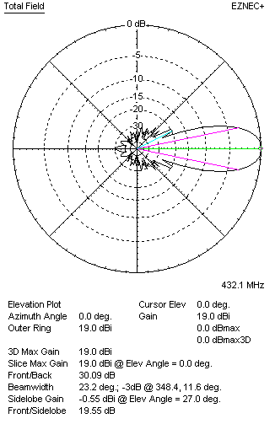
Horizontal and vertical pattern in free space, loss included for aluminum
STACKING
(ALL DATA GIVEN IN ACCORDANCE WITH KF2YN CORRECTION, LOSS INCLUDED)
RECOMMENDED STACKING DISTANCES
 |  |  |  | Two antennas vertically  (mm) |  |  | Two antennas horizontally  (mm) |  |  |  | Four antennas in H-stack  (mm)
Horizontal distance |  |  |  |  |  |  | 2000 |  |  |  | 2000
Vertical distance |  |  |  | 1880 |  |  |  |  |  |  | 1880
TWO ANTENNAS STACKED VERTICALLY
DISTANCE  (mm) |  |  | G  (dBi) |  |  | TA  (K) |  | Tloss  (K) |  |  |  | G/T  (dB)
1880 |  |  | 21.91 |  |  | 29.2 |  | 6.3 |  |  |  | +7.26
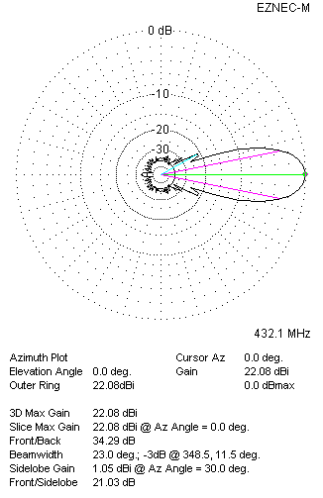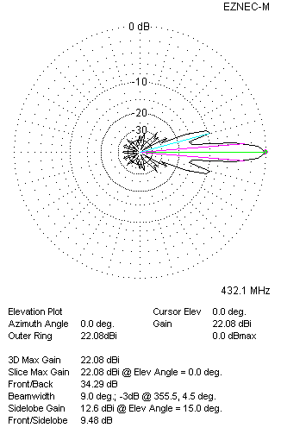
Two antennas stacked vertically
TWO ANTENNAS STACKED HORIZONTALLY
DISTANCE  (mm) |  |  | G  (dBi) |  |  | TA  (K) |  |  | Tloss  (K) |  |  |  | G/T  (dB)
2000 |  |  | 21.93 |  |  | 29.5 |  |  | 6.3 |  |  |  | +7.24
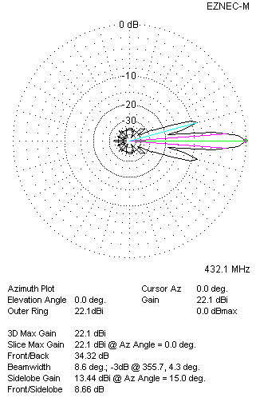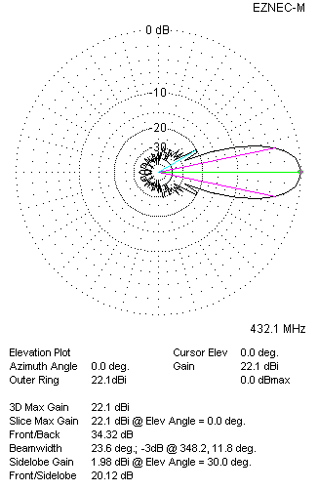
Two antennas stacked horizontally
FOUR ANTENNAS IN H-STACK
DISTANCE  (mm) |  |  | G  (dBi) |  |  | TA  (K) |  |  | Tloss  (K) |  |  |  | G/T  (dB)
H = 2000 |  |  | 24.93 |  |  | 29.2 |  |  | 6.3 |  |  |  | +10.28
V = 1880
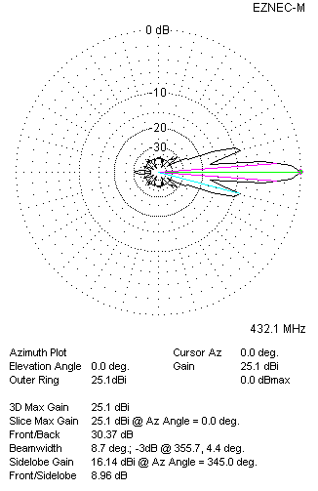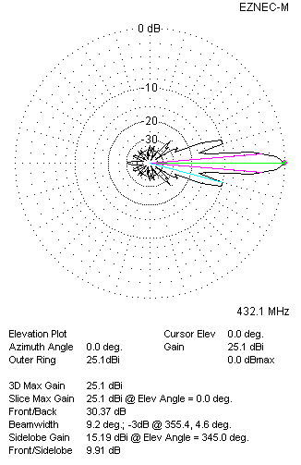
Four antennas in H-stack

