ANTENNA QY72305XL1D16
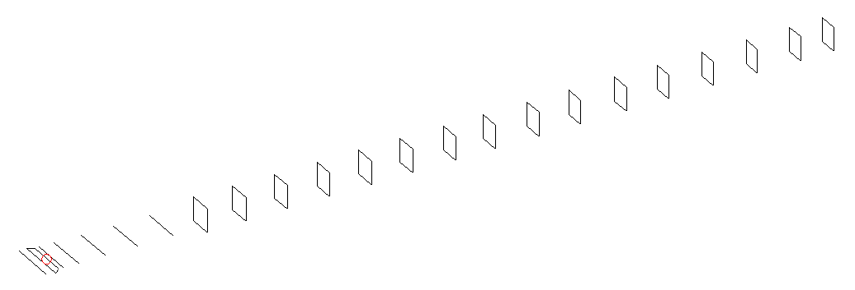
DESCRIPTION
Radiator |  |  | Number of  yagi elements |  |  | Number of  oblong elements |  |  |  | Total number  of elements |  |  |  | Boomlength  (mm)
LFA |  |  | 6 |  |  | 16 |  |  |  | 23 |  |  |  | 5595
DIMENSIONS
 | Ref | De1 |  | De2 | D1 |  | D2 | D3 | D4 |  | D5 | DQ1 | DQ2 |  | DQ3 | DQ4
Position | 0 | 60 |  | 100 | 132 |  | 237 | 428 | 654 |  | 906 | 1179 | 1454 |  | 1746 | 2046
Length | 336 | 345 |  | 290 | 308 |  | 310 | 301 | 295.5 |  | 287.5 | 171 | 165 |  | 159 | 157
 | DQ5 | DQ6 |  | DQ7 | DQ8 |  | DQ9 | DQ10 | DQ11 |  | DQ12 | DQ13 | DQ14 |  | DQ15 | DQ16
Position | 2338 | 2628 |  | 2932 | 3214 |  | 3522 | 3812 | 4136 |  | 4434 | 4748 | 5059 |  | 5364 | 5595
Length | 156 | 154 |  | 153 | 152 |  | 149 | 145 | 143 |  | 141 | 137 | 137 |  | 137 | 137

Remark | All elements made of Al tubes Ǿ5 mm  The height of rectangles is 170 mm  All dimensions given in milimetres
PERFORMANCES (No loss condition)
G  (dBi) |  | F/B  (dB) |  | F/Sh  (dBi) | F/Sv  (dBi) |  | Hor  (◦) |  |  | Ver  (◦) | Temp  (◦K) |  |  | G/T  (dB)
18.76 |  | 49.39 |  | 21.19 | 18.08 |  | 24.0 |  |  | 24.2 | 24.4 |  |  | +5.73
DIAGRAMS
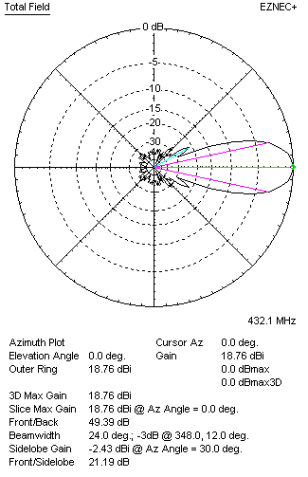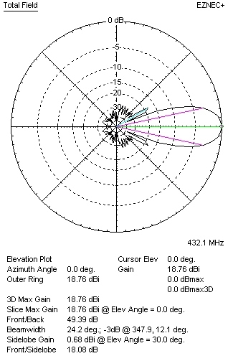
Horizontal and verticall pattern in free space, no loss condition
PERFORMANCES (Loss included for aluminum)
Aluminum |  |  |  | G  (dBi) | Tloss  (K) |  | T_{A}  (◦K) |  |  | G/T  (dB) | Bandwidth for SWR=1.5  (MHz)
After NEC/EZNEC |  |  |  | 18.68 | 5.7 |  | 24.4 |  |  | +4.61 | 426.000 – 437.800
After KF2YN correction |  |  |  | 18.60 | 5.7 |  | 29.6 |  |  | +3.89
Remark: Red coloured data are the final antenna data, which means: KF2YN correction formula applied and loss for aluminum included
DIAGRAMS
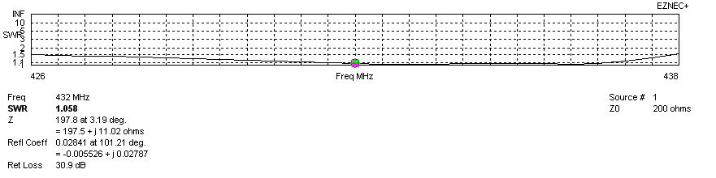
Frequency diagram for SWR better than 1.5
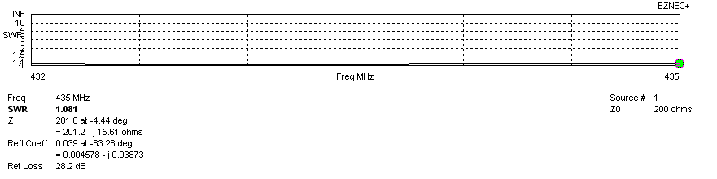
SWR diagram for the range from 432.000 – 435.000 MHz
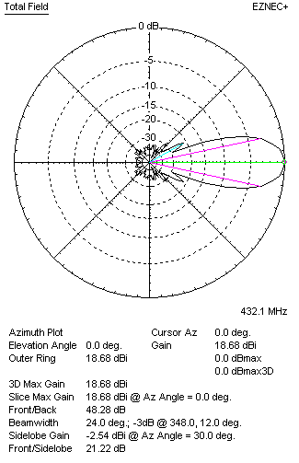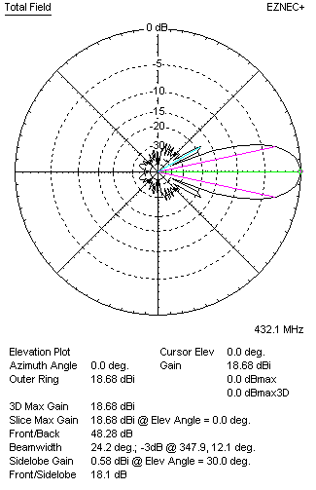
Horizontal and vertical pattern in free space, loss included for aluminum
STACKING
(ALL DATA GIVEN IN ACCORDANCE WITH KF2YN CORRECTION, LOSS INCLUDED)
RECOMMENDED STACKING DISTANCES
 |  |  |  | Two antennas vertically  (mm) |  |  | Two antennas horizontally  (mm) |  |  |  | Four antennas in H-stack  (mm)
Horizontal distance |  |  |  |  |  |  | 2040 |  |  |  | 2040
Vertical distance |  |  |  | 1980 |  |  |  |  |  |  | 1980
TWO ANTENNAS STACKED VERTICALLY
DISTANCE  (mm) |  |  | G  (dBi) |  |  | TA  (K) |  | Tloss  (K) |  |  |  | G/T  (dB)
1980 |  |  | 21.64 |  |  | 28.8 |  | 5.7 |  |  |  | +7.06
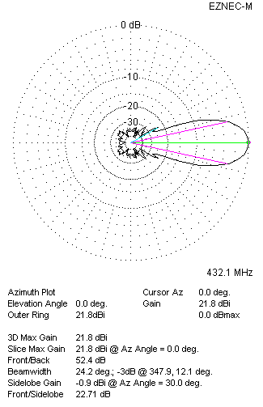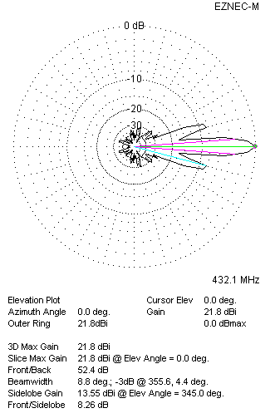
Two antennas stacked vertically
TWO ANTENNAS STACKED HORIZONTALLY
DISTANCE  (mm) |  |  | G  (dBi) |  |  | TA  (K) |  |  | Tloss  (K) |  |  |  | G/T  (dB)
2020 |  |  | 21.64 |  |  | 29.1 |  |  | 5.7 |  |  |  | +7.00
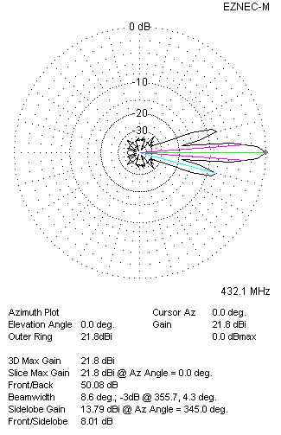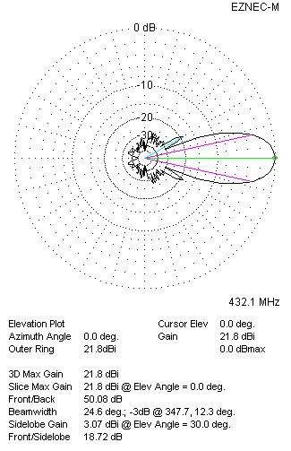
Two antennas stacked horizontally
FOUR ANTENNAS IN H-STACK
DISTANCE  (mm) |  |  | G  (dBi) |  |  | TA  (K) |  |  | Tloss  (K) |  |  |  | G/T  (dB)
H = 2020 |  |  | 24.68 |  |  | 28.6 |  |  | 5.7 |  |  |  | +10.13
V = 2020
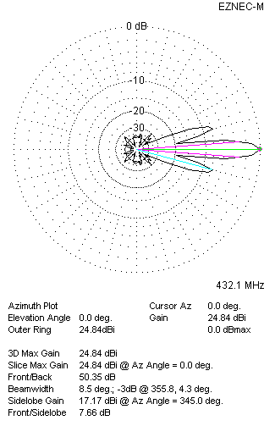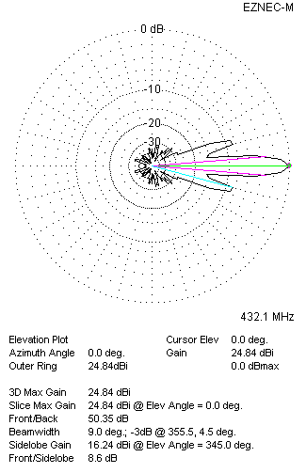
Four antennas in H-stack

