ANTENNA Q734D9XL
PERFORMANCES: (No loss condition)
TYPE | ELE | L (mm) | G (dBi) | F/B (dB) | F/Sh (dBi) | F/Sv (dBi) | Hor (◦) | Ver (◦) | Temp (◦K) | G/T (dB) | ΔF * (kHz)
Q734D9XL | 34 | 9339 | 20,68 | 45,74 | 21,58 | 20,75 | 19,0 | 19,2 | 15,4 | +8,80 | 5650
* ΔF given for SWR=1,5

PERFORMANCES: (Losses included)
Element material | G (dBi) | Temp (◦K) | G/T (dB)
Aluminum rods | 20,65 | 17,9 | +8,13
Silvered rods | 20,66 | 17,0 | +8,35

DIMENSIONS:
 | Ref | De | D1 | D2 | D3 | D4 | D5 | D6 | D7 | D8 | D9 | D10 | D11
Pos | 0 | 125 | 204 | 351 | 488 | 688 | 942 | 1222 | 1519 | 1829 | 2142 | 2461 | 2775
Length | 288 | 256 | 245 | 222 | 218 | 217 | 212 | 207 | 201 | 196 | 193 | 191 | 189
 | D12 | D13 | D14 | D15 | D16 | D17 | D18 | D19 | D20 | D21 | D22 | D23 | D24
Pos | 3098 | 3426 | 3750 | 4075 | 4404 | 4723 | 5054 | 5376 | 5705 | 6023 | 6339 | 6644 | 6958
Length | 185 | 182 | 181 | 180 | 175 | 175 | 173 | 171 | 170 | 169 | 168 | 167 | 166
 | D25 | D26 | D27 | D28 | D29 | D30 | D31 | D32 | - All elements made of Al rods Ǿ10,0 mm  - The height of all rectangles is 100 mm  - All dimensions given in milimetres
Pos | 7268 | 7551 | 7860 | 8157 | 8486 | 8767 | 9081 | 9339
Length | 163 | 162 | 161 | 160 | 159 | 158 | 157 | 154

COMPARISON
Antenna | Boomlength (mm) | Material | Gain (dBi) | TA (◦K) | G/T (dB) | Bandwidth  (MHz)
Q734D9XL | 9339 | No loss | 20,68 | 15,4 | +8,80 | 429,000-434,650
Q734D9XL | 9339 | Aluminum | 20,65 | 17,9 | +8,13 | 429,000-434,650
Q734D9XL | 9339 | Silver | 20,66 | 17,0 | +8,35 | 429,000-434,650
NO REFERENCE TO COMPARE |  | No loss
 |  | Aluminum
 |  | Silver

DIAGRAMS
NO LOSS INCLUDED
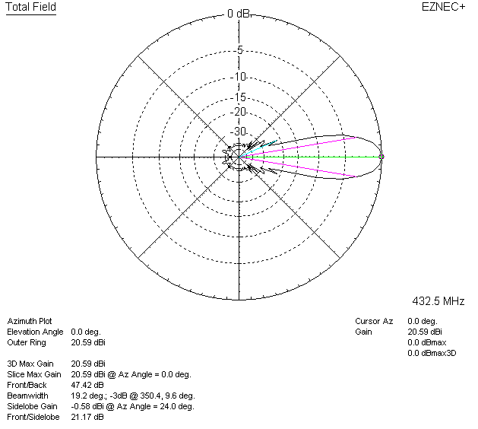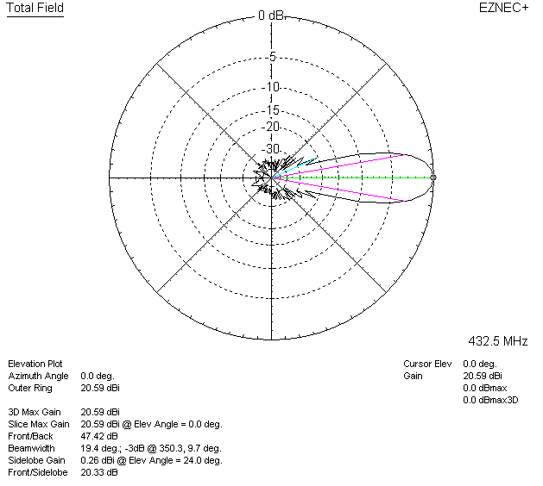

LOSSES INCLUDED (aluminum)
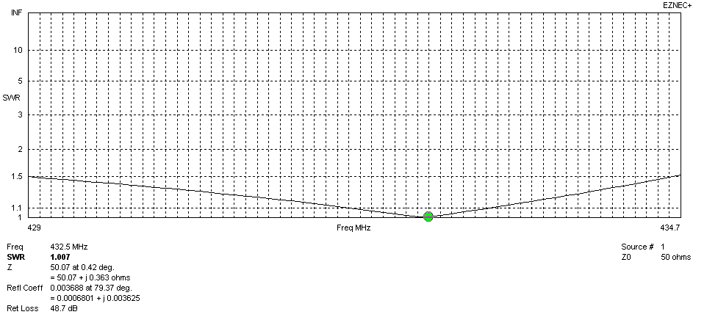
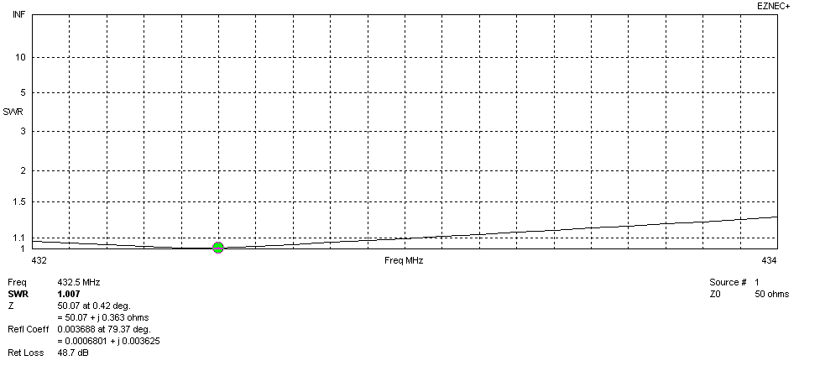
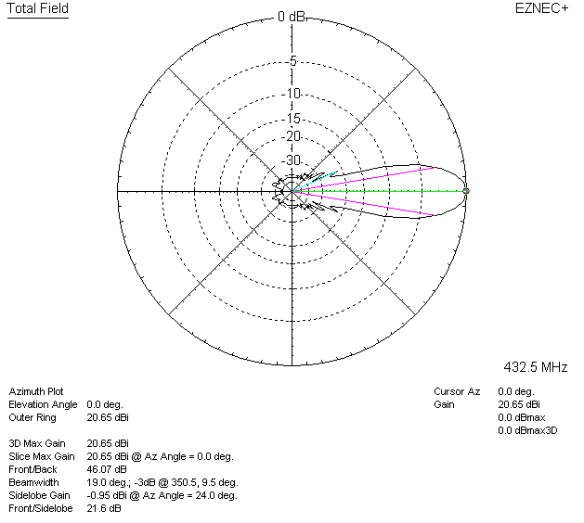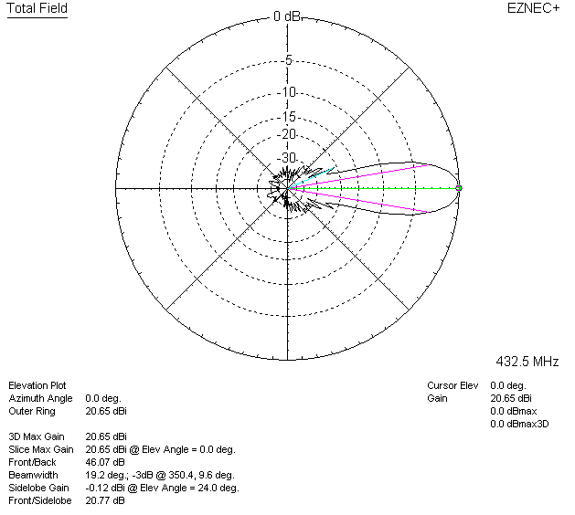

LOSSES INCLUDED (silver)
