ANTENNA Q730D5XL
PERFORMANCES: (No loss condition)
TYPE | ELE | L (mm) | G (dBi) | F/B (dB) | F/Sh (dBi) | F/Sv (dBi) | Hor (◦) | Ver (◦) | Temp (◦K) | G/T (dB) | ΔF * (kHz)
Q730D5XL | 30 | 8115 | 20,54 | 27,56 | 19,67 | 18,85 | 19,0 | 19,2 | 16,3 | +8,42 | 4750
* ΔF given for SWR=1,5

PERFORMANCES: (Losses included)
Element material | G (dBi) | Temp (◦K) | G/T (dB)
Aluminum rods | 20,48 | 20,1 | +7,44
Silvered rods | 20,50 | 18,7 | +7,77

DIMENSIONS:
 | Ref | De | D1 | D2 | D3 | D4 | D5 | D6 | D7 | D8 | D9 | D10 | D11 | D12 | D13
Pos | 0 | 127 | 199 | 351 | 487 | 687 | 939 | 1227 | 1522 | 1825 | 2130 | 2449 | 2767 | 3089 | 3409
Length | 284 | 260 | 248 | 229 | 225 | 221 | 215 | 209 | 205 | 203 | 199 | 196 | 193 | 191 | 189
 | D14 | D15 | D16 | D17 | D18 | D19 | D20 | D21 | D22 | D23 | D24 | D25 | D26 | D27 | D28
Pos | 3733 | 4062 | 4382 | 4715 | 5045 | 5363 | 5685 | 5996 | 6319 | 6632 | 6935 | 7245 | 7555 | 7847 | 8115
Length | 186 | 184 | 182 | 180 | 180 | 180 | 180 | 176 | 176 | 176 | 176 | 171 | 171 | 171 | 168
- All elements made of Al rods Ǿ8,0 mm
- The height of all rectangles is 100 mm
- All dimensions given in milimetres

COMPARISON
Antenna | Boomlength (mm) | Material | Gain (dBi) | TA (◦K) | G/T (dB) | Bandwidth  (MHz)
Q730D5XL | 8115 | No loss | 20,54 | 16,3 | +8,42 | 429,400-434,150
Q730D5XL | 8115 | Aluminum | 20,48 | 20,1 | +7,44 | 429,400-434,150
Q730D5XL | 8115 | Silver | 20,50 | 18,7 | +7,77 | 429,400-434,150
EF7032-5 | 8670 | No loss | 19,93 | 19,9 | +6,94 | 429,700-433,980
EF7032-5 | 8670 | Aluminum | 19,85 | 25,5 | +5,78 | 429,700-433,980
EF7032-5 | 8670 | Silver | 19,88 | 23,3 | +6,20 | 429,700-433,980

DIAGRAMS
NO LOSS INCLUDED
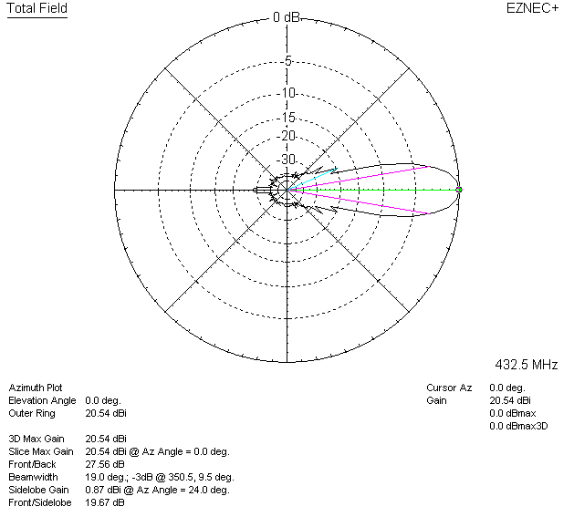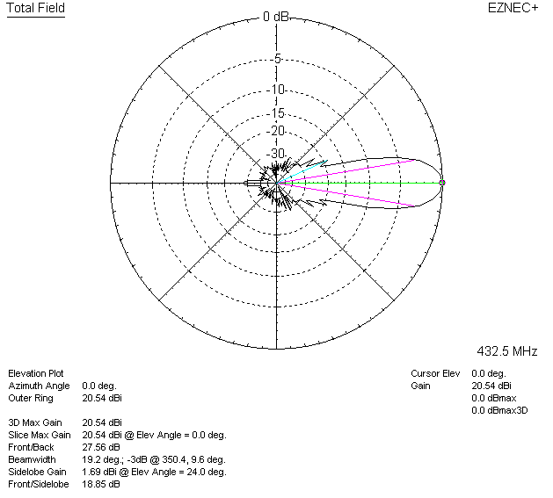

LOSSES INCLUDED (aluminum)
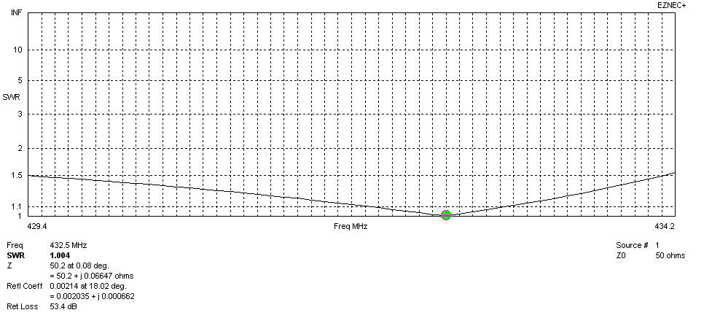
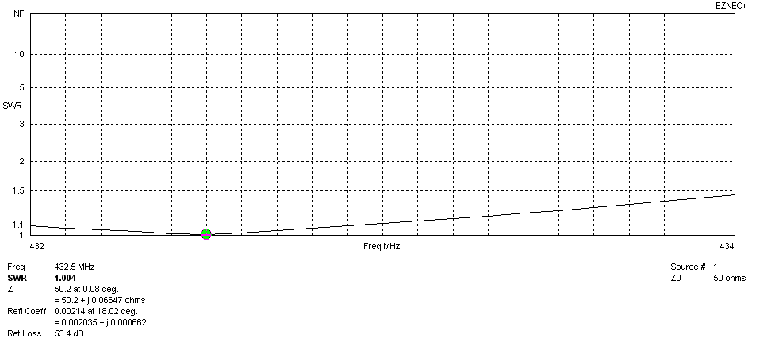
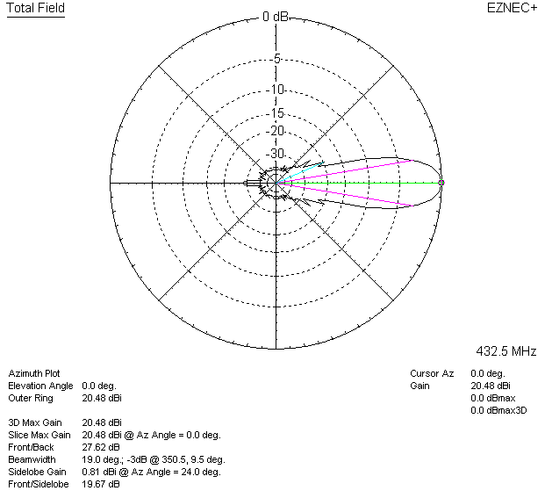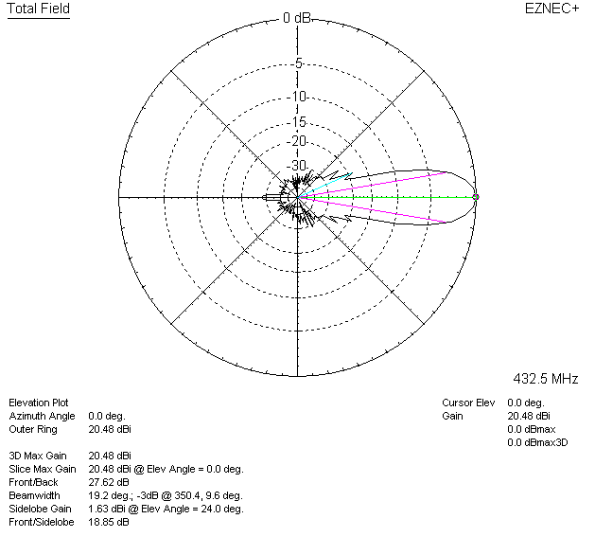

LOSSES INCLUDED (silver)
