ANTENNA Q728D9XL
PERFORMANCES: (No loss condition)
TYPE | ELE | L (mm) | G (dBi) | F/B (dB) | F/Sh (dBi) | F/Sv (dBi) | Hor (◦) | Ver (◦) | Temp (◦K) | G/T (dB) | ΔF * (kHz)
Q728D9XL | 28 | 7535 | 20,06 | 29,14 | 21,45 | 20,58 | 20,2 | 20,5 | 16,0 | +8,01 | 5950
* ΔF given for SWR=1,5

PERFORMANCES: (Losses included)
Element material | G (dBi) | Temp (◦K) | G/T (dB)
Aluminum rods | 20,03 | 18,6 | +7,34
Silvered rods | 20,04 | 17,7 | +7,57

DIMENSIONS:
 | Ref | De | D1 | D2 | D3 | D4 | D5 | D6 | D7 | D8 | D9 | D10 | D11 | D12
Pos | 0 | 116 | 198 | 349 | 485 | 690 | 942 | 1222 | 1519 | 1829 | 2139 | 2458 | 2775 | 3096
Length | 284 | 256 | 245 | 223 | 219 | 217 | 213 | 207 | 202 | 196 | 194 | 191 | 188 | 184
 | D13 | D14 | D15 | D16 | D17 | D18 | D19 | D20 | D21 | D22 | D23 | D24 | D25
Pos | 3427 | 3746 | 4072 | 4403 | 4728 | 5047 | 5369 | 5699 | 6028 | 6327 | 6645 | 6955 | 7265 | 7535
Length | 182 | 181 | 180 | 175 | 175 | 173 | 171 | 170 | 169 | 168 | 167 | 166 | 165 | 161
- All elements made of Al rods Ǿ10,0 mm
- The height of all rectangles is 100 mm
- All dimensions given in milimetres

COMPARISON
Antenna | Boomlength (mm) | Material | Gain (dBi) | TA (◦K) | G/T (dB) | Bandwidth  (MHz)
Q728D9XL | 7215 | No loss | 20,06 | 15,9 | +7,92 | 429,600-434,550
Q728D9XL | 7215 | Aluminum | 20,03 | 18,6 | +7,34 | 429,600-434,550
Q728D9XL | 7215 | Silver | 20,04 | 17,7 | +7,57 | 429,600-434,550
EF7032-5 | 8670 | No loss | 19,93 | 19,9 | +6,94 | 429,700-433,980
EF7032-5 | 8670 | Aluminum | 19,85 | 25,5 | +5,78 | 429,700-433,980
EF7032-5 | 8670 | Silver | 19,88 | 23,3 | +6,20 | 429,700-433,980

DIAGRAMS
NO LOSS INCLUDED
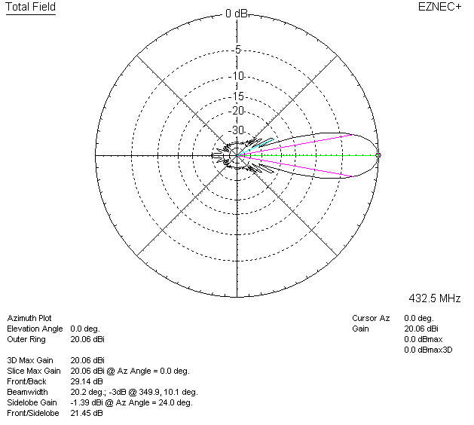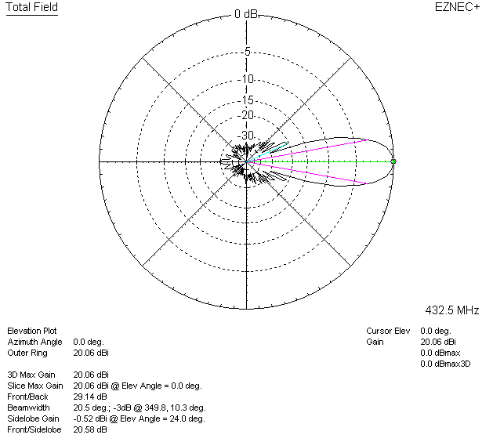

LOSSES INCLUDED (aluminum)
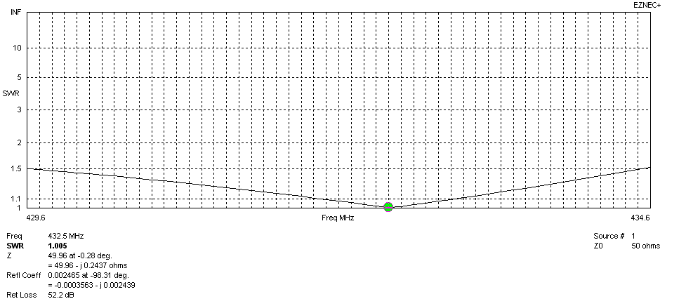
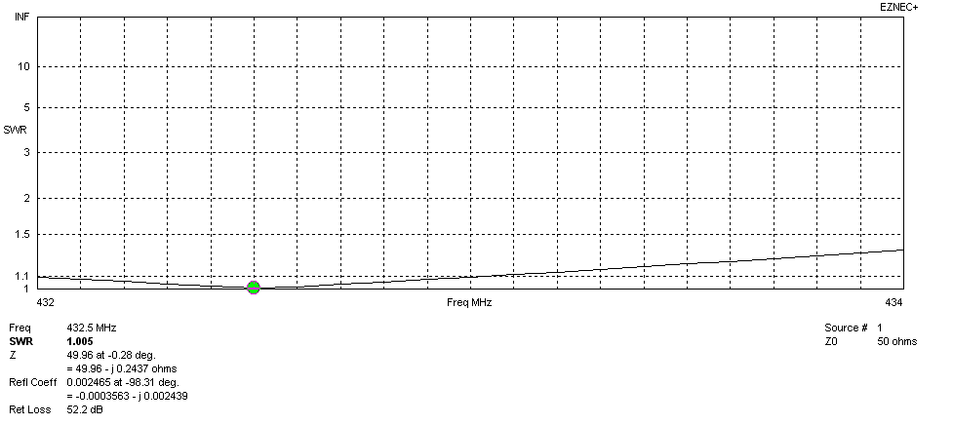
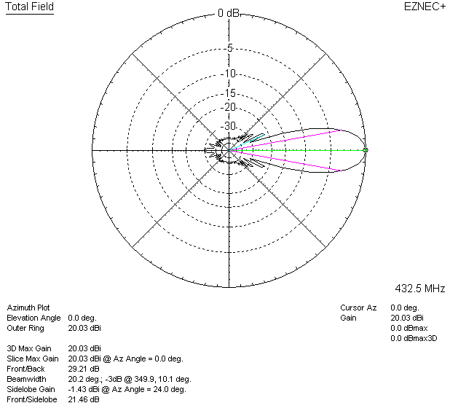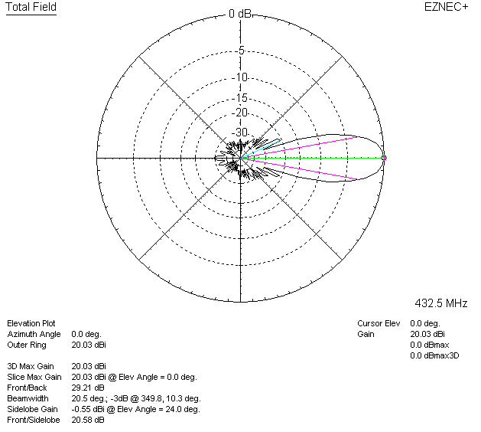

LOSSES INCLUDED (silver)
