ANTENNA Q725D5XL
PERFORMANCES: (No loss condition)
TYPE | ELE | L (mm) | G (dBi) | F/B (dB) | F/Sh (dBi) | F/Sv (dBi) | Hor (◦) | Ver (◦) | Temp (◦K) | G/T (dB) | ΔF * (kHz)
Q725D5XL | 25 | 6575 | 19,82 | 30,44 | 19,70 | 18,73 | 20,2 | 20,6 | 16,7 | +7,60 | 7400
* ΔF given for SWR=1,5

PERFORMANCES: (Losses included)
Element material | G (dBi) | Temp (◦K) | G/T (dB)
Aluminum rods | 19,76 | 20,5 | +6,64
Silvered rods | 18,78 | 19,1 | +6,96

DIMENSIONS:
 | Ref | De | D1 | D2 | D3 | D4 | D5 | D6 | D7 | D8 | D9 | D10 | D11
Pos | 0 | 128 | 199 | 350 | 484 | 687 | 939 | 1227 | 1522 | 1825 | 2130 | 2449 | 2767
Length | 282 | 263 | 248 | 229 | 225 | 222 | 215 | 210 | 206 | 202 | 199 | 196 | 193
 | D12 | D13 | D14 | D15 | D16 | D17 | D18 | D19 | D20 | D21 | D22 | D23
Pos | 3089 | 3409 | 3733 | 4062 | 4382 | 4715 | 5045 | 5363 | 5685 | 5996 | 6309 | 6575
Length | 191 | 189 | 186 | 184 | 182 | 180 | 180 | 180 | 178 | 176 | 174 | 172
- All elements made of Al rods Ǿ8,0 mm
- The height of all rectangles is 100 mm
- All dimensions given in milimetres

COMPARISON
Antenna | Boomlength (mm) | Material | Gain (dBi) | TA  (◦K) | G/T  (dB) | Bandwidth  (MHz)
Q725D5XL | 6575 | No loss | 19,82 | 16,7 | +7,60 | 427,000-434,400
Q725D5XL | 6575 | Aluminum | 19,76 | 20,5 | +6,64 | 427,000-434,400
Q725D5XL | 6575 | Silver | 19,78 | 19,1 | +6,96 | 427,000-434,400
EF7032-5 | 8670 | No loss | 19,93 | 19,9 | +6,94 | 429,700-433,980
EF7032-5 | 8670 | Aluminum | 19,85 | 25,5 | +5,78 | 429,700-433,980
EF7032-5 | 8670 | Silver | 19,88 | 23,3 | +6,20 | 429,700-433,980

DIAGRAMS
NO LOSS INCLUDED
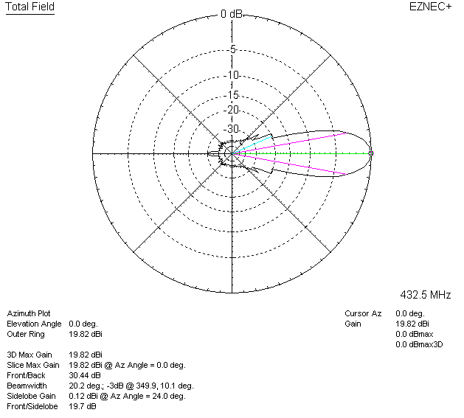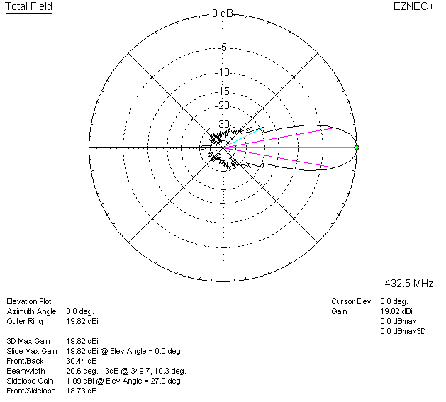

LOSSES INCLUDED (aluminum)
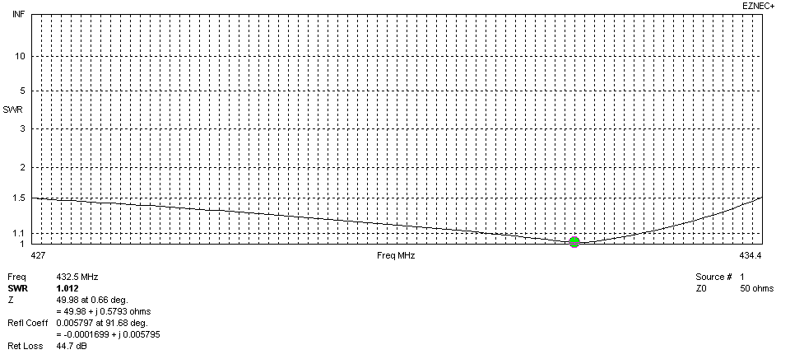
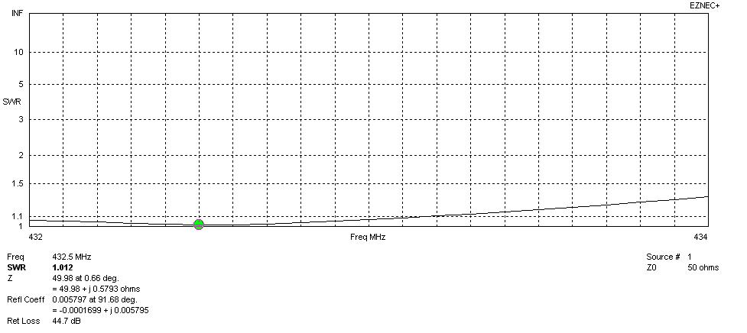
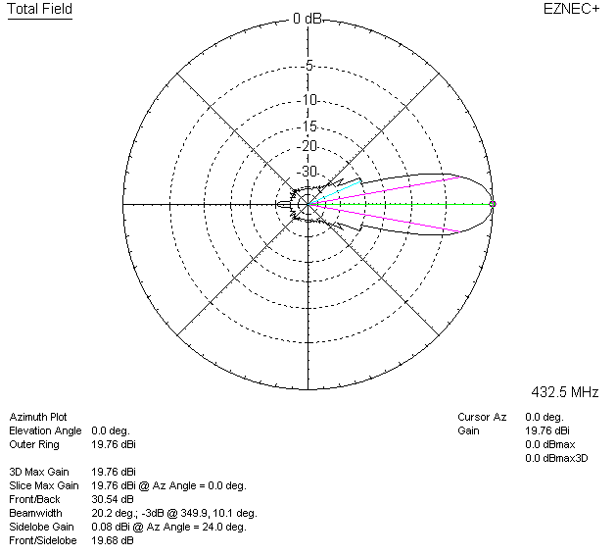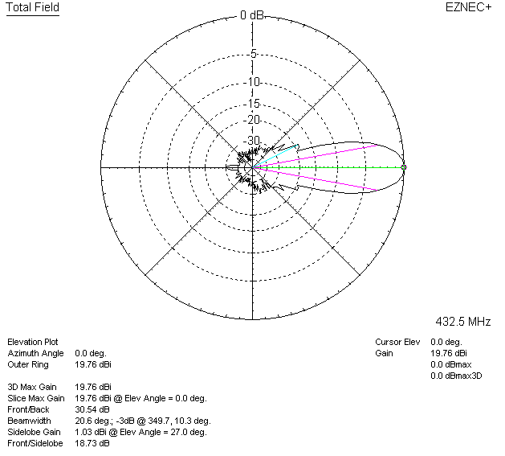

LOSSES INCLUDED (silver)
