ANTENNA Q723D9XL
PERFORMANCES: (No loss condition)
TYPE | ELE | L (mm) | G (dBi) | F/B (dB) | F/Sh (dBi) | F/Sv (dBi) | Hor (◦) | Ver (◦) | Temp (◦K) | G/T (dB) | ΔF * (kHz)
Q723D9XL | 23 | 5975 | 19,47 | 30,05 | 19,03 | 17,97 | 21,0 | 21,6 | 16,4 | +7,32 | 3800
* ΔF given for SWR=1,5

PERFORMANCES: (Losses included)
Element material | G (dBi) | Temp (◦K) | G/T (dB)
Aluminum rods | 19,43 | 19,3 | +6,57
Silvered rods | 19,45 | 18,2 | +6,85

DIMENSIONS:
 | Ref | De | D1 | D2 | D3 | D4 | D5 | D6 | D7 | D8 | D9 | D10 | D11 | D12
Pos | 0 | 125 | 199 | 351 | 485 | 690 | 940 | 1223 | 1519 | 1829 | 2139 | 2458 | 2773 | 3094
Length | 286 | 257 | 247 | 225 | 221 | 218 | 213 | 207 | 203 | 199 | 196 | 193 | 189 | 186
 | D13 | D14 | D15 | D16 | D17 | D18 | D19 | D20 | D21 | - All elements made of Al rods Ǿ10,0 mm  - The height of all rectangles is 100 mm  - All dimensions given in milimetres
Pos | 3422 | 3745 | 4072 | 4403 | 4728 | 5047 | 5369 | 5691 | 5975
Length | 184 | 182 | 180 | 178 | 176 | 174 | 172 | 170 | 168

COMPARISON
Antenna | Boomlength (mm) | Material | Gain (dBi) | TA (◦K) | G/T (dB) | Bandwidth  (MHz)
Q723D9XL | 5605 | No loss | 19,47 | 16,4 | +7,32 | 430,100-433,900
Q723D9XL | 5605 | Aluminum | 19,43 | 19,3 | +6,57 | 430,100-433,900
Q723D9XL | 5605 | Silver | 19,45 | 18,2 | +6,85 | 430,100-433,900
EF7023-5 | 5965 | No loss | 19,05 | 20,4 | +5,96 | 428,000-434,200
EF7023-5 | 5965 | Aluminum | 18,97 | 25,7 | +4,87 | 428,000-434,200
EF7023-5 | 5965 | Silver | 19,00 | 23,7 | +5,25 | 428,000-434,200

DIAGRAMS
NO LOSS INCLUDED
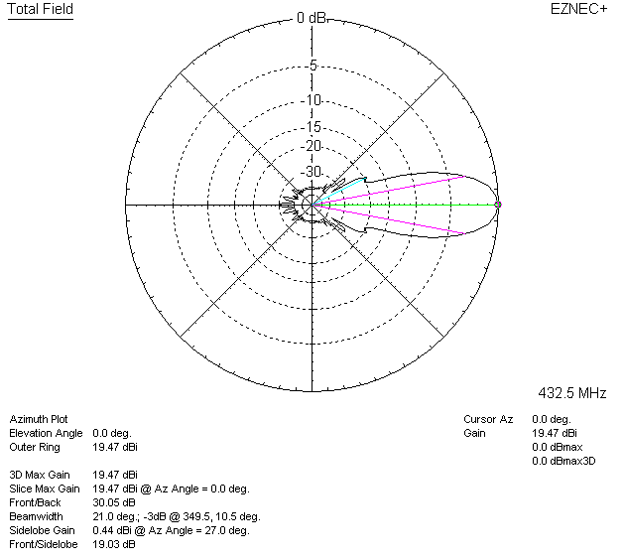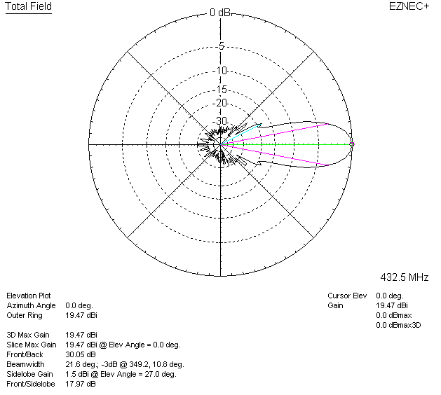

LOSSES INCLUDED (aluminum)
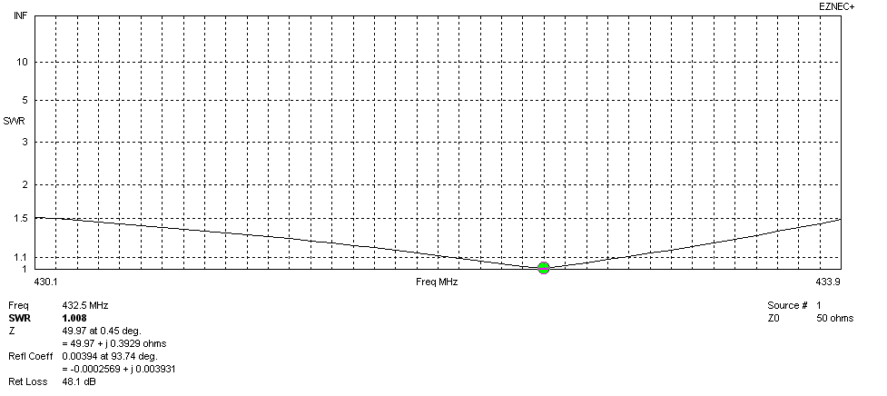
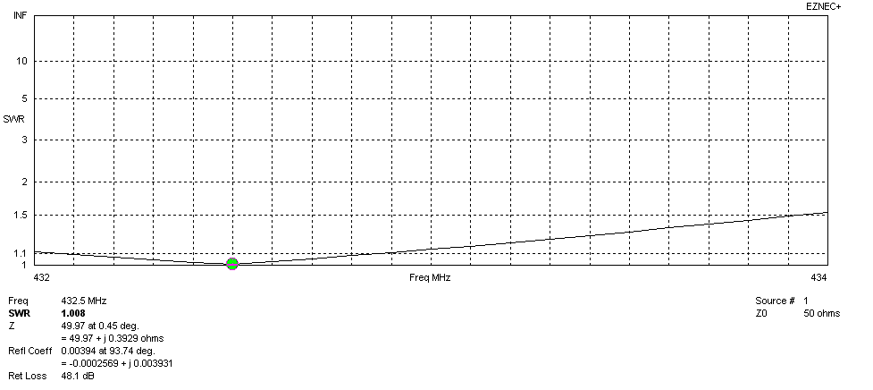
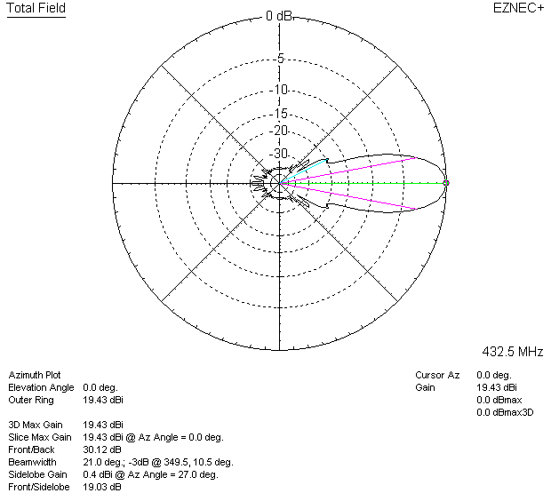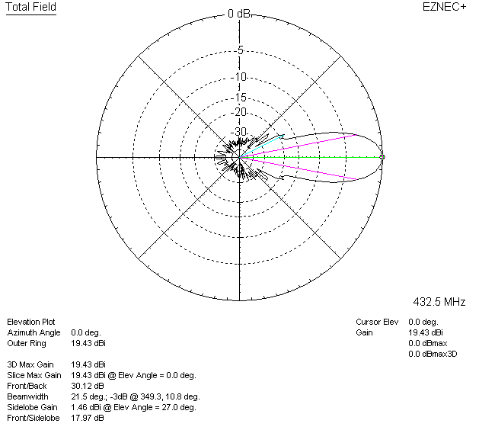

LOSSES INCLUDED (silver)
