ANTENNA Q723D8XL
PERFORMANCES: (No loss condition)
TYPE | ELE | L (mm) | G (dBi) | F/B (dB) | F/Sh (dBi) | F/Sv (dBi) | Hor (◦) | Ver (◦) | Temp (◦K) | G/T (dB) | ΔF * (kHz)
Q723D8XL | 23 | 5828 | 19,52 | 23,54 | 18,88 | 17,84 | 20,8 | 21,2 | 17,5 | +7,08 | 5780
* ΔF given for SWR=1,5

PERFORMANCES: (Losses included)
Element material | G (dBi) | Temp (◦K) | G/T (dB)
Aluminum rods | 19,46 | 21,5 | +6,13
Silvered rods | 19,49 | 20,0 | +6,47

DIMENSIONS:
 | Ref | De | D1 | D2 | D3 | D4 | D5 | D6 | D7 | D8 | D9 | D10 | D11 | D12 | D13
Pos | 0 | 129 | 198 | 348 | 483 | 685 | 939 | 1227 | 1522 | 1825 | 2130 | 2449 | 2767 | 3089 | 3409
Length | 283 | 262 | 248 | 229 | 225 | 222 | 215 | 210 | 206 | 202 | 199 | 196 | 193 | 191 | 189
 | D14 | D15 | D16 | D17 | D18 | D19 | D20 | D21 | - All elements made of Al rods Ǿ8,0 mm  - The height of all rectangles is 100 mm  - All dimensions given in milimetres
Pos | 3733 | 4062 | 4382 | 4715 | 5048 | 5362 | 5689 | 5964
Length | 186 | 184 | 182 | 180 | 178 | 177 | 177 | 177

COMPARISON
Antenna | Boomlength (mm) | Material | Gain (dBi) | TA (◦K) | G/T (dB) | Bandwidth  (MHz)
Q723D8XL | 5828 | No loss | 19,52 | 17,5 | +7,08 | 429,200-433,980
Q723D8XL | 5828 | Aluminum | 19,46 | 21,5 | +6,13 | 429,200-433,980
Q723D8XL | 5828 | Silver | 19,49 | 20,0 | +6,47 | 429,200-433,980
EF7023-5 | 5965 | No loss | 19,05 | 20,4 | +5,96 | 428,000-434,200
EF7023-5 | 5965 | Aluminum | 18,97 | 25,7 | +4,87 | 428,000-434,200
EF7023-5 | 5965 | Silver | 19,00 | 23,7 | +5,25 | 428,000-434,200

DIAGRAMS
NO LOSS INCLUDED
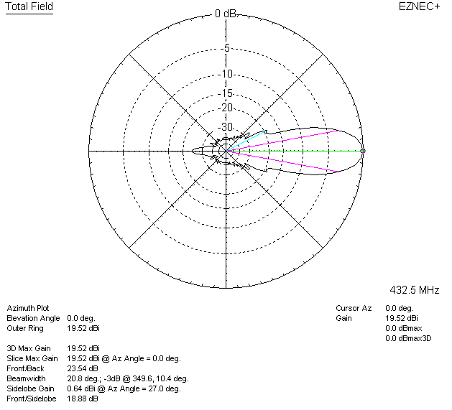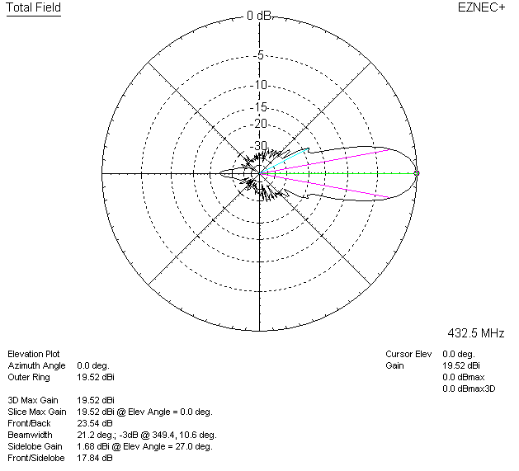

LOSSES INCLUDED (aluminum)
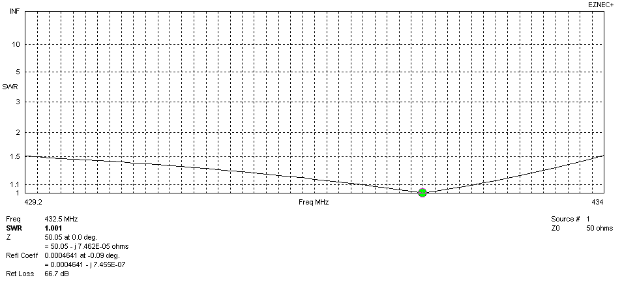
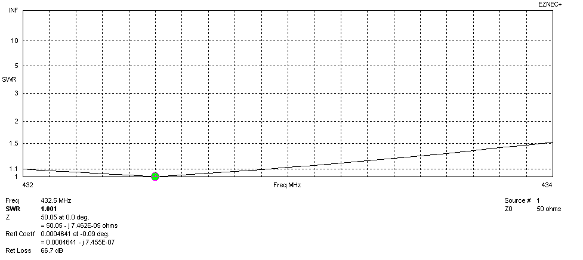
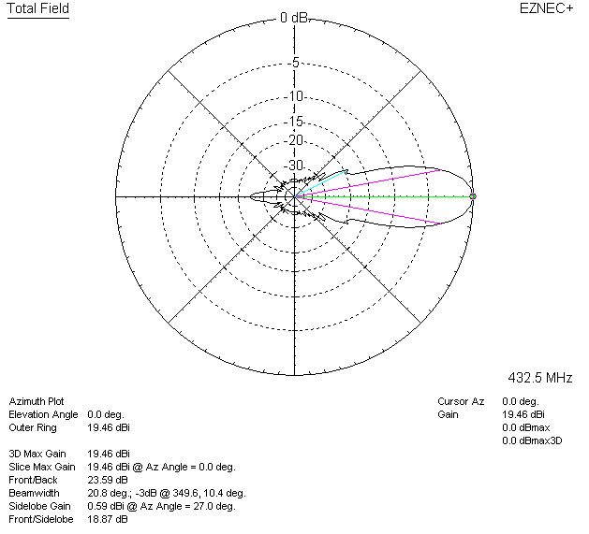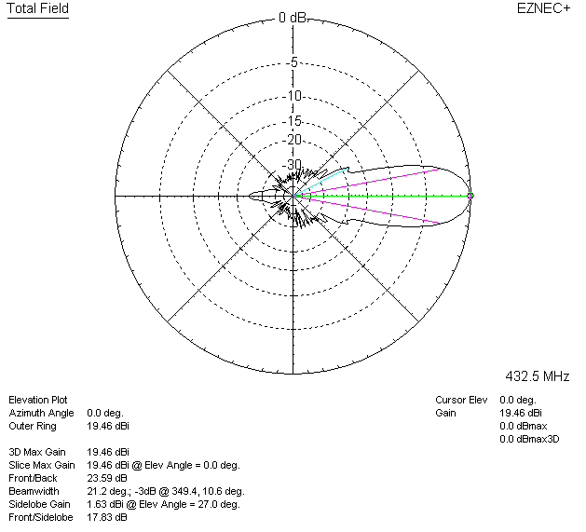

LOSSES INCLUDED (silver)
