ANTENNA Q719D9XL
PERFORMANCES: (No loss condition)
TYPE | ELE | L (mm) | G (dBi) | F/B (dB) | F/Sh (dBi) | F/Sv (dBi) | Hor (◦) | Ver (◦) | Temp (◦K) | G/T (dB) | ΔF * (kHz)
Q719D9XL | 19 | 4660 | 18,50 | 28,83 | 19,61 | 18,29 | 23,8 | 24,4 | 17,3 | +6,11 | 6150
* ΔF given for SWR=1,5

PERFORMANCES: (Losses included)
Element material | G (dBi) | Temp (◦K) | G/T (dB)
Aluminum rods | 18,46 | 20,0 | +5,46
Silvered rods | 18,47 | 19,0 | +5,68

DIMENSIONS:
 | Ref | De | D1 | D2 | D3 | D4 | D5 | D6 | D7 | D8 | D9 | D10 | D11 | D12
Pos | 0 | 120 | 199 | 351 | 484 | 691 | 939 | 1223 | 1519 | 1831 | 2139 | 2456 | 2769 | 3089
Length | 286 | 259 | 247 | 225 | 221 | 219 | 213 | 207 | 202 | 198 | 195 | 191 | 189 | 184
 | D13 | D14 | D15 | D16 | D17 | - All elements made of Al rods Ǿ10,0 mm  - The height of all rectangles is 100 mm  - All dimensions given in milimetres
Pos | 3416 | 3734 | 4062 | 4362 | 4660
Length | 182 | 180 | 178 | 176 | 172

COMPARISON
Antenna | Boomlength (mm) | Material | Gain (dBi) | TA (◦K) | G/T (dB) | Bandwidth  (MHz)
Q719D9XL | 4325 | No loss | 18,50 | 17,3 | +6,11 | 428,500-434,650
Q719D9XL | 4325 | Aluminum | 18,46 | 20,0 | +5,46 | 428,500-434,650
Q719D9XL | 4325 | Silver | 18,27 | 19,0 | +5,68 | 428,500-434,650
EF7019-5 | 4692 | No loss | 18,21 | 20,4 | +5,11 | 429,700-433,800
EF7019-5 | 4692 | Aluminum | 18,12 | 26,0 | +3,98 | 429,700-433,800
EF7019-5 | 4692 | Silver | 18,16 | 23,9 | +4,38 | 429,700-433,800

DIAGRAMS
NO LOSS INCLUDED
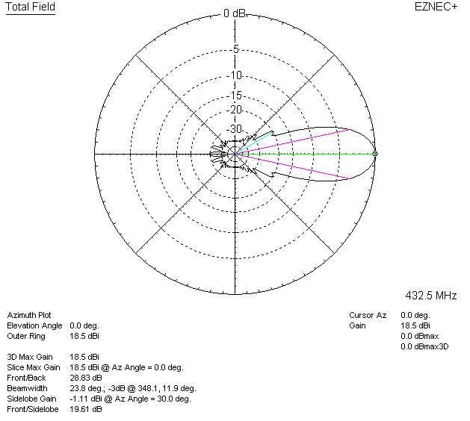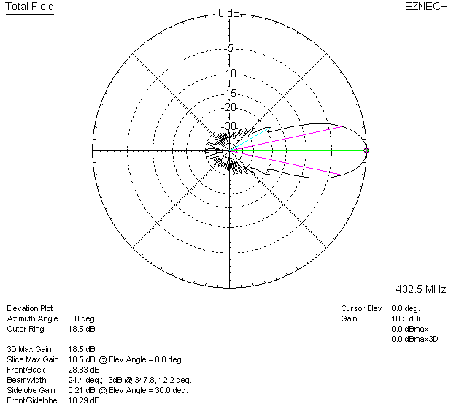

LOSSES INCLUDED (aluminum)
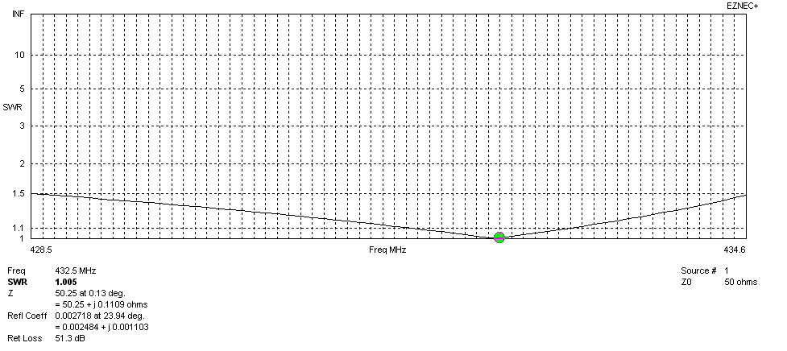
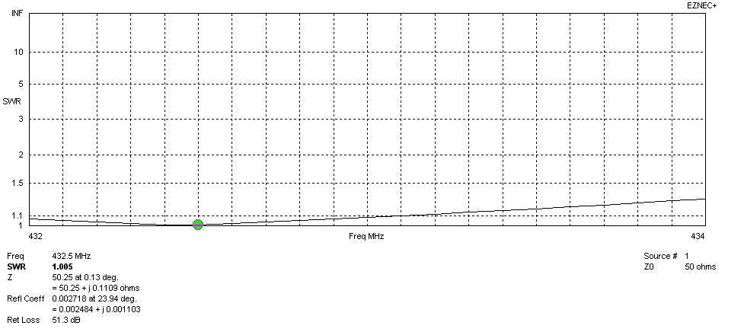
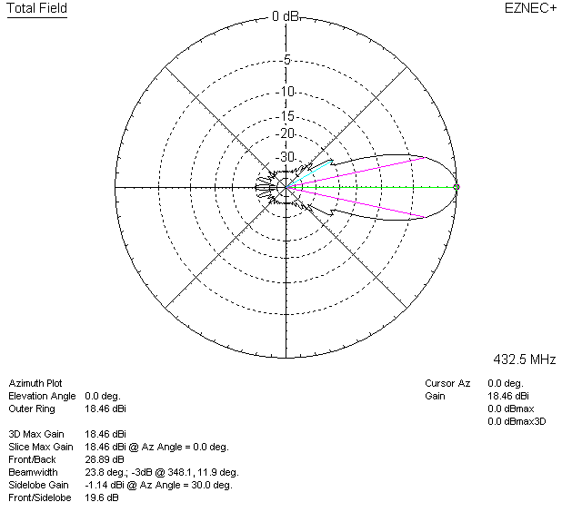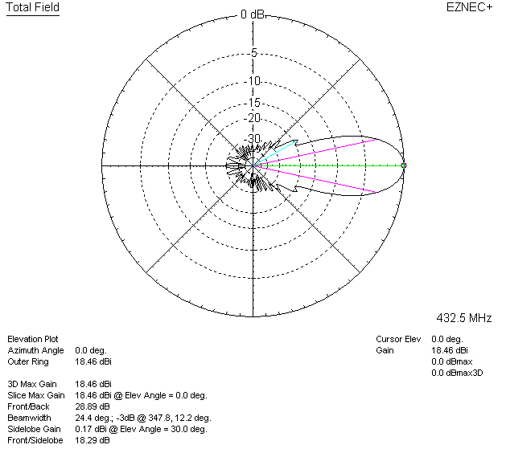

LOSSES INCLUDED (silver)
