ANTENNA Q716D9XL
PERFORMANCES: (No loss condition)
TYPE | ELE | L (mm) | G (dBi) | F/B (dB) | F/Sh (dBi) | F/Sv (dBi) | Hor (◦) | Ver (◦) | Temp (◦K) | G/T (dB) | ΔF * (kHz)
Q716D9XL | 16 | 3670 | 17,61 | 23,57 | 19,96 | 18,36 | 26,0 | 26,9 | 18,9 | +4,84 | 7220
* ΔF given for SWR=1,5

PERFORMANCES: (Losses included)
Element material | G (dBi) | Temp (◦K) | G/T (dB)
Aluminum rods | 17,58 | 21,3 | +4,30
Silvered rods | 17,59 | 20,4 | +4,50

DIMENSIONS:
 | Ref | De | D1 | D2 | D3 | D4 | D5 | D6 | D7 | D8 | D9 | D10 | D11 | D12
Pos | 0 | 120 | 199 | 352 | 483 | 692 | 939 | 1223 | 1519 | 1831 | 2139 | 2456 | 2769 | 3089
Length | 284 | 260 | 246 | 224 | 221 | 219 | 213 | 205 | 201 | 195 | 192 | 190 | 188 | 184
 | D13 | D14 | - All elements made of Al rods Ǿ10,0 mm  - The height of all rectangles is 100 mm  - All dimensions given in milimetres
Pos | 3395 | 3670
Length | 181 | 178

COMPARISON
Antenna | Boomlength (mm) | Material | Gain (dBi) | TA (◦K) | G/T (dB) | Bandwidth  (MHz)
Q716D9XL | 3670 | No loss | 17,61 | 19,6 | +4,37 | 428,100-435,320
Q716D9XL | 3670 | Aluminum | 17,58 | 21,3 | +4,30 | 428,100-435,320
Q716D9XL | 3670 | Silver | 17,59 | 20,4 | +4,50 | 428,100-435,320
EF7016-5 | 3763 | No loss | 17,45 | 21,1 | +4,20 | 430,300-433,550
EF7016-5 | 3763 | Aluminum | 17,36 | 27,0 | +3,05 | 430,300-433,550
EF7016-5 | 3763 | Silver | 17,39 | 24,9 | +3,44 | 430,300-433,550

DIAGRAMS
NO LOSS INCLUDED

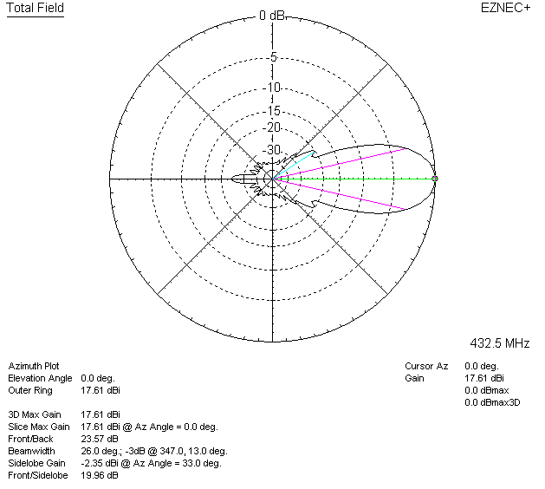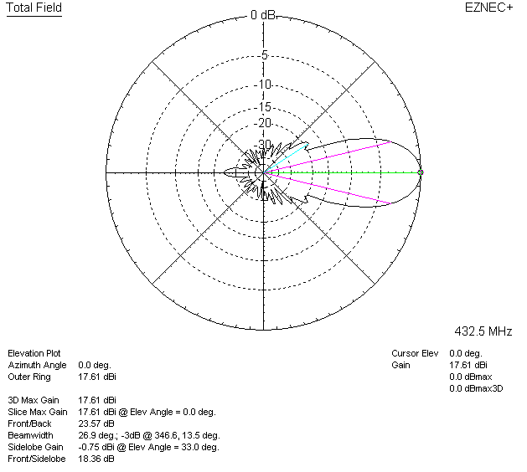

LOSSES INCLUDED (aluminum)
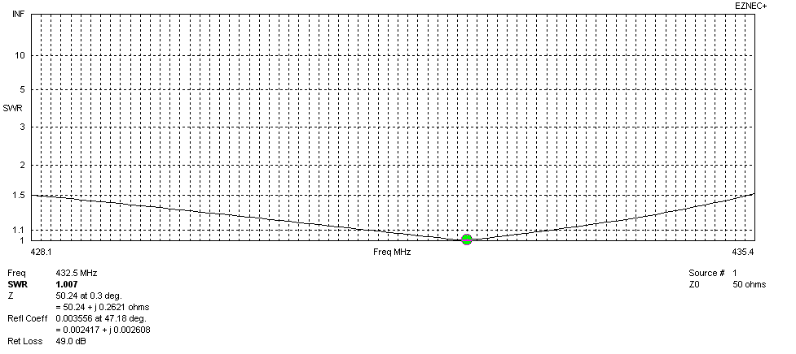
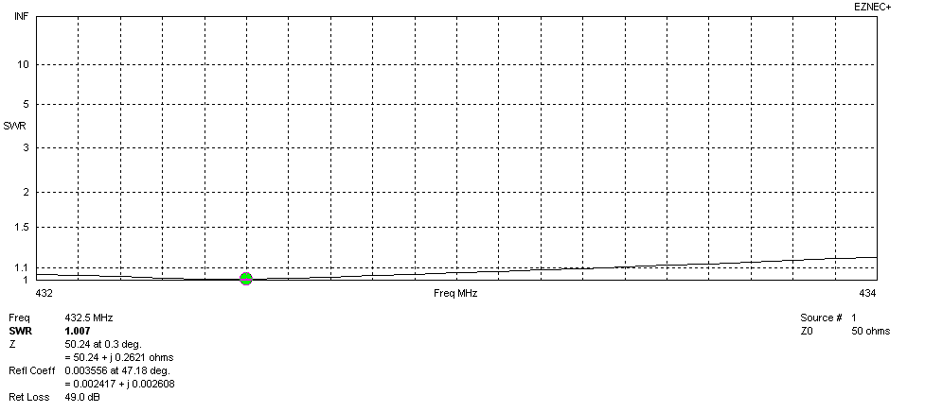
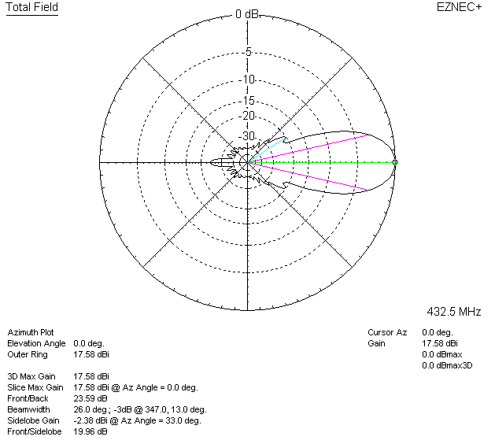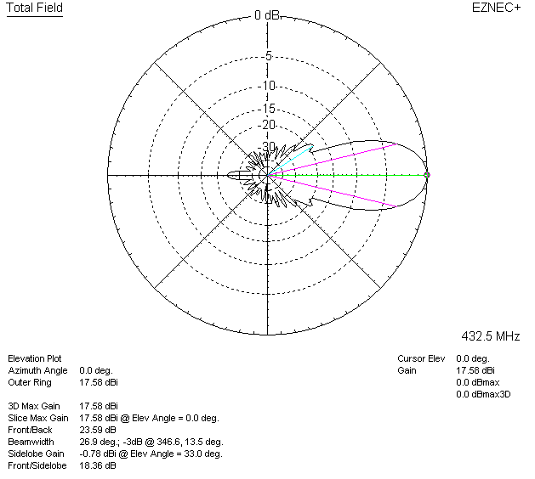

LOSSES INCLUDED (silver)
