ANTENNA Q715D9XL
PERFORMANCES: (No loss condition)
TYPE | ELE | L (mm) | G (dBi) | F/B (dB) | F/Sh (dBi) | F/Sv (dBi) | Hor (◦) | Ver (◦) | Temp (◦K) | G/T (dB) | ΔF * (kHz)
Q715D9XL | 15 | 3360 | 17,29 | 22,54 | 20,58 | 18,02 | 27,0 | 27,9 | 19,6 | +4,37 | 7500
* ΔF given for SWR=1,5

PERFORMANCES: (Losses included)
Element material | G (dBi) | Temp (◦K) | G/T (dB)
Aluminum rods | 17,25 | 21,9 | +3,84
Silvered rods | 17,27 | 21,0 | +4,04

DIMENSIONS:
 | Ref | De | D1 | D2 | D3 | D4 | D5 | D6 | D7 | D8 | D9 | D10 | D11 | D12 | D13
Pos | 0 | 122 | 200 | 352 | 483 | 692 | 939 | 1223 | 1519 | 1831 | 2139 | 2456 | 2769 | 3063 | 3360
Length | 286 | 260 | 246 | 224 | 221 | 219 | 212 | 205 | 200 | 195 | 192 | 190 | 188 | 184 | 180
- All elements made of Al rods Ǿ10,0 mm - The height of all rectangles is 100 mm - All dimensions given in milimetres

COMPARISON
Antenna | Boomlength (mm) | Material | Gain (dBi) | TA (◦K) | G/T (dB) | Bandwidth  (MHz)
Q715D9XL | 3360 | No loss | 17,29 | 19,6 | +4,37 | 428,100-435,600
Q715D9XL | 3360 | Aluminum | 17,25 | 21,9 | +3,84 | 428,100-435,600
Q715D9XL | 3360 | Silver | 17,27 | 21,0 | +4,04 | 428,100-435,600
EF7015-5 | 3392 | No loss | 17,04 | 21,6 | +3,69 | 430,670-433,480
EF7015-5 | 3392 | Aluminum | 16,96 | 27,2 | +2,62 | 430,670-433,480
EF7015-5 | 3392 | Silver | 16,99 | 25,1 | +2,99 | 430,670-433,480

DIAGRAMS
NO LOSS INCLUDED

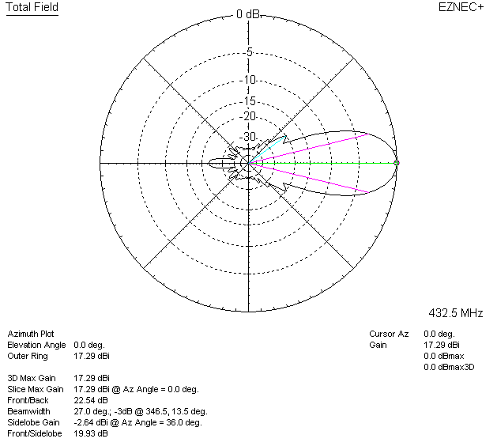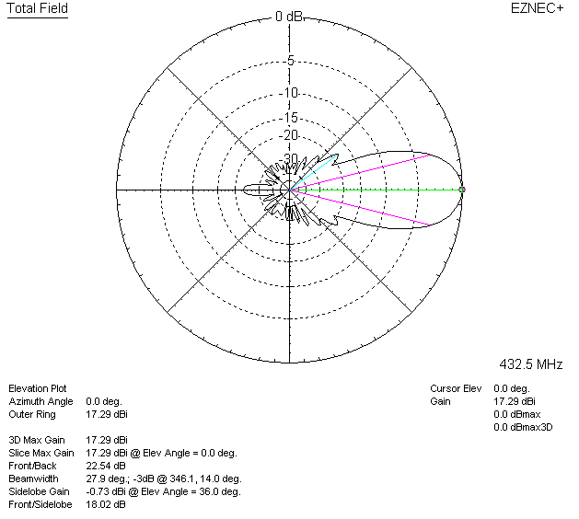

LOSSES INCLUDED (aluminum)
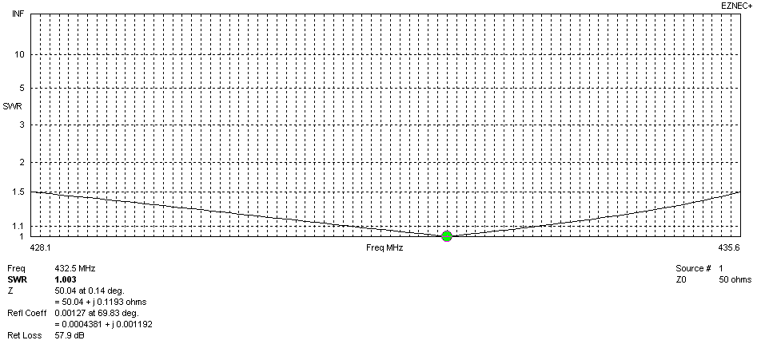
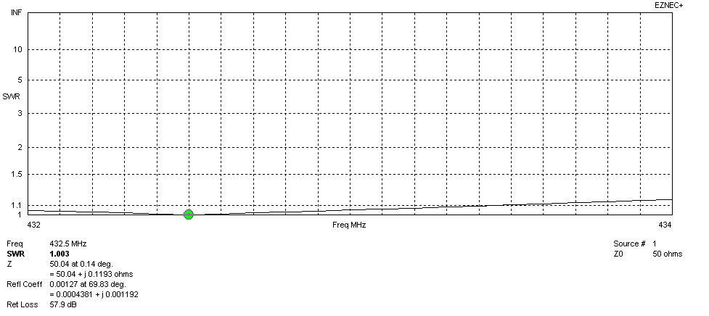
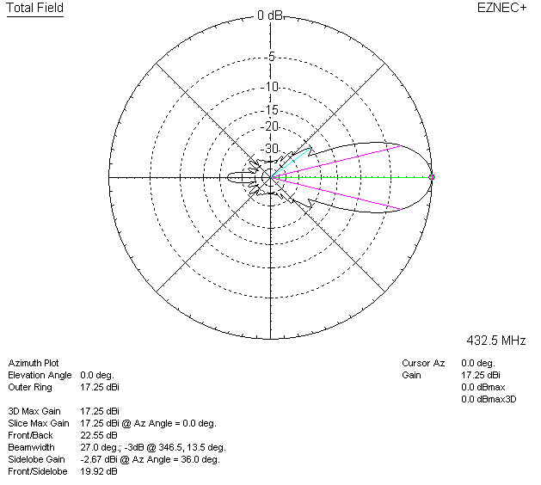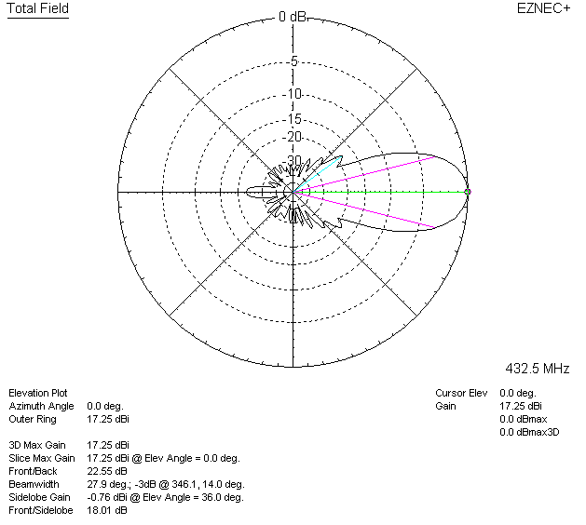

LOSSES INCLUDED (silver)
