ANTENNA Q714E3XL
PERFORMANCES: (No loss condition)
TYPE | ELE | L (mm) | G (dBi) | F/B (dB) | F/Sh (dBi) | F/Sv (dBi) | Hor (◦) | Ver (◦) | Temp (◦K) | G/T (dB) | ΔF * (kHz)
Q714E3XL | 13 | 3385 | 16,95 | 30,87 | 20,68 | 19,03 | 28,8 | 29,9 | 18,8 | +4,22 | 5200
* ΔF given for SWR=1,5

PERFORMANCES: (Losses included)
Element material | G (dBi) | Temp (◦K) | G/T (dB)
Aluminum rods | 16,85 | 25,0 | +2,87
Silvered rods | 16,89 | 22,7 | +3,33

DIMENSIONS:
 | Ref | De | D1 | D2 | D3 | D4 | D5 | D6 | D7 | D8 | D9 | D10 | D11 | D12
Pos | 0 | 116 | 205 | 393 | 642 | 916 | 1219 | 1535 | 1846 | 2158 | 2478 | 2775 | 3127 | 3385
Length | 242 | 221 | 215 | 205 | 199 | 191 | 185 | 181 | 178 | 175 | 170 | 165 | 162 | 160
- All elements made of Al rods Ǿ3,2 mm - The height of all rectangles is 135 mm - All dimensions given in milimetres

COMPARISON
Antenna | Boomlength (mm) | Material | Gain (dBi) | TA (◦K) | G/T (dB) | Bandwidth  (MHz)
Q714E3XL | 3385 | No loss | 16,95 | 18,8 | +4,22 | 429,700-434,900
Q714E3XL | 3385 | Aluminum | 16,85 | 25,0 | +2,87 | 429,700-434,900
Q714E3XL | 3385 | Silver | 16,89 | 22,7 | +3,33 | 429,700-434,900
EF7014-5 | 3050 | No loss | 16,78 | 22,9 | +3,17 | 430,450-433,650
EF7014-5 | 3050 | Aluminum | 16,70 | 28,4 | +2,16 | 430,450-433,650
EF7014-5 | 3050 | Silver | 16,73 | 26,4 | +2,52 | 430,450-433,650

DIAGRAMS
NO LOSS INCLUDED
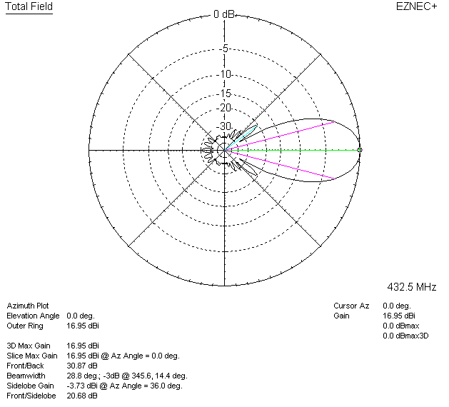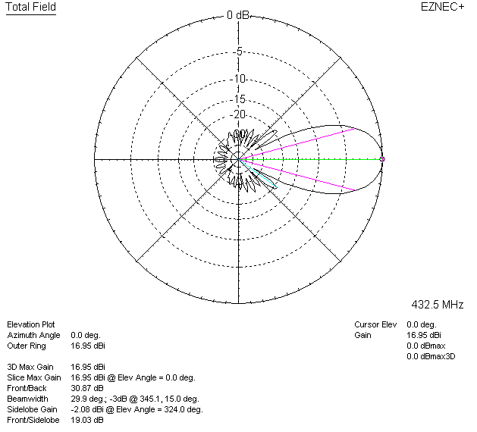

LOSSES INCLUDED (aluminum)
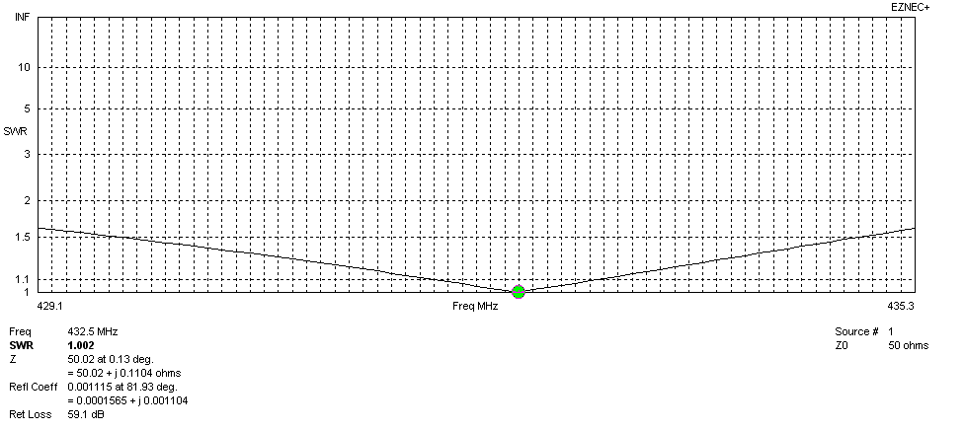
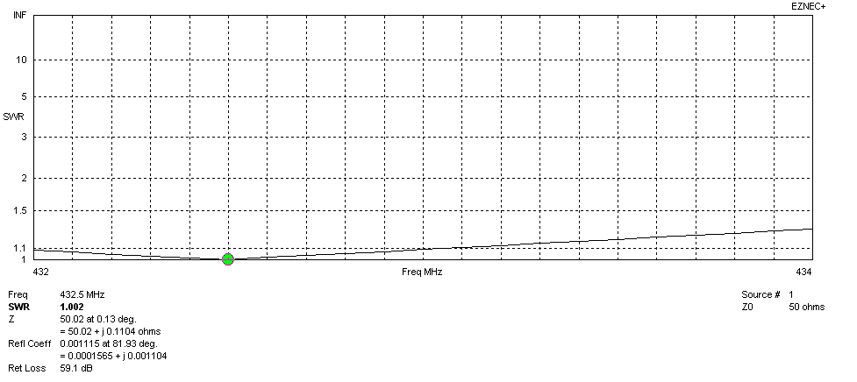
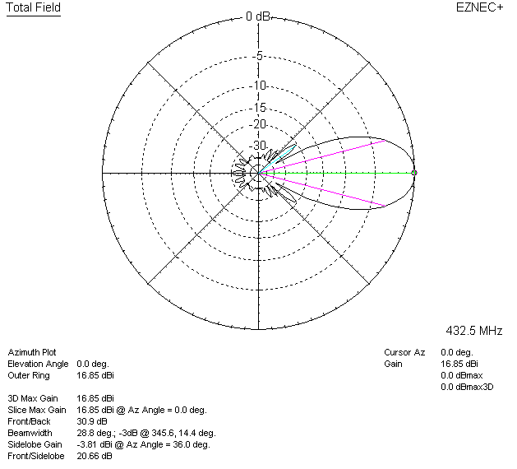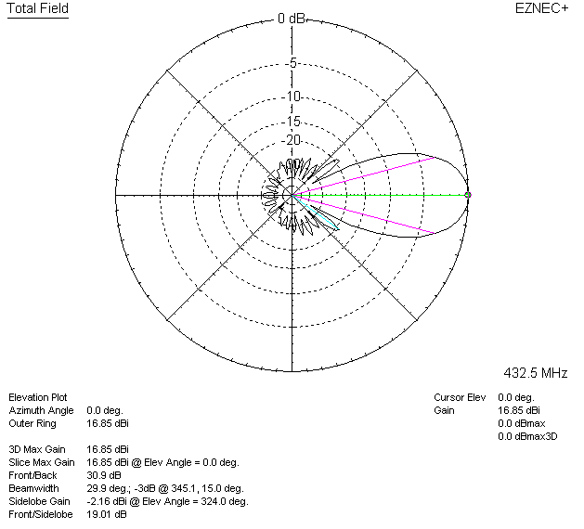

LOSSES INCLUDED (silver)
