ANTENNA Q714D9XL
PERFORMANCES: (No loss condition)
TYPE | ELE | L (mm) | G (dBi) | F/B (dB) | F/Sh (dBi) | F/Sv (dBi) | Hor (◦) | Ver (◦) | Temp (◦K) | G/T (dB) | ΔF * (kHz)
Q714D9XL | 14 | 3035 | 16,88 | 23,60 | 20,58 | 18,61 | 29,8 | 29,5 | 19,8 | +3,91 | 8900
* ΔF given for SWR=1,5

PERFORMANCES: (Losses included)
Element material | G (dBi) | Temp (◦K) | G/T (dB)
Aluminum rods | 16,85 | 22,4 | +2,95
Silvered rods | 16,86 | 21,2 | +3,60

DIMENSIONS:
 | Ref | De | D1 | D2 | D3 | D4 | D5 | D6 | D7 | D8 | D9 | D10 | D11 | D12
Pos | 0 | 123 | 200 | 352 | 483 | 692 | 939 | 1223 | 1519 | 1831 | 2139 | 2453 | 2745 | 3035
Length | 284 | 261 | 246 | 224 | 221 | 218 | 212 | 205 | 198 | 194 | 192 | 190 | 186 | 182
- All elements made of Al rods Ǿ10,0 mm - The height of all rectangles is 100 mm - All dimensions given in milimetres

COMPARISON
Antenna | Boomlength (mm) | Material | Gain (dBi) | TA (◦K) | G/T (dB) | Bandwidth  (MHz)
Q714D9XL | 3035 | No loss | 16,88 | 19,8 | +3,91 | 427,200-436,100
Q714D9XL | 3035 | Aluminum | 16,85 | 22,4 | +2,95 | 427,200-436,100
Q714D9XL | 3035 | Silver | 16,86 | 21,2 | +3,60 | 427,200-436,100
EF7014-5 | 3050 | No loss | 16,78 | 22,9 | +3,17 | 430,450-433,650
EF7014-5 | 3050 | Aluminum | 16,70 | 28,4 | +2,16 | 430,450-433,650
EF7014-5 | 3050 | Silver | 16,73 | 26,4 | +2,52 | 430,450-433,650

DIAGRAMS
NO LOSS INCLUDED

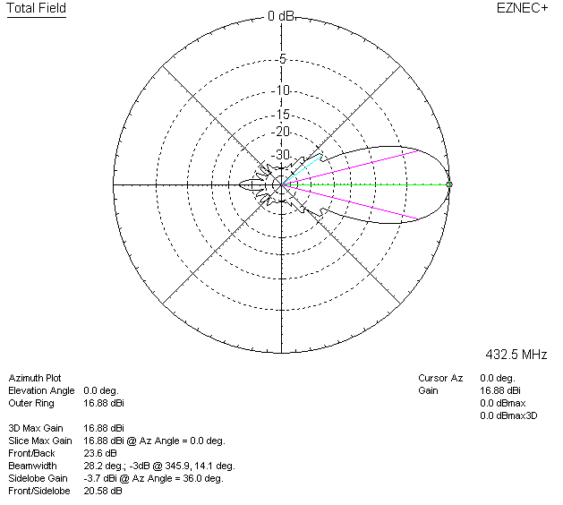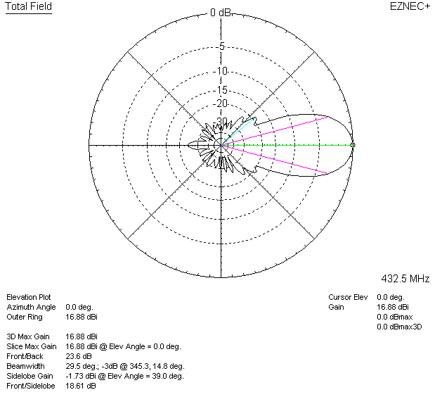

LOSSES INCLUDED (aluminum)
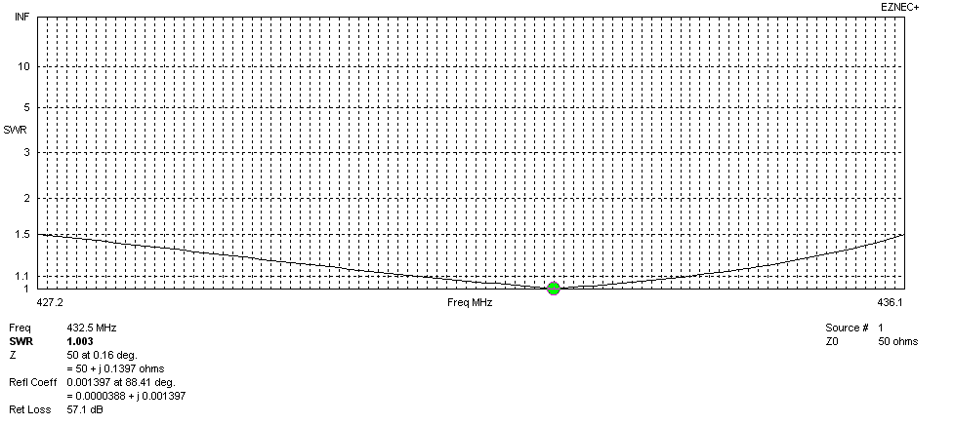
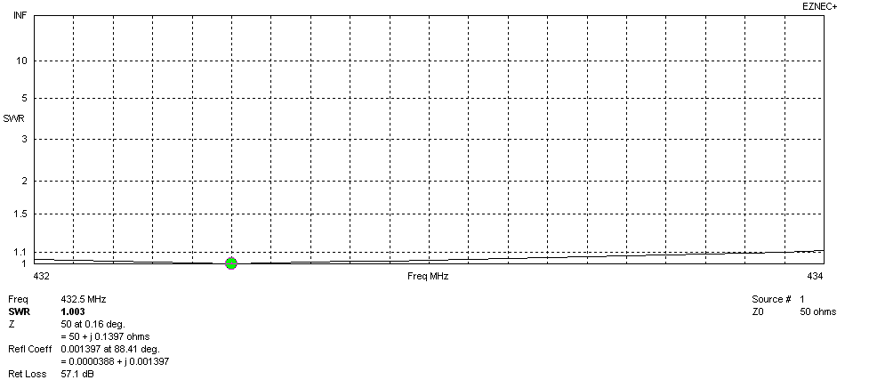
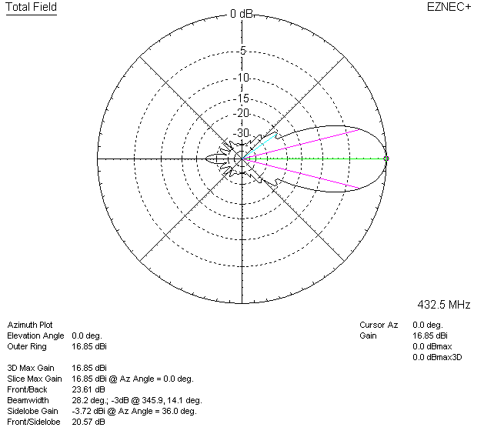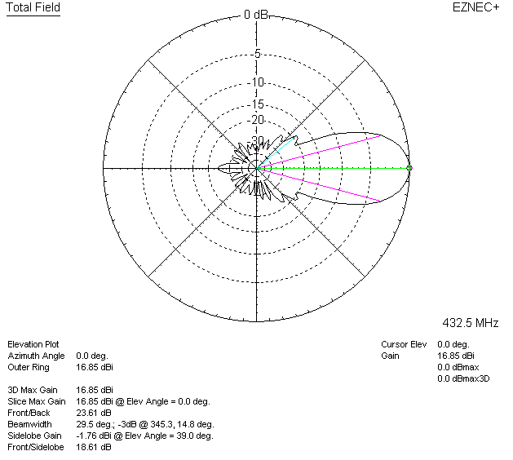

LOSSES INCLUDED (silver)
