ANTENNA Q711D9XL
PERFORMANCES: (No loss condition)
TYPE | ELE | L (mm) | G (dBi) | F/B (dB) | F/Sh (dBi) | F/Sv (dBi) | Hor (◦) | Ver (◦) | Temp (◦K) | G/T (dB) | ΔF * (kHz)
Q711D9XL | 11 | 2105 | 15,45 | 20,25 | 21,95 | 18,74 | 33,2 | 35,4 | 20,9 | +2,26 | 12850
* ΔF given for SWR=1,5

PERFORMANCES: (Losses included)
Element material | G (dBi) | Temp (◦K) | G/T (dB)
Aluminum rods | 15,42 | 22,7 | +1,85
Silvered rods | 15,43 | 22,0 | +2,00

DIMENSIONS:
 | Ref | De | D1 | D2 | D3 | D4 | D5 | D6 | D7 | D8 | D9 | - All elements made of Al rods Ǿ10,0 mm  - The height of all rectangles is 100 mm  - All dimensions given in milimetres
Pos | 0 | 125 | 200 | 351 | 484 | 692 | 939 | 1223 | 1519 | 1811 | 2105
Length | 286 | 261 | 246 | 222 | 218 | 215 | 209 | 203 | 195 | 189 | 184

COMPARISON
Antenna | Boomlength (mm) | Material | Gain (dBi) | TA (◦K) | G/T (dB) | Bandwidth  (MHz)
Q711D9XL | 2105 | No loss | 15,45 | 20,9 | +2,26 | 426,200-437,500
Q711D9XL | 2105 | Aluminum | 15,42 | 22,7 | +1,85 | 426,200-437,500
Q711D9XL | 2105 | Silver | 15,43 | 22,0 | +2,00 | 426,200-437,500
EF7011-5 | 2110 | No loss | 15,28 | 26,0 | +1,12 | 430,050-434,540
EF7011-5 | 2110 | Aluminum | 15,22 | 30,5 | +0,28 | 430,050-434,540
EF7011-5 | 2110 | Silver | 15,24 | 28,9 | +0,63 | 430,050-434,540

DIAGRAMS
NO LOSS INCLUDED

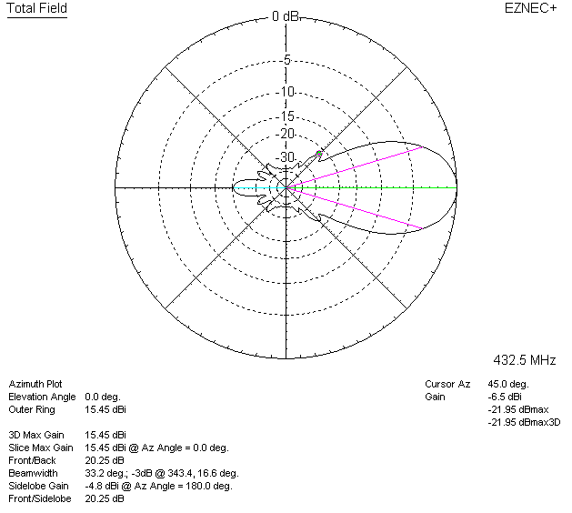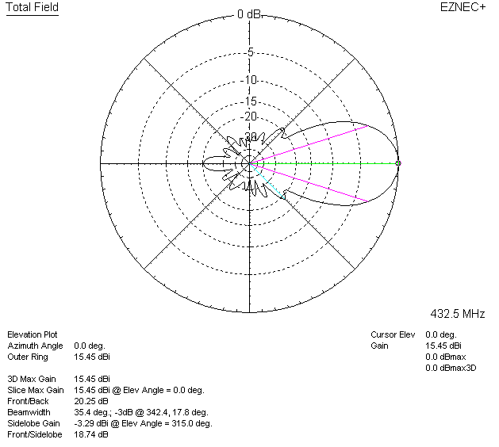

LOSSES INCLUDED (aluminum)
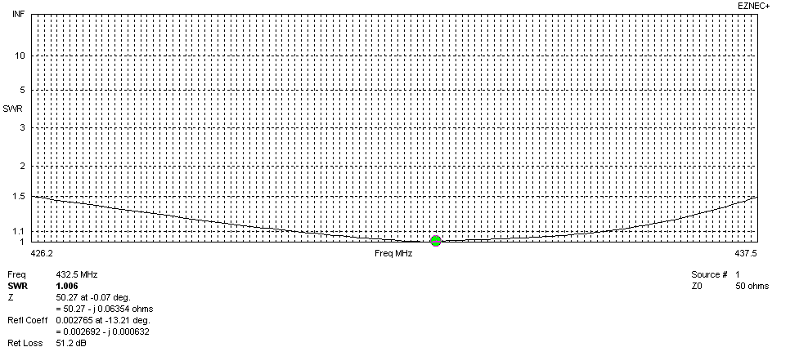
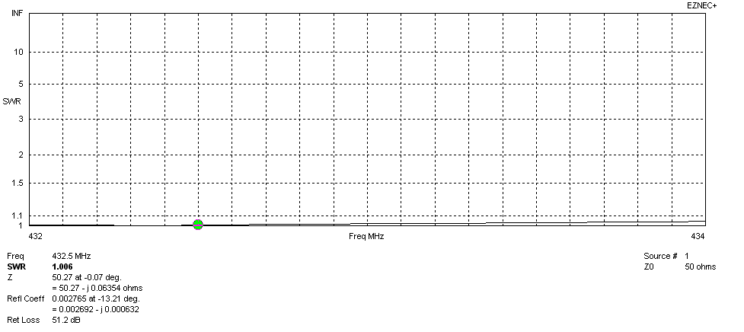
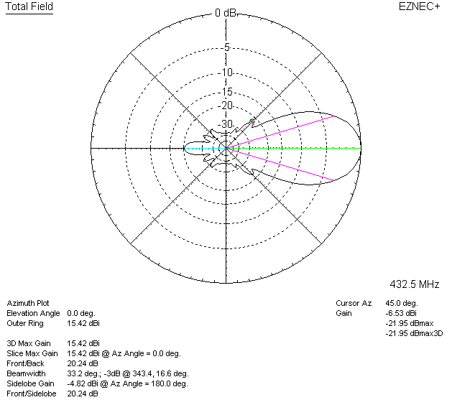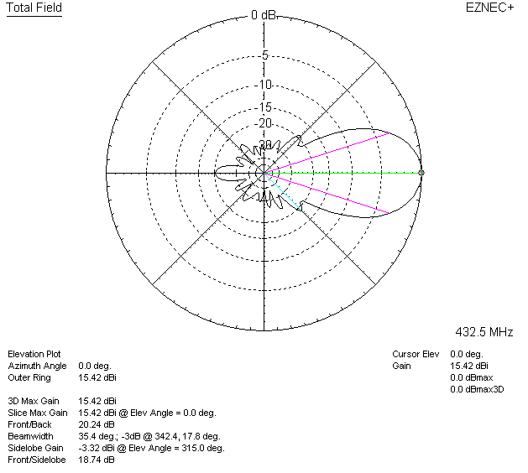

LOSSES INCLUDED (silver)
