ANTENNA Q2326B1XL
DESCRIPTION:
Boomlength | Number of elements | Diameter of elements | Height of elements | Antenna for high gain, light construction, recommended material: silver
2478 mm | 26 | 1,5 mm | 30 mm

PERFORMANCES:
Element material | G (dBi) | F/B  (dB) | F/Sh (dBi) | F/Sv (dBi) | Hor  (◦) | Ver  (◦) | Temp (◦K) | G/T (dB) | Bandwidth (MHz)  for SWR=1,5
No loss | 19,74 | 36,92 | 20,13 | 19,00 | 20,8 | 21,2 | 13,6 | +8,40 | 1288,400-1302,300
Aluminum rods | 19,62 | 37,38 | 20,18 | 19,05 | 20,6 | 21,1 | 22,0 | +6,20 | 1288,400-1302,300
Silvered rods | 19,66 | 37,24 | 20,16 | 19,04 | 20,6 | 21,2 | 18,9 | +6,89 | 1288,400-1302,300

DIMENSIONS:
 | Ref | De | D1 | D2 | D3 | D4 | D5 | D6 | D7 | D8 | D9 | D10 | D11
Pos | 0 | 58 | 100 | 176 | 263 | 359 | 456 | 557 | 659 | 763 | 869 | 976 | 1082
Length | 96 | 88 | 82 | 79 | 75 | 73 | 71 | 70 | 69 | 67 | 67 | 67 | 65
 | D12 | D13 | D14 | D15 | D16 | D17 | D18 | D19 | D20 | D21 | D22 | D23 | D24
Pos | 1192 | 1298 | 1409 | 1516 | 1622 | 1740 | 1846 | 1955 | 2066 | 2173 | 2282 | 2388 | 2478
Length | 65 | 64 | 64 | 63 | 61 | 61 | 61 | 61 | 60 | 60 | 60 | 60 | 60
All measures given in milimeters

DIAGRAMS
NO LOSS INCLUDED
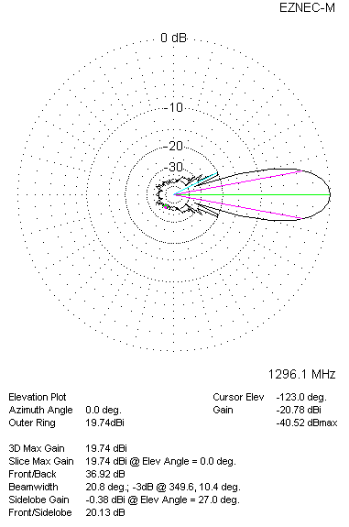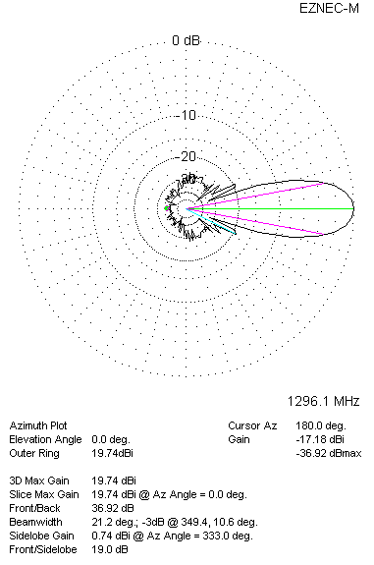

LOSSES INCLUDED (aluminum)
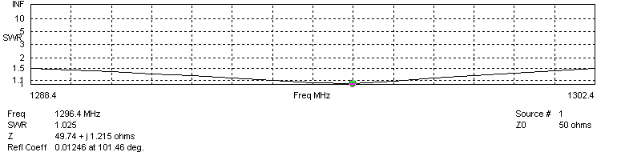
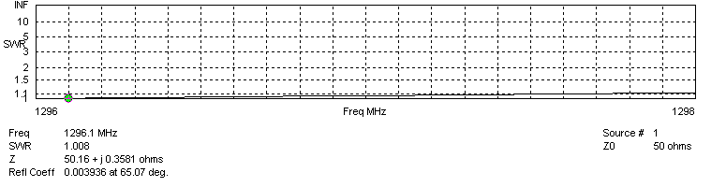
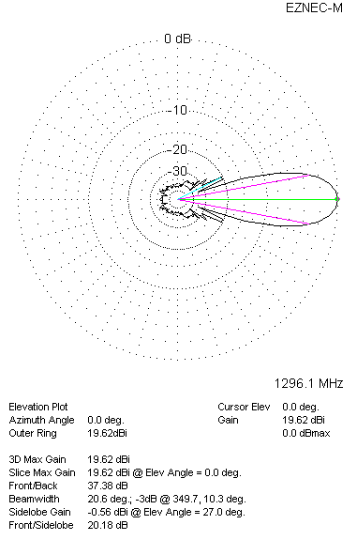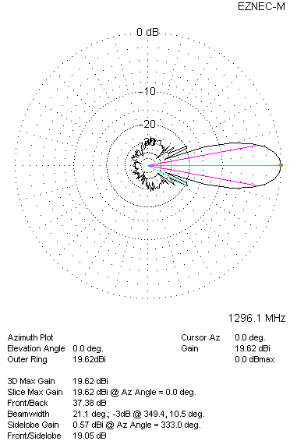

LOSSES INCLUDED (silver)
