ANTENNA Q217D1XL
PERFORMANCES: (No loss condition)
TYPE | ELE | L (mm) | G (dBi) | F/B (dB) | F/Sh (dBi) | F/Sv (dBi) | Hor (◦) | Ver (◦) | Temp (◦K) | G/T (dB) | ΔF * (kHz)
Q217D1XL | 17 | 12000 | 17,96 | 31,39 | 19,00 | 17,47 | 25,0 | 25,7 | 215,8 | -5,44 | 2570
* ΔF given for SWR=1,5

PERFORMANCES: (Losses included)
Element material | G (dBi) | Temp (◦K) | G/T (dB)
Aluminum rods | 17,84 | 220,9 | -5,60

COMPARISON
Antenna | Boomlength (mm) | Material | Gain (dBi) | TA (◦K) | G/T (dB) | Bandwith (MHz)
Q217D1XL | 12000 | No loss | 17,96 | 215,8 | -5,44 | 143,530-145,700
Q217D1XL | 12000 | Aluminum | 17,84 | 220,9 | -5,60 | 143,530-145,700
EF0215-5 | 10060 | No loss | 17,26 | 223,0 | -6,22 | 143,750-144,460
EF0215-5 | 10060 | Aluminum | 17,06 | 226,7 | -6,49 | 143,750-144,460

DIMENSIONS:
 | Ref | De | D1 | D2 | D3 | D4 | D5 | D6 | D7 | D8 | D9 | D10 | D11 | D12
Pos | 0 | 256 | 437 | 855 | 1486 | 2189 | 2973 | 3805 | 4678 | 5597 | 6528 | 7455 | 8397 | 9318
Length | 784 | 736 | 712 | 694 | 678 | 660 | 644 | 632 | 624 | 610 | 604 | 598 | 594 | 588
 | D13 | D14 | D15 |  | REMARKS: : - All elements made of Al rods Ǿ5 mm  - The height of all rectangles is 320 mm  - All dimensions given in milimetres
Pos | 10311 | 11165 | 12000
Length | 584 | 578 | 576

DIAGRAMS (no losses included)
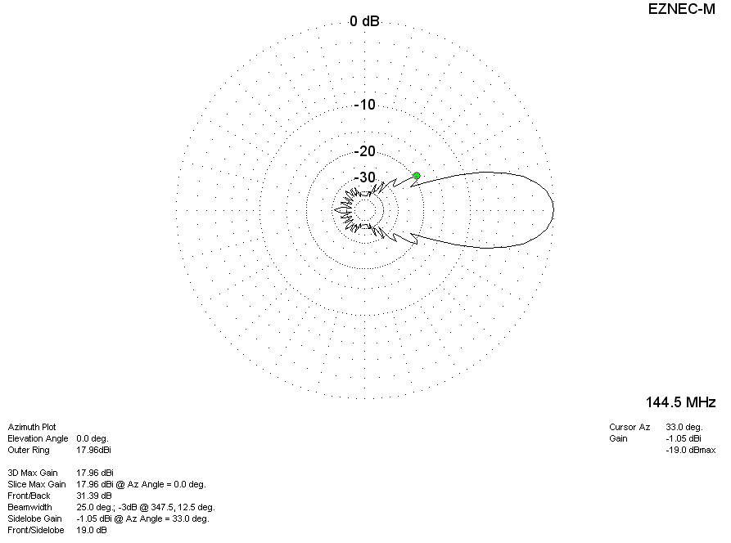
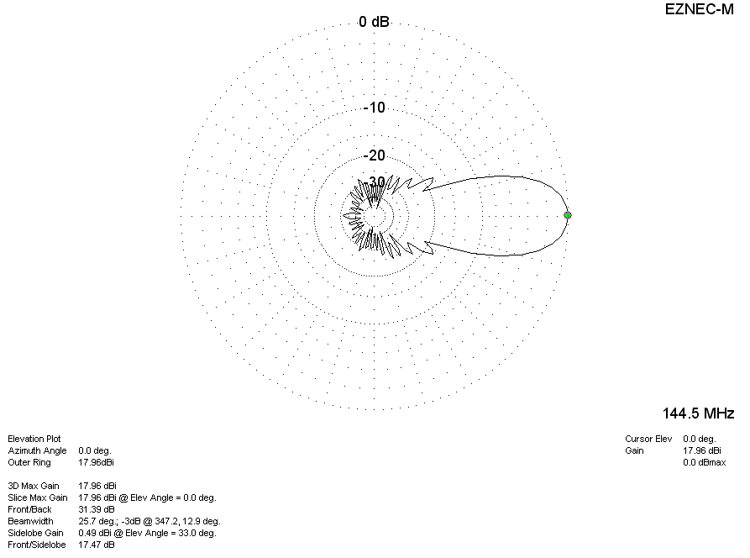

DIAGRAMS (losses included)
