ANTENNA Q210H2XL
PERFORMANCES: (No loss condition)
TYPE | ELE | L (mm) | G (dBi) | F/B (dB) | F/Sh (dBi) | F/Sv (dBi) | Hor (◦) | Ver (◦) | Temp (◦K) | G/T (dB) | ΔF * (kHz)
Q210H2XL | 10 | 6245 | 15,67 | 21,66 | 20,81 | 18,13 | 32,4 | 33,9 | 225,4 | -7,86 | 1520
* ΔF given for SWR=1,5

PERFORMANCES: (Losses included)
Element material | G (dBi) | Temp (◦K) | G/T (dB)
Aluminum rods | 15,55 | 227,5 | -8,02

COMPARISON
Antenna | Boomlength (mm) | Material | Gain (dBi) | TA (◦K) | G/T (dB) | Bandwidth (MHz)
Q210H2XL | 6245 | No loss | 15,67 | 225,4 | -7,86 | 143,700-145,220
Q210H2XL | 6245 | Aluminum | 15,55 | 227,5 | -8,02 | 143,700-145,220
EF0211-5 | 6325 | No loss | 15,24 | 226,7 | -8,31 | 142,500-144,750
EF0211-5 | 6325 | Aluminum | 15,14 | 228,5 | -8,45 | 142,500-144,750

DIMENSIONS:
 | Ref | De | D1 | D2 | D3 | D4 | D5 | D6 | D7 | D8 | - All elements made of Al rods Ǿ5 mm  - The height of all rectangles is 400 mm  - All dimensions given in milimetres
Pos | 0 | 335 | 551 | 1115 | 1876 | 2692 | 3566 | 4489 | 5405 | 6315
Length | 712 | 668 | 652 | 624 | 606 | 588 | 576 | 562 | 556 | 548

DIAGRAMS (no loss included)
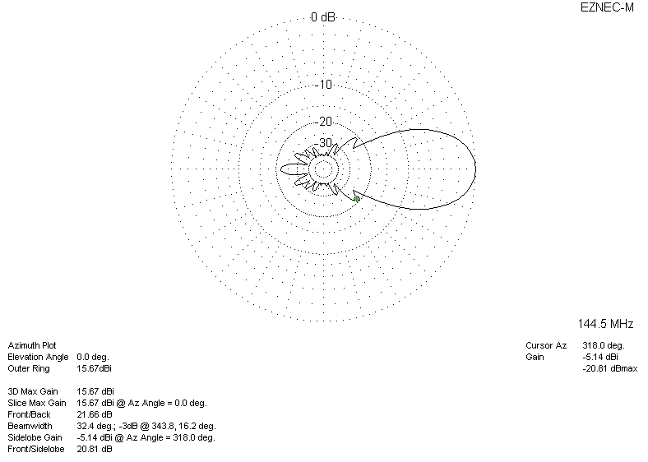
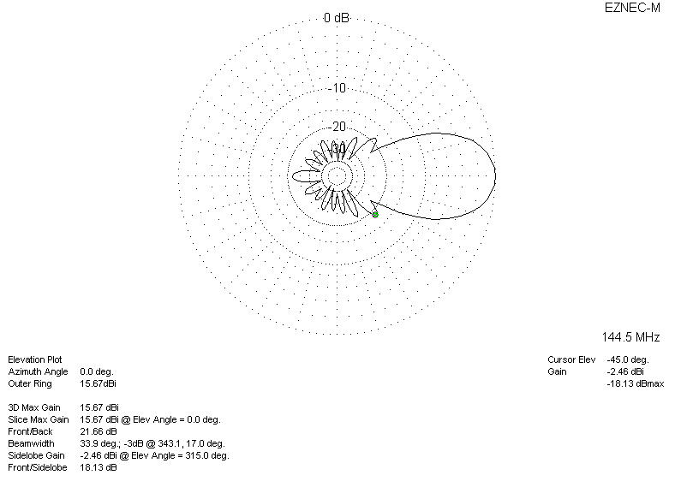

LOSSES INCLUDED
